Background Information Sheet
Name | Class | Date | Lesson Type | Plan type | Length
YUK YUNGJU | TESOL | 2020.08.26 | Reading | PPP | 30 min

Lesson
Topic | Romeo and Juliet
Main Aim | Ss practice their reading comprehension.
Secondary Aim | Ss practice their speaking fluency.

Materials and References
the text, worksheets, picture slides

Reference : https://learnenglishkids.britishcouncil.org/sites/kids/files/attachment/short-stories-shakespeare-romeo-and-juliet-transcript.pdf

Student Profile
Level | Low-Intermediate
Age | 9-11 | Number of Students | 2
Detail | They are native Korean. They are satisfy basic survival needs and very routine social demands. Understand simple learned phrases easily and some new simple phrases containing familiar vocabulary, spoken slowly with frequent repetition.

Anticipated Difficulties and their Solutions:
The quantity of new language points to be learned about the 2nd conditional is too much for students to handle in a short 30-minute lesson. This could lead to anxiety, rushing, and a lot of teacher talk. For this lesson I will manage this by selectively presenting only a few new concepts about the 2nd conditional. The remaining new language points can be presented in the next lesson.

My Personal Aim
What I hope most to demonstrate in this lesson is the ability to make the learning as easy and clear to understand as possible.

Stage Name: Lead-in
Purpose of this stage: To relax both the teacher and students. To focus attention on the lesson. To lead in to the topic, activating background knowledge – this will help to contextualize the text. This is a BEFORE READINING stage.
Materials: List all materials that will be needed in this stage.
Timing | Interaction | Procedure
30 sec  1 min  30 sec | T  T-S/S-S  T-S | Greet. Instructions.  Hello guys. Do you like storybook? What is your favorite story? I like Beauty and the Beast. It was very impression and romantic to me. How about you? Talk with your partner.  Brainstorm/talk to a partner.  Feedback if appropriate.

Stage Name: Presentation
Purpose of this stage: To pre-teach keywords if necessary, and answer a guiding questions (such as a predicting task, or a specific question). These steps provide extra help for students to comprehend the text. This is a BEFORE READINING stage.
Materials: List all materials that will be needed in this stage.
Timing | Interaction | Procedure
4 min  10 sec  1 min  50 sec | T-S  T  S-S  T-S | Pre-teach keywords  Ok guys. Look at this picture (keyword)  Look at this picture. What do you think?  (decide)  CCQ- do I need to choose something (YES)  Do I need to think carefully? (YES)  Is it easy? (No)  Drill - Repeat after me 3 times  Individual drilling  Board- How many syllables in decide? 2 syllables  Divides decide into syllables: de-cide  Stressed syllable in decide: de-cide  (Poison)  Elicit – How do you think this picture?  CCQ – Is it dangerous? (YES)  Drill – Repeat after me 3 times  Individual drilling  Board – How many syllables in poison? 2 syllables  Divide poison into syllables: poi-son  Stressed syllable in poison: poi-son  Guiding Question  Do you know this story? (show picture)  Is its sad story or happy story? Talk to your partner about them.  Student Discuss  Feedback. Nominate a few students to share their ideas.

Stage Name: Practice – Literal Comprehension
Purpose of this stage: is to get students to practice reading for literal detail. They will also practice fast reading (skimming and scanning). This is a WHILE READINING stage.
Materials: List all materials that will be needed in this stage.
Timing | Interaction | Procedure
30 sec  4 min  1 min  1 min | T  S  S-S  T-S | Instructions. Set the purpose for reading. Hand out worksheets.  Guys, now we are going to work on a worksheet. Before, we start please read story first and  read the questions carefully and fill in the correct answers.’ please do exercise 1 only.  ICQ  Do you only work on exercise 1? (Yes)  Do you answer exercise 2 when you are done with exercise1? (No)  Students read the whole text for the 1st time and write answers on the worksheet.  Time’s up. Now, please you check your answer with your partner.  Pair check.  Feedback to check accuracy.

Stage Name: Practice – Interpretive Comprehension
Purpose of this stage: is to get students to get students to practice interpreting a text correctly This will require more detailed, careful reading, and thinking time to arrive at the correct answer. This is a WHILE READINING stage.
Materials: List all materials that will be needed in this stage.
Timing | Interaction | Procedure
30 sec  3 min  1 min 30 min  1 min 30 min | T  S  S-S  T-S | Instructions. Set the purpose for reading. Hand out worksheets.  Now we will work on the next exercise. This time it will be little bit more challenging. ‘please read the question carefully and answer the question. I will give you 3 minutes for this exercise.  Students read for the 2nd time. Students write their answers down.  Pair check. Monitor.  Feedback to check accuracy.

Stage Name: Production - Applied Comprehension
Purpose of this stage: is for students to practice their speaking fluency and is related to the lesson topic. This is an AFTER READINING stage.
Materials: List all materials that will be needed in this stage.
Timing | Interaction | Procedure
30 sec  4 min  1 min | T  S-S  T-S | Instructions. Give students a question to discuss with partner.  Ok guys. Now you are doing discuss with your partner. There is no answer for this question.  Just talk each other and discuss your opinion please.  How do you think Romeo action? Is it good or bad?  Have you ever liked someone?? And if your parent does like her how will you do?  Students discuss.  Feedback. Students share their ideas with the class.

Stage Name: Wrap-up
Purpose of this stage: is to end the lesson on a positive note so that students feel they have achieved progress. This is an AFTER READINING stage.
Materials: List all materials that will be needed in this stage.
Timing | Interaction | Procedure
3 min | T | Lesson feedback. Tell the class what they did well, and what needs to improve.  Offer delayed corrections to the previous stage.  Guys you did great today. Everyone knows about this story. Thank you so much for sharing your ideas! Do you enjoy it?  All of you were focused during your reading trying to understand. Exercise 2 was a bit challenging but did great. Thank you for following my lesson.  Next class, I will prepare another topic.  No homework for today. See you guys.

Please delete this message and the guidelines in the Timing, Interaction and Procedure columns and write your own detail.

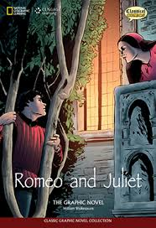

Many years ago, in Verona, Italy, there were two families.
‘We are the Capulets.’
‘We are the Montagues.’
These families are always fighting. The Montagues have a son, Romeo. The Capulets have a daughter, Juliet.
One night the Capulets have a party and Romeo goes. He meets Juliet and they fall in love. Juliet’s cousin, Tybalt, sees Romeo and is very angry.
‘He’s a Montague! Get him!’
‘Oh Romeo, why are you a Montague?’
Romeo and Juliet talk and decide to get married.
They know that their families will be very angry, so they go to Friar Lawrence and are married in secret.
The next day, Tybalt sees Romeo. He is still angry with Romeo and wants to fight him.
Romeo does not want to fight but his best friend, but Mercutio, does.
‘If you won’t fight him, I will!’
Mercutio fights Tybalt. Tybalt kills Mercutio! Romeo is so upset he fights Tybalt and
kills him too! Another fight broke out between the two families, Romeo, outraged, kills Juliet's cousin.
The Prince of Verona is very angry and sends Romeo away. Juliet goes to Friar. He helps Juliet.
‘Here is a special drink. You will sleep for two days. Your family will think you are dead
but you will wake up. Then you and Romeo can be free together.’
Friar Lawrence sends Romeo a letter to tell him the plan. But Romeo does not get the
message. He hears that Juliet is dead! Romeo still believing Juliet to be dead, Romeo poisons himself.
‘Now I will stay with you forever.’
Too late, Juliet wakes up! She sees what happened.
‘Oh no! You didn’t leave any poison for me but here is your knife.’
Romeo and Juliet are both dead. Friar Lawrence tells the Capulets and Montagues
what happened. They are so sad they agree not to fight any more
Exercise 1
Read the questions carefully and fill in the correct answer.

1) Whose family is Romeo?

2) Where did Romeo and Juliet meet?

3) Why Tybalt angry to Romeo?

4) Why the Prince of Verona is very angry and sends Romeo away?

5) Why Romeo think Juliet died?

Exercise 2
Read the questions carefully and fill in the correct answer.
1) Why the two families solve conflict?
2) why they had married in secret?
3) Why Romeo kill Tybalt?
4) Why did Romeo die follow Juliet?

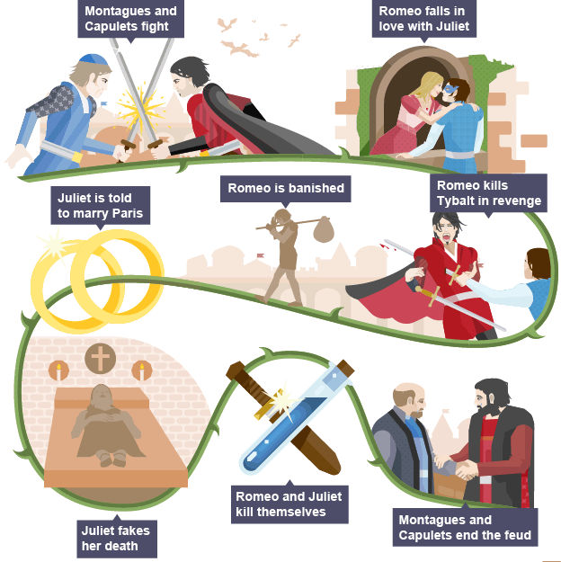

Answer)

Exercise 1
1) Whose family is Romeo?
The Montagues have a son, Romeo.

2) Where did Romeo and Juliet meet?
One night the Capulets have a party and Romeo goes. He meets Juliet and they fall in love.

3) Why Tybalt angry to Romeo?
Juliet’s cousin, Tybalt, sees Romeo and is very angry because Romeo visit the party.

4) Why the Prince of Verona is very angry and sends Romeo away?
He killed Tybalt.

5) Why Romeo think Juliet died?
Because he did not receive Juliet message.

Exercise 2
1) Why the two families solve conflict?
Friar Lawrence tells the Capulets and Montagues
what happened. They are so sad they agree not to fight any more.

2) why they had married in secret?
Romeo and Juliet talk and decide to get married.
They know that their families will be very angry, so they go to Friar Lawrence and are married in secret.

3) Why Romeo kill Tybalt?
Mercutio fights Tybalt. Tybalt kills Mercutio! Romeo is so upset he fights Tybalt and kills him too!

4) Why did Romeo die follow Juliet?
Romeo still believing Juliet to be dead, Romeo poisons himself.
‘Now I will stay with you forever.’

Instructor’s Comments and Assessment
Pros
Cons
Change
Overall Comments
Grade
Above Standard 85%-100% | Standard 70%-84% | Below Standard 69%-0%
Instructor | Student Signature | Date
Taute, David

