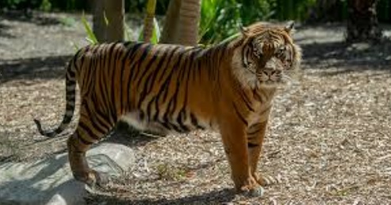
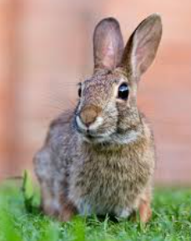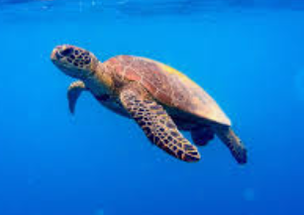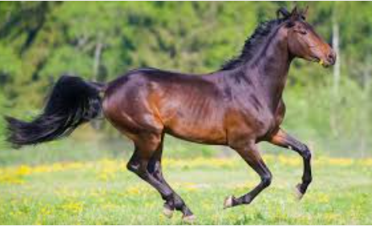

Controlled practice – worksheet

Change adjectives to comparative adjectives.
Adjective | Comparative
Big | Bigger
Cute
Large
Short
Small
Smart
Tall
Thin

Less controlled practice – worksheet

Animal comparison
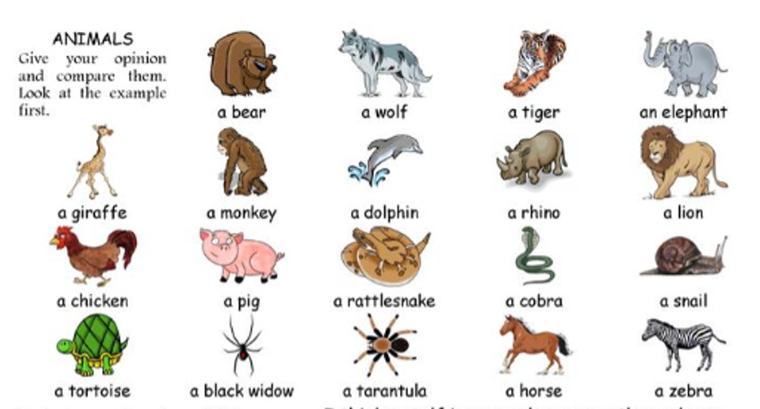
Make a sentence using the words provided.
- An elephant / a giraffe / tall
- _____________________________________________________________
- A rhino / an elephant / big
- ______________________________________________________________
- A bear / a lion /strong
- ______________________________________________________________
- A snail / a tortoise / slow
- _______________________________________________________________
- A horse / a zebra / fast
- ________________________________________________________________

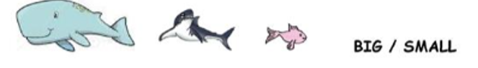
- A whale is _____________ than a shark.
- A goldfish is _____________ than a shark.
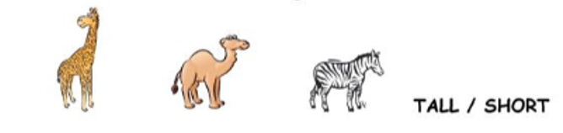
- A giraffe is _____________ than a camel.
- A zebra is ____________ than a camel.
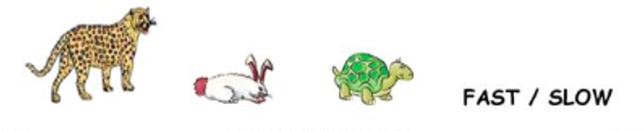
- A cheetah is ______________ than a rabbit.
- A tortoise is _____________ than a rabbit.

Production – Freer practice
Play a game!
You | Your partner

