Background Information Sheet
Name | Class | Date | Lesson Type | Plan type | Length
Binnie | TESOL 215 | 07/12/2020 | Listening | PPP | 35 min
Lesson
Topic | A princess of Mars Part 4
Main Aim | Students will practice their listening comprehension using an integrated listening model.
Secondary Aim | Students can speak their opinion in English freely.
Materials and References
https://youtu.be/sD1UsOdLMKA
; PPT / worksheet / board pens; P.Ck and audio equipment.

Student Profile
Level | Intermediate
Age | teens | Number of Students | 9
Detail | This is a general English class and students are highly motivated learners. The students are all koreans and enjoy having conversation and science fiction. They prefer to have work with partner. But they feel not comfortable to deliver their opinion in English. They engage actively in kinaesthetic learning. And tend to visual learner mode more than auditory learning.
Anticipated Classroom Management Difficulties and their Solutions
Electronic equipment could be fail -> arrive earlier at least 1 hour before class start and check whether computer is working, wifi can be connected or not, for dealing with the problems. Down load all audio file in the usb and smartphone; print A4 size picture of my PPT.
Nervousness at the start of lesson -> do micro-teaching before the class as much as you can and try to prepare what you want to say by writing down your own script from start to finish.
My Personal Aim
What I aim to demonstrate is the ability to write out a complete, detailed lesson plan.

Stage Name: Lead-in
Purpose of this stage: : to make both teacher and students get relaxed and prepared for the class by giving some questions;
To get them have interest in the topic,
Materials:
Time | Interaction | Procedure
30 sec  2 min  30 sec | T/T-S  S-S  T-S | Organize seating arrangements so everyone has a partner. With one group of 3 sitting together, and all can easily see the screen. Show PPT1  T- “Hello everyone. Look at the picture. And think about the question like who is your important person in your life? Talk to your partner about your idea. You have 2 minute.”  Students talk to their partners.  (By clapping hands and get them notice that time is up)  Gesture to a person of each group and ask  “Tell me about your ideas.”

Stage Name: Presentation
Purpose of this stage: To offer any needed help which students may need in order to comprehend the text more easily. This includes teaching from 1 to 4 key words using the C.C.C. technique, and asking a guiding question which will allow students the opportunity to think of and share ideas they are likely to encounter when listening. This encourages the use of their schema when comprehending a text.
Materials:
Time | Interaction | Procedure
2 min  2 min  10 sec  1 min  50 sec | T-S  T-S | Pre-teach keywords (Princess/save)  Princess A close female relation of a king and queen, especially a daughter  Elicit – Point to PPT2  T: How do they like?  S: pretty/ cute/ Disney/princess  T: yes! They are princess  CCQ – T: Is the princess close relation of king and queen? (YES)  is the princess son of king and queen? (NO)  Is the princess women? (YES)  Drill – T: Listen and repeat 3 times together (Gesture)  Nominate 2 individually.  Board – Write princess on the right of the board  How many syllables? (2) Mark with a blue pen  Where is the stress? (1st) Mark with a red pen  Save To make someone or something safe from danger, harm, or destruction  Elicit – Pick a person of one group and get them come next to teacher. and give a student picture that show something dangerous (PPT3) like fire, tsunami. And direct that student pretend to be in the dangerous situation while And teacher pretend to take that student out of the dangerous situlation. And ask.  T: what did I do?  S: rescue/ save?  T: yes! I ‘saved’  CCQ – T: if you save someone, someone would be safe? (YES)  Can you save person in good situation? (NO)  Can you save animals? (YES)  Drill – T: Listen and repeat 3 times together (Gesture)  Nominate 2 individually.  Board – Write princess on the right of the board  How many syllables? (1) Mark with a blue pen  What type of word? (verb)  Guiding question  Talk to your partner you have ever experienced to save someone or something and share your experience to your partner.  Students discuss the question with a partner.  Feedback. Nominate a few students to share their ideas, if necessary.

Stage Name: Practice - Literal Comprehension Listening
Purpose of this stage: For students to listen for the first time in order to get the facts. This may include the overall idea or topic of the text; to notice who the speakers are; where they are; and perhaps why they are speaking. The responses are short, objective and are only a surface understanding. This is an accuracy focused stage.
Materials:
Time | Interaction | Procedure
1min  2 min  1 min  1 min | T  S  S-S  T-S | Instructions. Set the purpose for listening. Hand out worksheets.  T: Now, it’s time to listen to a story about what happen to princess.  As you listen you have to answer these question in exercise one only!  You can find answer yourself if you listen carefully  Don’t do exercise 2  I.C.Q – Do you have to finish all exercise? (NO)  Will you do with your partner? (NO)  Do you need to write your answer? (YES)  Read each question aloud for the students. Hand out the work sheet.  Students listen for the 1st time, and write answers on the worksheet.  (By clapping the hands and let them know time Is up)  Pair check. Compare your answers with your partner. Monitor.  .  Feedback to check accuracy.  Check the right answer together. and if someone say wrong answer, give someone reason of answer by asking to others about the reason like  T: how did you know the name of the city?

Stage Name: Practice - Interpretive Comprehension Listening
Purpose of this stage: Students listen a second time, more carefully, to infer or interpret meaning of the literal facts. This is still an accuracy focused stage – answers need to be checked for accuracy. Students are required to think about the why in order to support their answers. They may need to focus on things like the overall situation, tone of voice, multiple pieces of information, or a single statement to explain the unspoken intended meaning.
Materials:
Time | Interaction | Procedure
1 min  3 min  2 min | T  S  T-S | T: now, listen again and answer exercise 2  These questions are more difficult than exercise 1 so you should focus on listening the story  I will give you time afterwards to think and write.  I.CQ – Do you have to write down the answer while listening the story? (NO)  Are you ready with your pen? (YES)  Students listen for the 2nd time.  T: think and write your answer. you have 1 min  (monitor whether they can fill out the answer.)  ( by clapping to let them know time is up)  T: now let’s check the answer together. first.  -Why the red men of helium thought they were an attacking army?  (pick one student and listen to her opinion)  -Why tears filled grandfather of Dejah Thoris’s eyes and he could not speak?  (pick one student and listen to her opinion)  As teacher listen to all answer, teacher should check accuaracy

Stage Name: Production - Applied Comprehension Speaking
Purpose of this stage: For students to practice their speaking fluency. Therefore this stage should be no less than 2 minutes to allow students to practice. Give them a few questions to help them communicate without intervention from the teacher. This is a fluency focused stage.
Materials:
Time | Interaction | Procedure
1 min  8 min  3 min | T  S-S  T-S | T: Make 3 groups of 3 students. Wait for students to move.  Now, turn over tour worksheets.  Talk to your partner about this question freely you don’t need to write anything.  “ If you could go to Mars. would you? Why or why not ? “  I.C.Q. –do you need to write the answer? (NO)  You have 9 min  Students discuss.  Monitor from the distance in order to help them concentrate on speaking.  Feedback. Students share their ideas with the class.  (By clapping the hands, let them know time is up)  T: anyone want to share the answer for this question?  (pick 2 students to share of their opinion.)

Stage Name: Wrap-up
Purpose of this stage: To end the lesson on a positive note. This will give students a sense of accomplishment, encourage students to continue progressing, and realize how to improve in future. A teacher may also get valuable feedback from students regarding the activities used in the lesson.
Materials:
Time | Interaction | Procedure
2 min | T | T: Our class is almost over. I really like to watch you guys to pay attention to listen the story. And compare to the previous class. Remarkably, I noticed you have confidence to speak.  Did you like what we did today?  (listen students feedback)  Next class you are summing up of the story of what we have learned from Monday. I’m not sure who I will pick to have presentation. So you all should prepare for next class.  What will you should prepare?  S: summery of a princess of mars  T: I will post assignment to our group chat so don’t forget to do it. So! Our class is over  See you next Monday!

Instructor’s Comments and Assessment
Pros
Cons
Change
Overall Comments
Grade
Above Standard 85%-100% | Standard 70%-84% | Below Standard 69%-0%
Instructor | Student Signature | Date
Taute, David

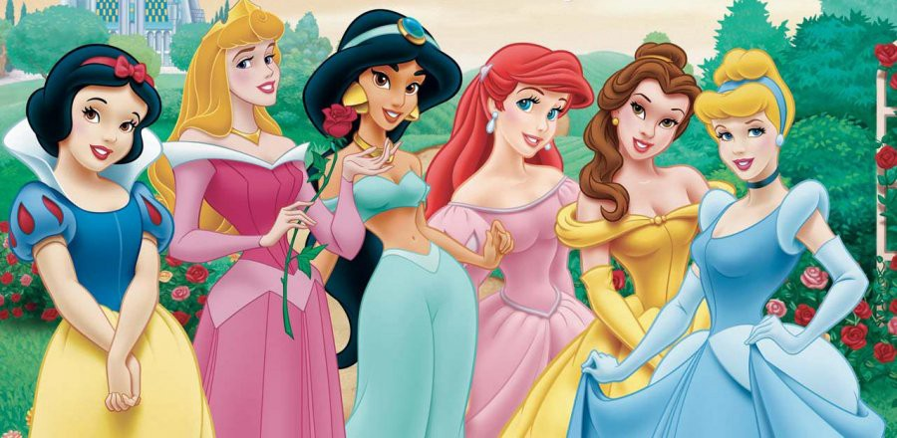

[princess]

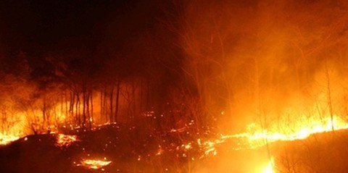

Transcript / Time: 1 min 45 seconds
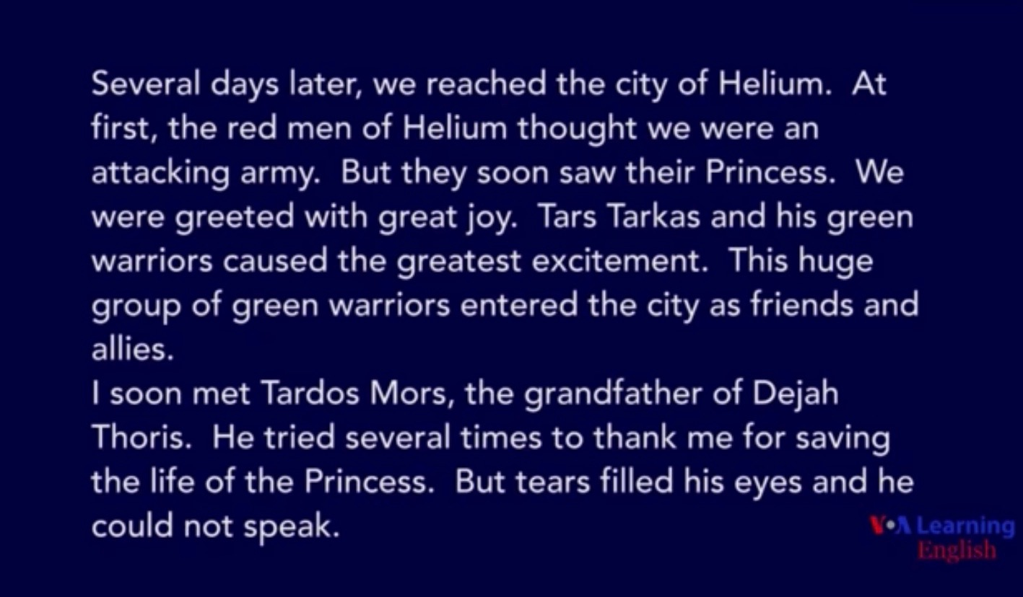

Worksheet 1 – A princess of Mars

Exercise 1 : Listen and write the answer below the question
- What is the name of the city where they arrived
- What red men thought of them before saw their princess?
- Are they greeted with great joy?
- What color of warrior entered the city as friends and allies?

Exercise 1 : Listen carefully, think, and write your answer.

- Why the red men of helium thought they were an attacking army?

- Why tears filled grandfather of Dejah Thoris’s eyes and he could not speak?

Worksheet (answer) – A princess of Mars

Exercise 1 : Listen and write the answer below the question
- Helium
- Attacking army
- Yes
- Green

Exercise 1 : Listen carefully, think, and write your answer.

- Those who reached doesn’t look like them.

- He met princess unexpectedly so he is touching

