Background Information Sheet
Name | Class | Date | Lesson Type | Plan type | Length
Grace Eunhye Oh | TESOL 215WD | 12/08/2020 | Listening | PPP | 30 min
Lesson
Topic | A Princess of Mars Part 4
Main Aim | Student will practice their listening comprehension using an audio material.
Secondary Aim | Students will practice their speaking fluency & accuracy.
Materials and References
PPT; http;//www.youtube.com/watch?v=sD1UsOdLMKA; worksheet; board pens; P.C., ipad pro 12.9 inch and audio equipment.

Student Profile
Level | Upper Intermediate
Age | Teens | Number of Students | 8
Detail | This is a general English class. The students are both Koreans who are highly motivated learners. The students are all Koreans, and enjoy science fiction. They are used to have pair work, but still need to be relaxed before they will communicate freely. They participate actively in both kinesthetic learning and the visual learner mode, but their listening skill needs developing.
Anticipated Classroom Management Difficulties and their Solutions
The audio equipment could fail ->bring a set of portable speakers to use with my smartphone; bring my Ipad pro 12.9inch to show my PPT; smartphone, print two A4 size pictures of my PPT 1 & 2 (back-up plan).
At the start of the lesson-> Check the equipment is working; sit down and follow the planner teacher talk.

My Personal Aim
What I aim to demonstrate is the ability to write out a complete, detailed lesson plan; have a confidence.

Stage Name: Lead-in
Purpose of this stage: To relax both the students and the teacher; to increase student talk through the sharing of ideas or experiences; to introduce the topic, or something topic-related.

Materials:
Time | Interaction | Procedure
30 sec  1 min  1 min | T  S-S  T-S | Organize seating arrangement so everyone has a partner with one group of 2 sitting together, and all can easily see the screen. Show PPT 1.  Hello guys, look at this picture. Have you ever wondered if aliens existed in the universe?  Gesture for student to begin talking to their partners.  Students talk to their partners. Monitor for any use of key words.  Feedback if appropriate. Gesture to a few groups and ask – “Let’s talk. Tell me your ideas.”  If there aren’t volunteers, Point to 3 students.

Stage Name: Presentation
Purpose of this stage: To offer any needed help which students may need in order to comprehend the text more easily. This includes teaching from 1 to 4 key words using the C.C.C. technique, and asking a guiding question which will allow students the opportunity to think of and share ideas they are likely to encounter when listening. This encourages the use of their schema when comprehending a text.
Materials:
Time | Interaction | Procedure
30 sec  30 sec  30 sec  10 sec  2 min  1min | T-S  T-S  T-S  T  S-S  T-S | Pre-teach keywords: warrior; Greet; ally  Elicit – Pint to PPT 1. What does he look like? (He’s a warrior.)  CCQ – Is a warrior acting like a soldier?  Does he have a skill in fighting?  Does the warrior kill people?  Drill – Listen and repeat 3 times together. (Gesture)  Nominate 2 or 3 individually.  Board – Write warrior on the left of the board.  How many syllables? (3) Mark with a blue pen.  Where is the stress? (1st) Mark with a red pen.  Is it verb or noun? Noun. Write it.  Elicit- Mime I welcome someone with delight. What am I doing? (I greeted my friend)  CCQ- When you greet someone, do you welcome warmly?  When you greet someone, do you give word of pleasure?  When you greet someone, do you receive a quest?  Drill-Listen and repeat 3 times together. (Gesture)  Nominate 2 or 3 individually.  Board-Write greet on the left of the board.  How many syllables? (1) Mark with a blue pen.  Where is the stress? (2) Mark with a red pen.  Is it verb or noun? Verb. Write it.  Elicit-Point to PP2. What do you see? Any relationship between these two? (They are allies.)  Do they look like they officially agreed?  Are they supporting each other?  Did they officially help each other during a war?  Drill-Listen and repeat 3 times together. (Gesture)  Nominate 2 or 3 individually.  Board-Write greet on the left of the board.  How many syllables? (2) Mark with a blue pen.  Where is the stress? (1) Mark with a red pen.  Is it noun? Yes, noun. Write it.  Guiding Question  Talk to your partners. What do you do if somebody greet you as a friend? How do you feel? Explain why.  Students discuss with their partners.  Feedback. Nominate a few students to share their ideas, Draw out the green huge group of green warriors caused the greatest excitement and entered the city of Helium as friends and allies.

Stage Name: Practice - Literal Comprehension Listening
Purpose of this stage: For students to listen for the first time in order to get the facts. This may include the overall idea or topic of the text; to notice who the speakers are; where they are; and perhaps why they are speaking. The responses are short, objectives, and are only a surface understanding. This is an accuracy focused stage.

Materials:
Time | Interaction | Procedure
1 min  2 min  1 min  2 min | T  S  S-S  T-S | Instructions. Set the purpose for listening. Hand out worksheets.  Hold up the worksheet.  Now it’s time to listen to a story about the warrior.  As you listen, you must answer these questions in exercise one only.  When you catch the answer, write it down next to the question.  Don’t do exercise 2.  I.C.Q.- Do you need to write your answer? (Yes)  Do we need to read the questions for exercise 2? (No.)  Do you have a pen or pencil ready? (Yes.)  Read each question aloud for the students. Hand out the work sheet.  Students listen for the 1st time, and write answers on the worksheet.  Pair check. Compare your answers with your partner. Monitor.  Feedback to check accuracy.  Ask students for answer, checking if others have the same or different answer.  Does anyone else have a different answer? Do you agree with this answer?

Stage Name: Practice - Interpretive Comprehension Listening
Purpose of this stage:

Materials:
Time | Interaction | Procedure
30 sec  4 min  2 min  1 min | T  S  S-S  T-S | Listen again. This time, answer exercise 2.  These questions are more difficult, but if you listen carefully and think about what you know, you can find the answer.  Write your answers next to the questions.  I will give you time to think and write.  I.C.Q.-Do you need to rush your answer these questions? (No, we will have time to write.)  Students listen for the 2nd time, and write their answers.  Pair check. Monitor. If students need, then replay the audio a 3rd time.  Feedback to check accuracy.  What is the answer?  Does anyone else have a different idea?  Do you agree this answer?

Stage Name: Production - Applied Comprehension Speaking
Purpose of this stage: For students to practice their speaking fluency. Therefore this stage should be no less than 5 minutes to allow students to practice. Give them a few questions to help them communicate without intervention from the teacher. This is a fluency focused stage.
Materials:
Time | Interaction | Procedure
1 min  6 min  1 min | T  S-S  T-S | Make 4 groups of 2 students. Wait for students to move.  Now, turn over your worksheets.  Talk to your partner about any of these questions.  Talk to your partner freely, and remember to listen and ask questions to your partner.  You have 6 minutes.  I.C.Q.- Do you need to write anything? (No)  Students discuss. Monitor from a distance  Feedback. Students share their ideas with the class.  Point to two students to share their ideas.

Stage Name: Wrap-up
Purpose of this stage: To end the lesson on a positive note. This will give students a sense of accomplishment, encourage students to continue progressing, and realize how to improve in future. A teacher may also get valuable feedback from students regarding the activities used in the lesson.
Materials:
Time | Interaction | Procedure
2 min | T | Lesson feedback. Tell the class what they did well, and what needs to improve.  You all did a great gob. Thank you for participating actively.  Set homework. For homework, write a letter to someone who you are thankful for. Write no more than 50 words. It is due tomorrow.  Inform students about the topic for the next lesson. Tomorrow we will do a reading lesson about John Carter’s the chessmen of Mars.  Dismissed.
PPT 1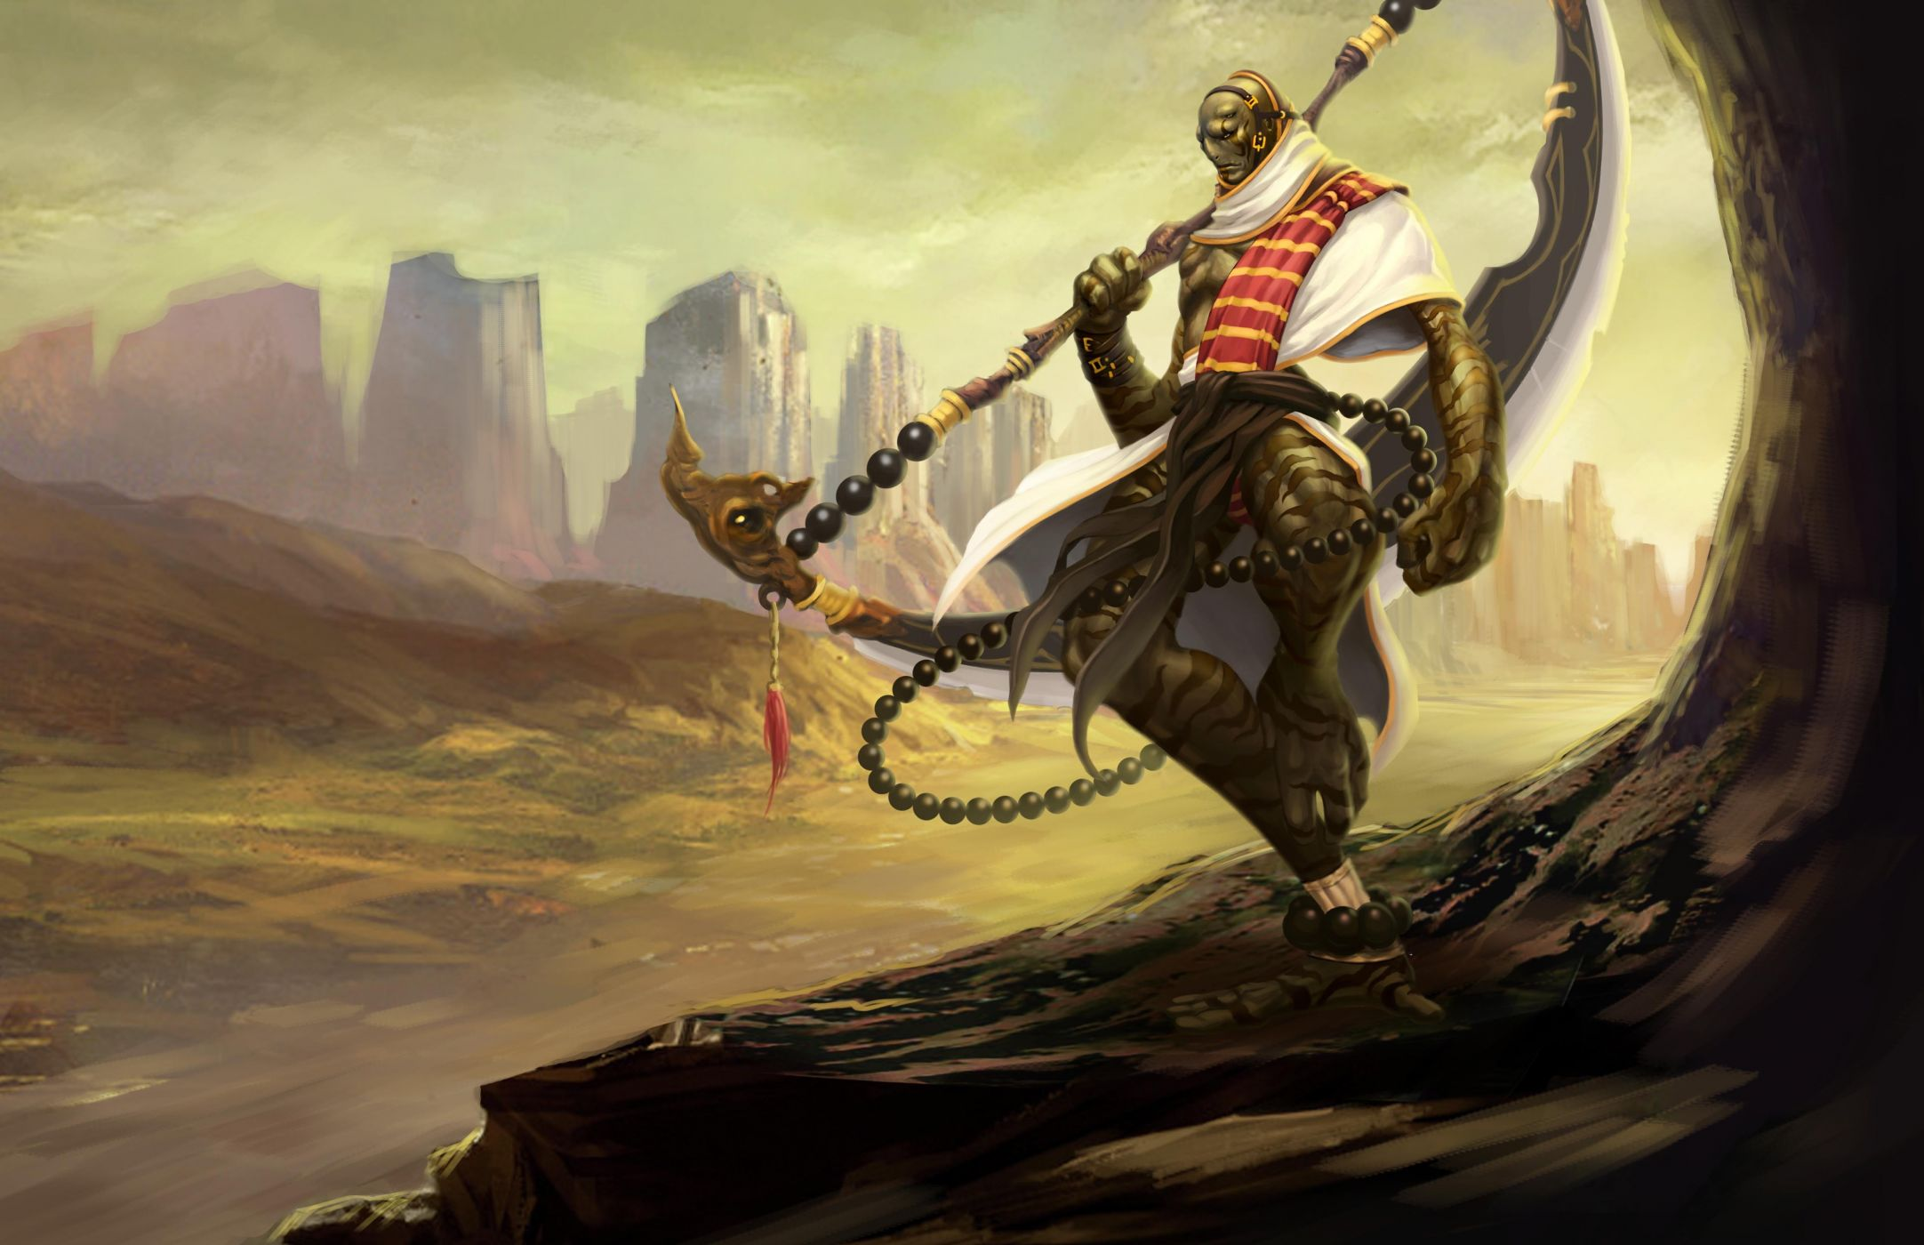

PPT2

Transcript
Time: 1 min 34 seconds

A Princess of Mars Part 4

Several days later, we reached the city of Helium. At first, the red men of Helium thought we were an attacking army. But they soon saw their Princess. We were greeted with great joy. Tars Tarkas and his green warrors caused the greatest excitement. This huge group of green warriors entered the city as friends and allies.

I soon met Tardos Mors, the grandfather of Dejah Thoris. He tried several times to thank me for saving the life of the Princess. But tears filled his eyes and he could not speak.

Worksheet 1- A Princess of Mars Part 4

Exercise One: Listen and write the answer next to the question.
- What is the name of the city where they reached?
- Who did the red men of Helium see?
- Who caused the greatest excitement?
- What is the name of Dejah Thoris’s grandfather?

Exercise Two: Listen carefully, think, and write your answer.
- Why didn’t the red men think they were an attacking army?

- How did the red men react when they saw their Princess?

Exercise Three: Talk to your partner freely about any of the question below.
No Writing!
- Do you have anyone to thank the most in your life?
- How do you do when you are thankful for someone?

Answer Sheet- A Princess of Mars Part 4
Exercise One: Listen and write the answer next to the question.
a) What is the name of the city where they reached? The city of Helium
b) Who did the red men of Helium see? Their princess
c) Who caused the greatest excitement? Tars Takas and his green warriors
d) What is the name of Dejah Thoris’s grandfather? Tardos Mors
Exercise Two: Listen carefully, think, and write your answer.
- Why didn’t the red men think they were an attacking army?
Because the red men saw their princess when we reached the city of Helium. Then, the red men noticed they weren’t attackers or killers.

- How did the red men react when they saw their Princess?
They were greeted with full of joy because they never expected their princess coming back to them. They would have thought the princess was killed by the attackers.

Instructor’s Comments and Assessment
Pros
Cons
Change
Overall Comments
Grade
Above Standard 85%-100% | Standard 70%-84% | Below Standard 69%-0%
Instructor | Student Signature | Date
Taute, David

