Background Information Sheet
Name | Class | Date | Lesson Type | Plan type | Length
Matilda | TESOL | 07/12/2020 | Listening | PPP | 30 min
Lesson
Topic | A Princess of Mars Part4
Main Aim | By the end of the lesson, students will practice listening comprehension using an integrated listening model.
Secondary Aim | Students will practice their speaking about applied comprehension.
Materials and References
PPT; https://www.youtube.com/watch?v=sD1UsOdLMKA ; worksheet; board pens; PPT; P.C and audio equipment

Student Profile
Level |  |  | Upper Intermediate
Age |  |  | Teens | Number of Students | 8
Detail |  |  | This is general English class and students are highly motivated learners. The students are all Koreans, and enjoy science fiction. They are accustomed to pair work, but still need to be relaxed  Before they will open up to communicate freely. They actively participate in kinesthetic learning mode but still need to develop auditory mode. They tend to speak without hesitation when they have an interesting topic.
Anticipated Classroom Management Difficulties and their Solutions
The audio equipment could fail->bring a set of portable speakers to use with my smartphone; print and A4 size picture of my PPT.
Nervousness and lack of confidence at the start of the lesson->Prepare the class by rehearsing based on this lesson plan. Check the equipment is working before the class starts.
Possible lack of student imagination->Give an example of famous sci-fi movie and pull out interest.
My Personal Aim
What I aim to demonstrate is the ability to write out a complete and student-centered lesson plan that can give me a confidence before teaching.

Stage Name: Lead-in
Purpose of this stage: To relax both the students and the teacher, to increase student talk through the sharing of ideas or experience; to introduce the topic, or something topic-related.

Materials:
Time | Interaction | Procedure
30 sec  2 min  1 min | T  T-S/S-S  T-S | Check desk arrangement so everyone has a partner, with one group of 2 sitting together, and all can easily see the screen.  Greet. Instructions.  Hello guys. Do you think creatures are living on Mars? Do you think we can live on Mars? Talk to your partner. You have 2 minutes.  Gesture for student to begin talking to their partners.  Brainstorm talk to a partner  Monitor for any interesting idea or use of keywords.  Feedback if appropriate  Gesture to a few groups and ask. Share your ideas for the whole class.

Stage Name: Presentation
Purpose of this stage:
To offer any needed help which students may need in order to comprehend the text more easily. This includes teaching from 1 to 4 key words using the C.C.C technique, and asking a guiding question which will allow students the opportunity to think of and share ideas they are likely to encounter when listening. This encourages the use of their schema when comprehending a text.
Materials: PPT1, PPT2, board pens
Time | Interaction | Procedure
1 min  1 min  1 min  10 sec  2 min  1 min | T-S  T-S  T-S  T  S-S  T-S | Pre-teach keywords-warrior, excitement, allies  Elicit – Point to PPT1. What does he do? (He’s a warrior.)  CCQ – Does he a warrior know how to fight? (Yes.)  Is he armed to fight? (Yes.)  Is a warrior like a soldier? (Yes.)  Drill – Listen and repeat 3 times together. (Gesture.)  Nominate 2 or 3 individually.  Board – Write warrior on the right side of the board.  How many syllables? (3) Mark with a blue pen.  Where is the stress? (1st) Mark with a red pen.  Elicit – Mime scream and big smile of eagerness and cheerful joy on your face with throwing hands  in the air  What do we call this feeling? (Excitement.)  CCQ – Is excited person happy? (Yes.)  Is excitement the same with uninterested or dislike? (No.)  Is excitement shown in your body reaction too? (Yes.)  Drill – Listen and repeat 3 times together. (Gesture.)  Nominate 2 or 3 individually.  Board – Write excitement on the right side of the board.  How many syllables? (3) Mark with a blue pen.  Where is the stress? (2nd) Mark with a red pen.  Elicit - Point to PPT2. What do we call them? (They’re allies.)  CCQ – Are allies on your side? (Yes.)  Do they have a common interest? (Yes.)  Is it important to have allies in war? (Yes.)  Drill – Listen and repeat 3 times together. (Gesture.)  Nominate 2 or 3 individually.  Board – Write allies on the right side of the board.  Allies is plural of ally.  How many syllables? (2) Mark with a blue pen.  Where is the stress? (1st) Mark with a red pen.  Guiding Question  Talk to your partner for 2 minutes. What would you do if someone turns out to be an ally, not your enemy?  Students discuss with their partners.  Feedback Nominate a few students to share their ideas.

Stage Name: Practice - Literal Comprehension Listening
Purpose of this stage: For students to listen for the first time in order to get the facts. This may include the overall idea or topic of the text, to notice who the speakers are; where they are; and perhaps why they are speaking. The responses are short, objective, and are only a surface understanding. This is an accuracy focused stage.

Materials: audio equipment, worksheet
Time | Interaction | Procedure
1 min  2 min  1 min  1 min | T  S  S-S  T-S | Instructions. Set the purpose for listening before handing out worksheets.  Now it’s time to listen to a story about people living on Mars and one of them came from the Earth like you.  As you listen, you must answer these questions in exercise 1 only.  When you catch the answer, write it down next to the question.  Don’t do exercise 2.  I.C.Q – Do you need to write your answer the questions? (Yes.)  Do you need to read the questions for exercise 2? (No)  Do you have a pen or pencil ready? (Yes.)  Read each question aloud for the students and Hand out the worksheet.  Play the audio  Students listen for the 1st time, and write answers on the worksheet.  Pair check.  Compare your answers with your partner. Monitor.  Feedback to check accuracy.  Ask students for answer, checking if others have the same or different answers.  Does anyone else have a different answer? Who agrees with this answer?  Does anyone have a difficulty in writing who Tardos Mos is?

Stage Name: Practice - Interpretive Comprehension Listening
Purpose of this stage: Students listen a second time, more carefully, to infer or interpret meaning of the literal facts. This is still and accuracy focused stage – answers need to be checked for accuracy. Students are required to think about the why in order to support their answers. They may need to focus on things like the overall situation, tone of voice, multiple pieces of information, or a single statement to explain the unspoken, intended meaning.
Materials: audio equipment, worksheet
Time | Interaction | Procedure
1 min  2 min  1 min  2 min | T  S  S-S  T-S | Instructions. Set the purpose for listening.  Listen again. This time, answer exercise 2.  These questions are more difficult, but if you listen carefully and think about what you know, you can find the answers.  Write your answers next to the questions.  I.C.Q- Do you need to rush to answer these questions? (No, we will have time afterwards to write.)  Read the questions aloud for the students.  Students listen for the 2nd time.  Pair check. Monitor. If students need, then replay the audio a 3rd time.  Compare your answers with your partner. Monitor.  Feedback to check accuracy.  Does anyone else have a different answer?  If there are students answering wrongly, encourage them.

Stage Name: Production - Applied Comprehension Speaking
Purpose of this stage: For students to practice their speaking fluency. Therefore this stage should be no less than 5 minutes to allow students to practice. Give them a few questions to help them communicate without intervention form the teacher. This is a fluency focused stage.

Materials: worksheet
Time | Interaction | Procedure
30 sec  5 min  1 min | T  S-S  T-S | Now, turn over your worksheets.  Talk to your partner about any of these questions.  You should talk freely and remember to listen and ask questions to your partner.  You have 5 minutes.  I.C.Q – Do you need to write anything? (No.)  Students discuss. Monitor from a distance.  Feedback. Students share their ideas for the whole class.  Nominate one student on each group.  Share your idea for the whole class.

Stage Name: Wrap-up
Purpose of this stage: To end the lesson on a positive note. This will give students a sense of accomplishment, encourage students to continue progressing, and realize how to improve in future. A teacher may also get valuable feedback from students regarding the activities used in the lesson.
Materials:
Time | Interaction | Procedure
2 min | T | Lesson feedback.  You guys listened to the story carefully and participated in the discussion actively.  Offer delayed corrections to the previous stage.  Set homework.  Here’s today’s homework.  If you were an author of this book, how would you make the story after this part?  Summarize it by writing no more than 100 words. Your creative imagination is welcome. It is due tomorrow.  Nominate 1 student.  I.C.Q – What was the homework for today? (Make a summary of the story after this part)  Maximum 50 words? (No, 100 words)  When is due date? (Tomorrow)  Inform students about the topic for the next lesson.  Tomorrow we will do a speaking lesson about [The most memorable trip in your life]  Dismissed.

Worksheet – A Princess of Mars Part 4

Exercise One: Listen and write the answer next to the question.
- What is the name of the city where they reached several days later?
- What color of men of 1) greeted them when they reached the city?
- Who caused the greatest excitement?
- Who is Tardos Mors?

Exercise Two: Listen again, and think carefully before writing your own answer.
- Why the red men of Helium thought they were an attacking army? Explain

- How did the red men of Helium respond when they saw their Princess?

- Why did Tardos Mors try several times to thank him?

Worksheet – A princess of Mars Part 4

Exercise Three: Talk to your partner freely about any of the questions below. No need to write!

Assume that you start living on Mars,
- What would you bring from Earth?

- How would you make friends there?

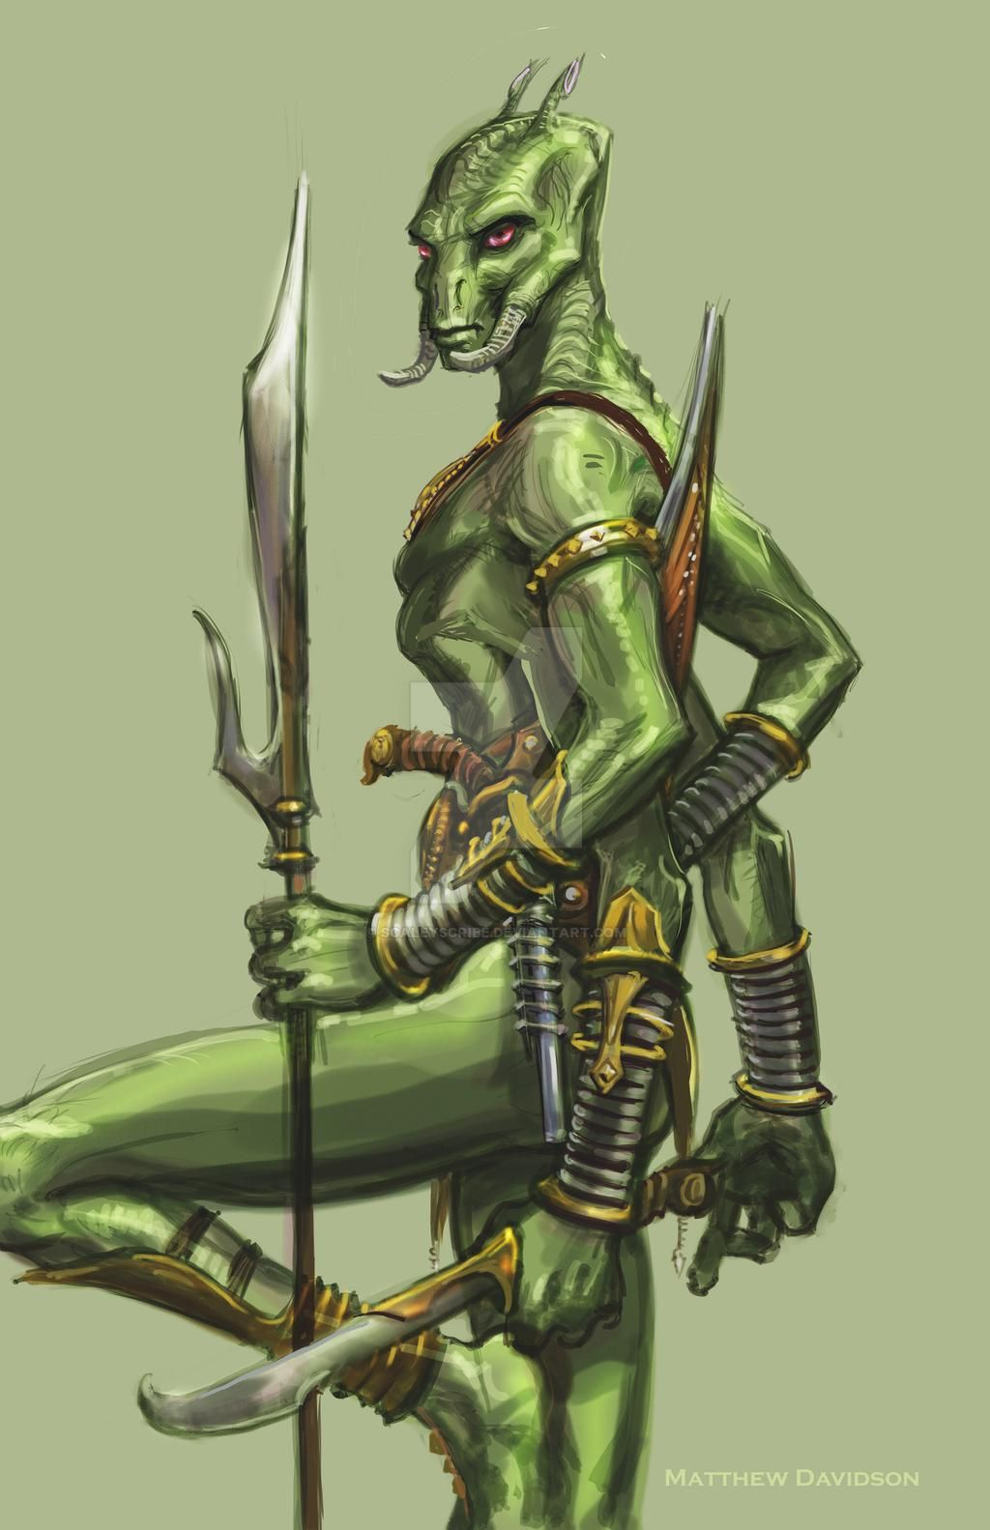
PPT1
PPT2

A Princess of Mars Part 4
https://www.youtube.com/watch?v=sD1UsOdLMKA 7:46 – 8:40

Several days later, we reached the city of Helium. At first, the red men of Helium thought we were an attacking army. But they soon saw their Princess. We were greeted with great joy. Tars Tarkas and his green warriors caused the greatest excitement. This huge group of green warriors entered the city as friends and allies.
I soon met Tardos Mors, the grandfather of Dejah Thoris. He tried several times to thank me for saving the life of the Princess. But tears filled his eyes and he could not speak.

Answer Sheet – A Princess of Mars Part 4

Exercise One: Listen and write the answer next to the question
- What is the name of the city where they reached several days later? City of Helium
- What color of men of 1) greeted them when they reached the city?
Red
- Who caused the greatest excitement? Tars Tarkas and his green warriors
- Who is Tardos Mors? The grandfather of Dejah Thoris
Exercise Two: Listen again, and think carefully before writing your own answer.
- Why the red men of Helium thought they were an attacking army? Explain.
Because there were different races of Martians and they had war.
- How did the red men of Helium respond when they saw their Princess?
They greeted with great joy and showed the greatest excitement because of Tars Tarkas and his green warriors.
- Why did Tardos Mors try several times to thank him?
Because the man saved his grandson’s life.

Instructor’s Comments and Assessment
Pros
Cons
Change
Overall Comments
Grade
Above Standard 85%-100% | Standard 70%-84% | Below Standard 69%-0%
Instructor | Student Signature | Date
Taute, David

