Background Information Sheet
Name | Class | Date | Lesson Type | Length
Binnie | TESOL 215 | 2020.12.13 | speaking | 20min

Lesson
Topic | Ranking/ Travel with friends
Main Aim | Students will practice their speaking fluency.
Secondary Aim | Students will improve their communication skill.
Materials and References
Preferences worksheet.

Student Profile
Level | advanced
Age | adults | Number of Students | 5
Detail | This is a general English class and students are highly motivated learners. The students are all Koreans and enjoy having conversation with partner. They are get used to express their thinking but still need ability to persuade someone
Assumptions about students’ knowledge as required for this lesson:
All students have ever traveled with friends, family etc. they can share of their experiences which is about difficulties in making plan. And they also know of their preferences for travel.

Anticipated Difficulties and their Solutions:
Some students didn’t experience difficulties with friends -> ask alternative question like “if you didn’t experience, what made your trip well”
Some students cannot understand the class -> by doing I.C.Q, help the students follow the class.

My Personal Aim
What I hope most to demonstrate in this lesson is the ability to deal with time management well

Stage Name: Pre Task
Purpose of this stage: Create interest in the topic. Brainstorm ideas which will be useful for the next stage. Students must be given a communicative task e.g. discuss, arrange/sort, create a list, etc.
The aim is to relax students, activate their background information, and gather useful ideas for the lesson.
Materials: List all materials that will be needed in this stage.
Time | Interaction | Procedure
2min  2min | T-S  S-S  S-SS | T during traveling, did you ever experience trouble with travel mate? Like friends, family someone like that. What factor made the problem between you guys.? If you didn’t experience, what made your travel well. Talk about this to your partner for 2min  I.C.Q. 1 are you gonna share bad experience with travel mate? (yes)  2 if you didn’t get problem with your friend, you don’t need to share?(no)  Have discussion  T pick 1person of each group and let them share of their experiences  Kyla what is your opinion? / Matilda how about you?  Share with classmates

Stage Name: Task Preparation
Purpose of this stage: This is a student centered stage, to give students time to prepare and practice a speaking task which they will perform in Task Realization. Clear detailed instructions or a demonstration must be provided so students know what is expected. Prepared materials may be provided to assist their preparation. Monitor and offer brief tips if necessary.
Materials: List all materials that will be needed in this stage.
Time | Interaction | Procedure
5min | T-S  S-S | T and I will give you this worksheet there are kinds of preferences for making travel plan, as you check this, share your preferences and reason of your choice in detail to your partner. You can start from money. You have 5 min.  I.C.Q 1. Don’t you need to use this worksheet? (no)  2. will you share reason of your choice? (yes)  Have discussion

Stage Name: Task Realization
Purpose of this stage: This is a very student centered stage to allow for maximum speaking fluency practice. Monitor discretely and take note of incorrect language. Students perform their task without interruptions from the teacher. Classroom management may be an important consideration here.
Materials: List all materials that will be needed in this stage.
Time | Interaction | Procedure
3min  1min | T-S  S-S  S-SS | T let’s make a ranking in the most important order with money, meal, transportation, preference, accommodations. It is group work so you have to make one ranking of each one group. You have 3min  I.C.Q 1. Will you make ranking with all classmates? (no)  2. do you make ranking in the most important order? (yes)  Have discussion  T pick 1 person of each group and let them share of their ranking  Share their ranking

Stage Name: Post Task
Purpose of this stage: To end the lesson with a final student centered task such as voting, summarizing, discussing, deciding etc. The teacher may offer delayed error correction to the previous stage, as well as mention positives and points to improve for next time such as useful strategies.
Materials: List all materials that will be needed in this stage.
Time | Interaction | Procedure
2min  1min | T-S  S-S  S-S | T if you and your friends are having trouble in making plan how you deal with this situation? What can be good solutions? You have 2min  Have discussion  T pick 1person of one group and let a student share of an opinion  Share their solution  T ask about feelings of this class and give them feedback briefly.

Worksheet 1
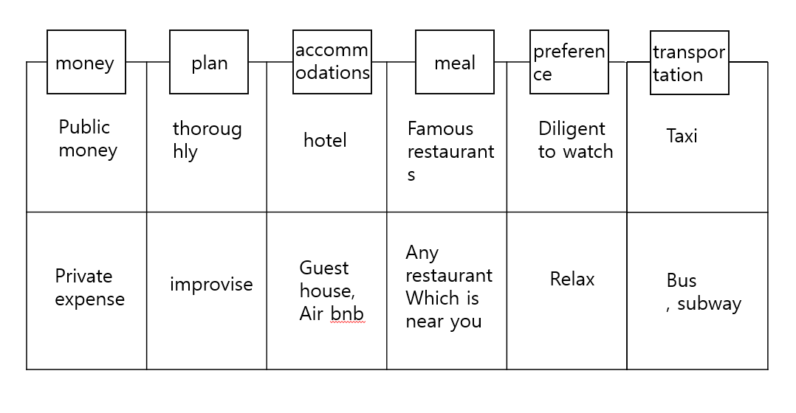

Instructor’s Comments and Assessment
Pros
Cons
Change
Overall Comments
Grade
Above Standard 85%-100% | Standard 70%-84% | Below Standard 69%-0%
Instructor | Student Signature | Date
Taute, David

