Worksheet: Present progressive

Exercise A
Change the sentence to the new form. Write your answer correctly.

Example
Positive: I am doing taekwondo these days.
Negative: I am not doing taekwondo these days.
Question: Are you doing taekwondo these days?

- Positive: I am learning English nowadays.
Negative:
Question:

- Positive:
Negative: We aren’t doing well this month.
Question:

- Positive: He is writing a book these days.
Negative:
Question:

- Positive:
Negative: I’m not taking Chinese class this year.
Question:

- Positive:
Negative:
Question: Are people travelling a lot these days?
Worksheet: Present Progressive

Exercise B

Write 4 sentences about the picture. Use present progressive that is happening around now.

Example: He’s doing exercises these days.

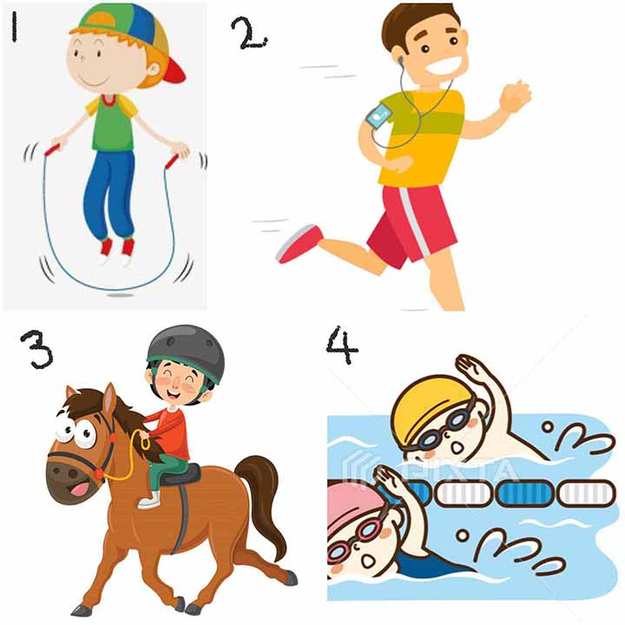

1)

2)

3)

4)

Worksheet: Present progressive

Answer Sheets

Exercise A
- Negative: I’m not learning English these days
Question: Are you learning English these days?

- Positive: We’re doing well this month.
Question: Are you all doing well this month?

- Negative: He isn’t writing a book these days.
Question: Is he writing a book these days.

- Positive: I’m taking Chinese class this year
Question: Are you taking Chinese class this year?

- Positive: People are travelling a lot these days.
Negative: People aren’t travelling a lot these days.

Exercise B

- He’s doing jump rope these days/nowadays.
- He’s Jogging nowadays/these days.
- He’s riding a horse these days/nowadays.
- He’s swimming nowadays/these days.

