Background Information Sheet
Name | Class | Date | Lesson Type | Plan type | Length
Cherry | TESOL | 12/26/2020 | Reading | PPP | 25 min

Lesson
Topic | “A white fluffy cloud”
Main Aim | Students practice their reading comprehension.
Secondary Aim | Students practice their speaking fluency.

Materials and References
Board, Colored markers, Pictures, Reading materials, Worksheets, Answer sheets.

Student Profile
Level | Low intermediate
Age | 8-9 | Number of Students | 2
Detail | This is a general English class and students are highly motivated learners. The students are all Koreans, and they are accustomed to pair work.

Anticipated Difficulties and their Solutions:
Time management -> Time may be delayed due to several pair work.
Count the time of students’ discussion with their pairs and manage a smooth transition.

My Personal Aim
What I hope most to demonstrate in this lesson is the ability to lead a reading lesson like water flowing without any mistakes.

Stage Name: Lead-in
Purpose of this stage: To relax both the teacher and students. To focus attention on the lesson. To lead in to the topic, activating background knowledge – this will help to contextualize the text. This is a BEFORE READINING stage.
Materials: List all materials that will be needed in this stage.
Timing | Interaction | Procedure
1 min  1 min  30 sec | T  S-S  T-S | Hi, Guys. How are you?  I will draw something on the board. Please guess what I am drawing.  Start to draw something slowly and children recognize what I am drawing. (Clouds)  Right. Do you like clouds? (Yes)  Holding a picture and showing it to the children.  In this picture, there are six shape’s clouds.  Talk to your partner what does each cloud look like? Hand out the picture.  Students talk with partner.  Feedback  What does it look like?

Stage Name: Presentation
Purpose of this stage: To pre-teach keywords if necessary, and answer a guiding questions (such as a predicting task, or a specific question). These steps provide extra help for students to comprehend the text. This is a BEFORE READINING stage.
Materials: List all materials that will be needed in this stage.
Timing | Interaction | Procedure
20 sec  10 sec  10 sec  20 sec  20 sec  10 sec  10 sec  20 sec  20 sec  10 sec  10 sec  20 sec  10 sec  1 min  30 sec | T-S  T-S  T-S  T-S  T-S  T-S  T-S  T-S  T-S  T-S  T-S  T-S  T-S  S-S  T-S | Pre-teach keywords  Elicit – forever  Look at this picture, what can you see? (man and woman)  What are they doing? (They are holding their hands)  Why? (Because, they love each other)  Do they want to love for a while? (No, forever)  CCQ  Do they want to love always? (Yes)  Do they want to stop the love? (No)  Do they want to love without end? (Yes)  Drill  Listen and repeat three times (with gesture)  choral and individual drilling for correct pronunciation  Board  Write down “forever” on the board.  How many syllables? (2), Mark with blue pen.  Where is the stress? (second), Mark with red pen.  Noun or adjective or adverb? (ad)  Elicit – mistake  Look at this picture. What can you imagine in this picture.  What is he doing? (He was shocked from something)  Why is he doing like this? (He made a mistake)  CCQ  Does he like this situation? (No)  Does he want this situation? (No)  Drill  Listen and repeat three times (with gesture)  choral and individual drilling for correct pronunciation  Board  Write down “mistake” on the board.  How many syllables? (2), Mark with blue pen.  Where is the stress? (Second), Mark with red pen.  Noun and Verb.  Elicit – fluffy  Look at this picture.  What can you see? (Cute dog)  Which hair the dog have? (soft hair)  If you touch the dog, How does it feel? (fluffy)  CCQ  Is this hair hard? (No)  Is this hair heavy? (No)  Is this hair soft? (Yes)  Drill  Listen and repeat three times (with gesture)  choral and individual drilling for correct pronunciation  Board  Write down “fluffy” on the board.  How many syllables? (1)  Where is the stress? (first), Mark with red pen.  Noun or adjective? (adj)  Guiding Question  Okay. If you have a problem, how do you solve the problem? Do you solve the problem alone or Do you receive someone’s help. Talk to your partner  Students talk with partner.  Feedback.  Sammy, How about you?, Chris, How about you?

Stage Name: Practice – Literal Comprehension
Purpose of this stage: is to get students to practice reading for literal detail. They will also practice fast reading (skimming and scanning). This is a WHILE READINING stage.
Materials: List all materials that will be needed in this stage.
Timing | Interaction | Procedure
30 sec  3 min  1 min  30 sec | T  S  S-S  T-S | Instructions.  Today, we will read about ‘A white fluffy cloud’.  (Holding the paper), Read the story. After that, write answers on the worksheet A. I will give you 3 minutes to read and answer. Only worksheet A.  Don’t look at the worksheet B. (Hand out the reading material and worksheets)  Students read the story and write answers on the worksheet A.  Pair Check.  Time’s up. Check the answers with your partner  Feedback to check accuracy.  Sammy! What is the answer No. 1?  Chris! Number 2?

Stage Name: Practice – Interpretive Comprehension
Purpose of this stage: is to get students to get students to practice interpreting a text correctly This will require more detailed, careful reading, and thinking time to arrive at the correct answer. This is a WHILE READINING stage.
Materials: List all materials that will be needed in this stage.
Timing | Interaction | Procedure
20 sec  3 min  1 min  1 min | T  S  S-S  T-S | Instructions.  Now, read the story one more time and write answers on the worksheet B.  I will give you 3 minutes to read and answer.  Students read the story once again and write answers.  Time’s up. Check the answers with your partner.  Feedback to check accuracy.  Chris! What’s your answer No.1 ?  Sammy! What’s your answer No.2 ?

Stage Name: Production - Applied Comprehension
Purpose of this stage: is for students to practice their speaking fluency and is related to the lesson topic. This is an AFTER READINING stage.
Materials: List all materials that will be needed in this stage.
Timing | Interaction | Procedure
30 sec  5 min  1 min | T  S-S  T-S | Instructions.  Now, we will talk about worksheet C.  Talk to your partner about this questions.  I will give you 5 minutes.  Students discuss.  Feedback.  Sammy! What is your answer?  Chris! What is your answer?  Students share their ideas.

Stage Name: Wrap-up
Purpose of this stage: is to end the lesson on a positive note so that students feel they have achieved progress. This is an AFTER READINING stage.
Materials: List all materials that will be needed in this stage.
Timing | Interaction | Procedure
1 min | T | Lesson feedback.  Okay. Today, we read and talked about a white and fluffy cloud.  You all understood the story perfectly and talked each other very well.  Offer delayed corrections to the previous stage.  Set homework.  Today, we have no homework.  Take a rest and see you tomorrow. Bye.

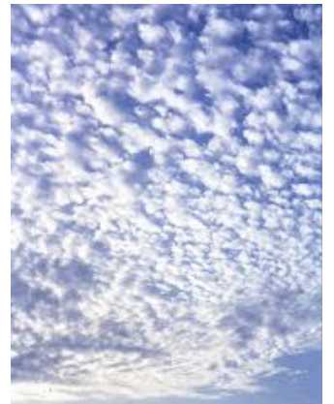

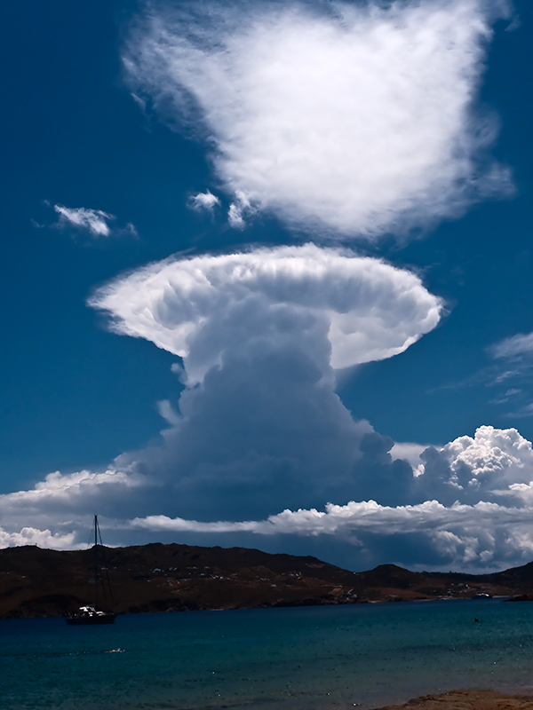

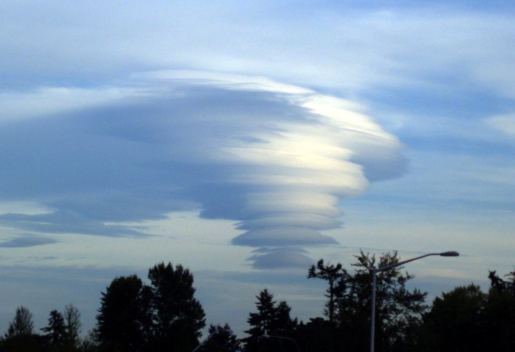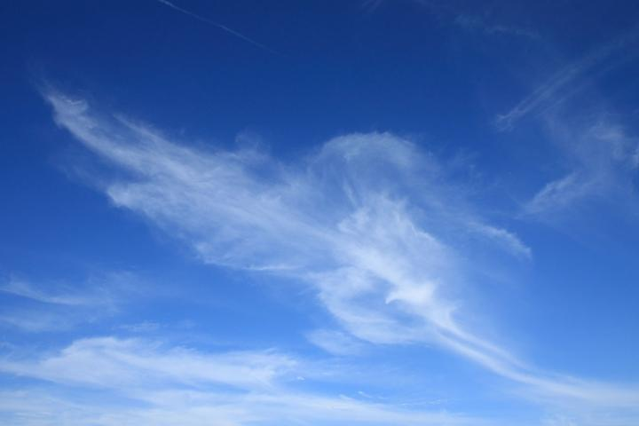

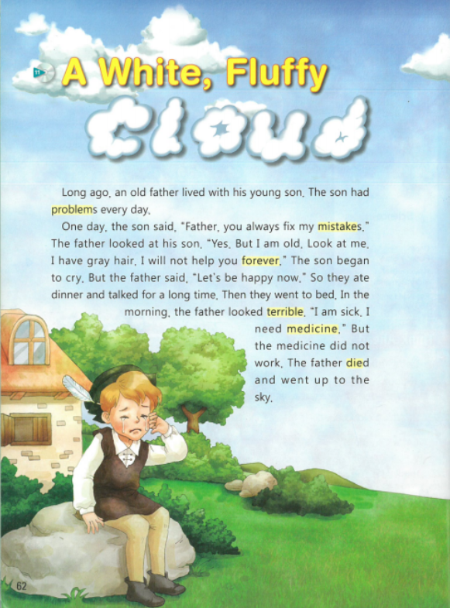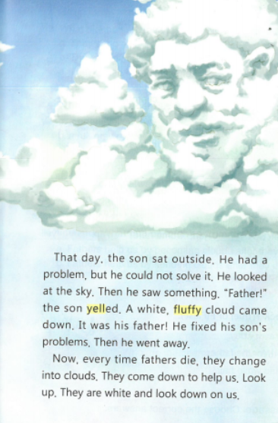

Worksheet A

- Finding the facts. Check T(True) or F(False)

- The father has problems every day. T F
- The medicine did not work for the father. T F
- The father was old and had white hair. T F

- Write down the correct answers.

- What did the father always do for the son?

- What did the father become after he died?

Worksheet B

- After his father died, why does he become a cloud?

- Why did the son look at the sky?

Worksheet C

- Who helps you the most in your life?

- If the person who helps you the most died, how will your life change?

- If the person who helps you the most died, which effort do you need in order to live without any problems?

Worksheet A (Answer Sheet)

- Finding the facts. Check T(True) or F(False)

- The father has problems every day. T F
- The medicine did not work for the father. T F
- The father was old and had white hair. T F

- Choose the correct answers.

- What did the father always do for the son?
The father always fixed son’s mistakes

- What did the father become after he died?
The father became a white fluffy cloud after he died.

Worksheet B (Answer Sheet)

- After his father died, why did he become a cloud?
His father became a cloud to help the son when the son has a problem.

- Why did the son look at the sky?
The son had a problem but he could not solve it. So the son missed his father and looked up the sky.

Instructor’s Comments and Assessment
Pros
Cons
Change
Overall Comments
Grade
Above Standard 85%-100% | Standard 70%-84% | Below Standard 69%-0%
Instructor | Student Signature | Date
Taute, David

