Background Information Sheet
Name | Class | Date | Lesson Type | Plan type | Length
CHELSEA | TESOL | 1/27/2021 | Listening | PPP | 30 min
Lesson
Topic | Meeting an old friend
Main Aim | Students will practice their listening comprehension using an integrated model.
Secondary Aim | Students will practice their speaking fluency based on their experiences.
Materials and References
https://learnenglish.britishcouncil.org/skills/listening/intermediate-b1/meeting-an-old-friend
PC; PPT; audio equipment (including smart phone); worksheet; board pen;

Student Profile
Level | UPPER INTERMEDIATE
Age | Adult | Number of Students | 4 S.S
Detail | This is a general English class and students are highly motivated learners. The students are all Koreans, and they all are interested in Western cultures. They are accustomed to pair work, but still need to be relaxed before they will open up to communicate freely. They engage actively in kinesthetic learning and tend to favor the visual learner mode, but, auditory learning still needs developing.
Anticipated Classroom Management Difficulties and their Solutions
The audio equipment (P.C) could fail -> bring a set of portable speakers to use with my smartphone; print an A4 size picture of my PPT.
Nervousness at the start of the lessons-> check the equipment is working; to start the lesson, sit down and follow the planned teacher talk.
My Personal Aim
My aim to demonstrate is the ability to write out a detail lesson plan as first time, and reduce teacher talk.

Stage Name: Lead-in
Purpose of this stage: To relax both the students and the teacher; to increase students talk through the sharing of ideas or experiences; to introduce the topic or something topic-related.

Materials:
Time | Interaction | Procedure
30 sec  2 min  30 sec | T  S-S  T-S | Greet. Instructions.  Organize seating arrangements to everyone has a partner, with one group of 2 pairing sitting together, and all can easily see the screen. Show PPT1.  Hello guys, look at this picture. Talk to your partners about them. For examples, who are they, how they look like, what are they doing, what kind of situations they are. You have 2 minutes to talk.  Gesture for students to begin talking to their partners.  Students talk to partners. Monitor for their greetings and expressions.  Feedback if appropriate.

Stage Name: Presentation
Purpose of this stage: To offer any needed help which students may need in order to comprehend the next more easily. This includes teaching from 1 to 4 key words using the C.C.C technique, and asking a guiding question which will allow students the opportunity to think of and share ideas they are likely to encounter when listening. This encourages the use of their schema when comprehending a text.

Materials:
Time | Interaction | Procedure
1 min  1 min  1 min  1min  10 sec  2 min  1 min | T-S  T-S  T-S  T-S  T  S-S  T-S | Pre-teach keywords: rent, flat, predictable, celebrate  - rent  Elicit – ask questions. When you like to move your house, you don’t have enough money to buy the house. What would you do? (renting) It is called rent.  CCQ – Do you pay money regularly to owner for rent? (YES)  - Do you pay rent to use a house or a flat or a piece of land? (YES)  - Do you pay rent for temporary stay or permanent stay? (temporary)  Drill – listen and repeat 3 times together. (Gesture)  Nominate 2 or 3 individually.  Board – Write “rent” on the board. Where is stress? (1st) mark with a red pen. It is used as N,V.  - flat  Elicit – Point to PPT. what do you see in the picture? What do we call this kind of buildings?  CCQ - Is a flat a set of rooms for living in? (YES)  - Is a flat same meaning of an apartment? (YES)  - Is there only one flat on one floor of a larger building? (No, many)  Drill – listen and repeat 3 times together. (Gesture)  Nominate 2 or 3 individually.  Board – Write “flat” on the board. Where is stress? (1st) mark with a red pen. Use as Noun.  - predictable  Elicit – ask questions. Do you know what is your boyfriend or girlfriend doing at the weekend? (-yes), what words means when you know how something will happen or be? (-predictable)  CCQ – Is it predictable to see in the future 100 years later? (No)  - If an event is predictable, is it obvious what will happen next? (yes)  - Can a person be predictable? (yes, sometimes)  Drill – listen and repeat 3 times together. (Gesture)  Nominate 2 or 3 individually.  Board – How many syllables? (4) mark with a blue pen.  Where is stress? (2nd) mark with a red pen. It is used as “Adjective”  - celebrate  Elicit – Mime my hands clapping and blowing out the candles on birthday cake. When it is your friend’s birthday, what are you going to do? – celebrate.  CCQ – do we celebrate a special occasion or an anniversary? (yes)  - If you celebrate, do you do something enjoyable? (yes)  - Do we celebrate when a person is dead? (no)  Drill – listen and repeat 3 times together. (Gesture)  Nominate 2 or 3 individually.  Board – How many syllables? (3) mark with a blue pen.  - Where is stress? (1st) mark with a red pen. It is used as “Verb”  Guiding Question  Talk to your partners. Do you have an old or best friend who hasn’t met for ages? If you do, what would you talk or ask him or her when you happen to meet them? Please share with your partners.  Students discuss the question with a partner.  Feedback. Nominate a few students to share their ideas, if necessary.

Stage Name: Practice - Literal Comprehension Listening
Purpose of this stage: For students to listen for the first time in order to get the facts. This may include the overall idea or topic of the text; to notice who the speakers are; where they are; and perhaps why they are speaking. The responses are short, objective, and are only a surface understanding. This is an accuracy focused stage.

Materials:
Time | Interaction | Procedure
1 min  2.5 min  30 sec  1.5 min | T  S  S-S  T-S | Instructions. Set the purpose for listening before Handing out worksheets.  Hold up the worksheet.  Now, please listen carefully and answer your worksheet questions in exercise 1 only. When you catch the answer, please write it down. Don’t do exercise 2.  ICQ – Do you need to write down your answer? (yes)  - Do you need to read the questions for exercise 2? (No)  - Do you have a pen or pencil ready? (yes)  Read each questions aloud for the students. Hand out the worksheet.  Students listen for the 1st time, and write answers on the worksheet.  Pair check.  Compare your answer with your partners. Monitor.  Feedback to check accuracy.  Ask students for answer, checking if others have the same or different answers. Does anyone else have a different answer?

Stage Name: Practice - Interpretive Comprehension Listening
Purpose of this stage: Students listen a second time, more carefully, to infer or interpret meaning of the literal facts. This is still an accuracy focused stage- answers need to be checked for accuracy. Students are required to think about the why in order to support their answers. They may need to focus on things like the overall situation, tone of voice, multiple pieces of information, or a single statement to explain the unspoken, intended meaning.

Materials:
Time | Interaction | Procedure
30 sec  4 min  1 min  1 min | T  S  S-S  T-S | Listen again, this time, answer exercise 2.  This question would be more difficult, but if you listen carefully, you can find the answer. Write your answers next to the questions. I will give you time afterwards to think and write.  ICQ – do you need to hurry to answer the question? (No)  Read questions aloud for the students.  Students listen for the 2nd time. And write their answers.  Pair check. Monitor. If students need, then replay the audio a 3rd time.  Feedback to check accuracy.

Stage Name: Production - Applied Comprehension Speaking
Purpose of this stage: for students to practice their speaking fluency. Therefore this stage should be no less than 5 minutes to allow students to practice. Give them a few questions to help them communicate without intervention from the teacher. This is a fluency focused stage.

Materials:
Time | Interaction | Procedure
30 sec  6 min  1 min | T  S-S  T-S | Make 2 groups of 2 students.  Please check exercise 3 on your worksheet, Talk to your partners about any of these questions.  You should talk freely, and remember to listen and ask questions to your partners.  You have 6 minutes.  ICQ- Do you need to write anything? (no)  Read questions aloud for the students.  Students discuss. Monitor from a distance.  Feedback. Students share their ideas with the class.

Stage Name: Wrap-up
Purpose of this stage: To end the lessons on a positive note. This will give students a sense of accomplishment, encourage students to continue progressing, and realize how to improve in future. A teacher may also get valuable feedback from students regarding the activities used in the lessons.

Materials:
Time | Interaction | Procedure
2 min | T | Lesson feedback. Tell the class what they did well, and what needs to improve.  Offer delayed corrections to the previous stage.  set homework. – Please review vocabulary we learned today.  Inform students about the topic for the next lesson.- Tomorrow we will do a reading lesson about different greeting from countries
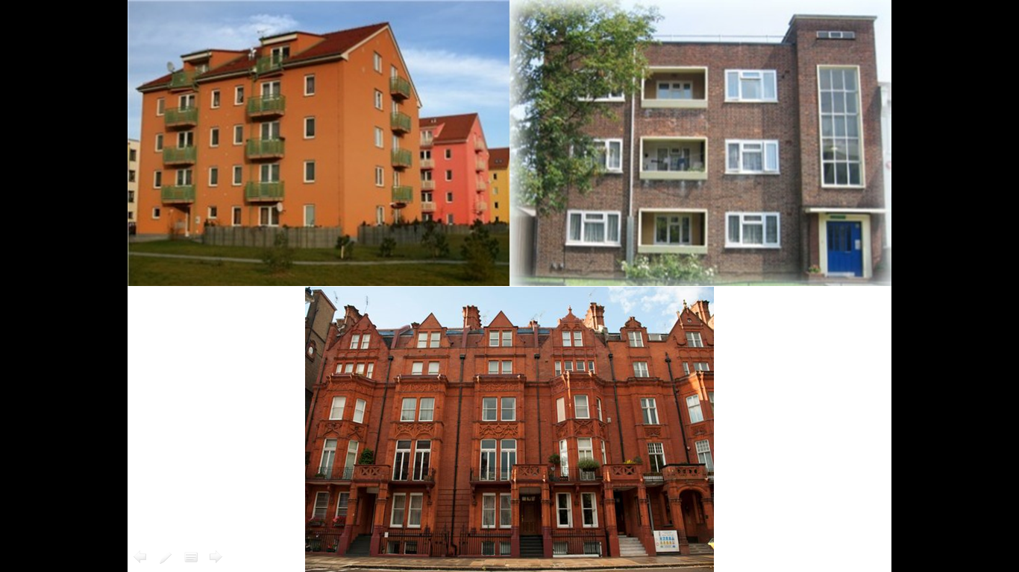
TRANSCRIPT
TIME: 2 MIN 24 SECONDS
Selina: Patrick? Is that you?
Patrick: Selina! Hello!
Selina: Well, well. Patrick Eastwood. How have you been?
Patrick: Good. Great, actually. How are you? I haven't seen you for ... how long?
Selina: It's been ages. At least fifteen years. Wow.
Patrick: Yeah. Wow.
Patrick and Selina: So, what are you doing here?
Selina: Sorry, you go first.
Patrick: OK. What are you doing here? I thought you'd moved to London.
Selina: I was in London for a couple of years. But it didn't work out.
Patrick: Oh, I'm sorry to hear that. Are you ... OK?
Selina: I'm fine! The dream job wasn't really a dream, you know? Um ... and London is great but it's so expensive. I mean, just the rent on a flat is ... uh … crazy expensive.
Patrick: I see.
Selina: So, I came back. I've been back now for almost five months. Living back home with Mum and Dad. Which is err ... interesting. Um ... but anyway, what about you?
Patrick: Me? Oh, nothing new. You know me – 'Patrick the predictable'. I never left here.
Selina: Oh. And is that ...?
Patrick: Oh, I'm very happy. I'm married now. We've just celebrated our tenth anniversary.
Selina: No way! You? Married? To …?
Patrick: I don't think you know her. Her name's Marigold. And we've got two kids. They're five and eight years old.
Selina: Married and with two kids? Wow!
Patrick: Don't look so surprised!
Selina: No, no … I'm just amazed how time flies! I'm happy for you. I really am.
Patrick: Thanks. You should really come round to the house one day.
Selina: That would be great. Let's swap numbers and ...

Worksheet 1 – Meeting an old friends

Exercise 1.
- How long have Patrick and Slina not met for?
- Who is Selina living with?
- How long has it been since Patrick got married?
- How old are Patrick’s children now? They’re five and eight years old?
- Why they switch their phone numbers?

Exercise 2.
A. Is Selina happy about living back with her parents? Please answer and explain the reasons.

Exercise 3. (DISCUSSION)
- Have you ever encountered an old friend unexpectedly? Please share your experiences.
- Do you have an old or close friend who is very predictable? If you have, Please explain why you think so.

Worksheet 1 – Meeting an old friends (Answers)

Exercise 1. (Literal Questions)
- How long have Patric and Slina not met for? a.15years
- Why did Selina leave from London? a. Because the dream job wasn’t really a dream job, the rent on a flat is crazy expensive.
- How long has it been since Patrick got married? a. 10 years.
- How old are Patrick’s children now? a. They’re five and eight years old
- Why they switch their phone numbers? a. Patrick likes to invite Selina to the house.

Exercise 2. (Interpretive Question)
A. Is Selina happy about living with her parents again? Please answer and explain the reasons.
a. She is not happy because the why how she talked was hesitant and her intonation when she said “interesting” suggested it was negative. Also she quickly changed the topic because she didn’t want to talk about it.

Execise 3. (Applied Questions)
- Have you ever encountered an old friend unexpectedly? Please share your experiences.
- Do you have an old or close friend who is very predictable? If you have, Please explain why you think so.

Instructor’s Comments and Assessment
Pros
Cons
Change
Overall Comments
Grade
Above Standard 85%-100% | Standard 70%-84% | Below Standard 69%-0%
Instructor | Student Signature | Date
Taute, David

