Background Information Sheet
Name | Class | Date | Lesson Type | Plan type | Length
Young Bin Lee | TESOL | 27/02/2021 | Listening | PPP | 30 min
Lesson
Topic | A Princess of Mars Part 4
Main Aim | Students will practice their listening comprehension using an integrated listening model.
Secondary Aim | Students will practice their speaking fluency.
Materials and References
PPT1, https://www.youtube.com/watch?v=sD1UsOdLMKA; worksheet, white board and pen; P.C and audio equipment.

Student Profile
Level | High Intermediate
Age | Teens | Number of Students | 4
Detail | This is a general English class and students are highly motivated learners. The students are all Koreans and enjoy science fiction. They are accustomed to pair work but still need to be relaxed before they will open up to communicate freely. They engage actively in kinesthetic learning and tend to favor the visual learner mode, but auditory learning still needs developing.
Anticipated Classroom Management Difficulties and their Solutions
The P.C could fail → Bring a laptop or ipad to use instead of P.C.
The Audio equipment could fail → prepare the record of the listening article on smartphone and bring it with a portable speaker.
Nervousness at the start of the lesson → check the equipment is working; to start the lesson, sit down and follow the planned teacher talk.
My Personal Aim
What I aim to demonstrate is the ability to write to write out a complete, detailed lesson plan.

Stage Name: Lead-in
Purpose of this stage: To relax both the students and the teacher; to increase student talk through the sharing of ideas or experiences; to introduce the topic, or something topic related.

Materials: PPT1
Time | Interaction | Procedure
30 sec  1 min  1 min | T  T-S/S-S  T-S | Organize seating arrangements so 4 students will divide into two pairs, and everyone can see the screen. Show PPT 1.  Hi guys, take a look at this picture and talk to your partner about this situation. For example, the place, weather, people, who are they, what are they doing in this picture. You have one minute.  Students start talking about their partners. Monitor them for any use of key words.  Ask one of the pairs – “What did you talk about with your partner?”

Stage Name: Presentation
Purpose of this stage: To offer any needed help which students may need in order to comprehend the text more easily. This includes teaching from 1 to 4 key words using the C.C.C technique and asking a guiding question which will allow students the opportunity to think of and share ideas they are likely to encounter when listening. This encourages the use of their schema when comprehending a text.

Materials:
Time | Interaction | Procedure
1 min  1 min  1 min  10 sec  2 min  1 sec | T-S  T-S  T-S  T  S-S  T-S | Pre-teach keywords: army, princess, warrior  Elicit – Point to PPT 1. How do you call them? (They are an army)  CCQ – Does an army fight? (Yes)  Is an army group of warriors? (Yes)  Drill – Listen and repeat 3 times with me. (with Gesture)  Nominate 2 or 3 times individually.  Board – Write army on the right of the board.  How many syllables? (2) Mark with a blue pen.  Where is the stress? (1st) Mark with a red pen.  Elicit – Point to PPT 1. Who is she? (She is a princess.)  CCQ – Is she a husband of a prince? (Yes)  Is she important in the kingdom? (yes)  Drill – Listen and repeat 3 times with me. (with Gesture)  Nominate 2 or 3 times individually.  Board – Write princess on the right of the board.  How many syllables? (2) Mark with a blue pen.  Where is the stress? (1st) Mark with a red pen.  Elicit – Point to PPT 1. How do you call them? (They are warriors.)  CCQ – Is warrior a fighter?  Does he obey the princess?  Drill – Listen and repeat 3 times with me. (with Gesture)  Nominate 2 or 3 times individually.  Board – Write army on the right of the board.  How many syllables? (3) Mark with a blue pen.  Where is the stress? (1st) Mark with a red pen.  Guiding Question  Talk to your partner. What reason do warriors usually fight for?  Students discuss with their partners.  Ask one of the pairs (which didn’t share idea to the teacher yet) to share their ideas. Draw out ideas that the warriors usually fight because to keep their princess safe and also to keep the kingdom or their city safe.

Stage Name: Practice - Literal Comprehension Listening
Purpose of this stage: For students to listen for the first time in order to get the facts. This may include the overall idea or topic of the text; to notice who the speakers are, where they are, and perhaps why they are speaking. The responses are short, objective, and are only surface understanding. This is an accuracy focused stage.

Materials:
Time | Interaction | Procedure
30 sec  1 min  1 min  2 min | T  S  S-S  T-S | Instructions. Set the purpose for listening. Hand out worksheets.  Hold up the worksheet.  Now let’s get to know if the warriors successfully guarded the princess.  While you are listening, you must answer these questions in exercise one only.  When you hear the answer, write it down below the question.  Don’t do the second exercise.  I.C.Q. – Do you need to write your answers? (Yes)  Do you need to answer exercise two? (No)  Where do you need to write your answers? (Below the question)  Read each question aloud for the students. Hand out the work sheet.  Students listen for the 1st time, and write answers on the worksheet.  Pair check. Compare your answers with another pair. Monitor.  Feedback to check accuracy. Ask students for answer, checking if others have the same or different answers. Does anyone else have a different answer? Who agrees with this answer? How did you know that the allies didn’t fight with the warriors who are entering the city?

Stage Name: Practice - Interpretive Comprehension Listening
Purpose of this stage: Students listen a second time, more carefully, to infer or interpret meaning of the literal facts. This is still an accuracy focused stage – answers need to be checked for accuracy. Students are required to think about the why in order to support their answers. They may need to focus on things like the overall situations, tone of voice, multiple pieces of information or a single statement to explain the unspoken, intended meaning.
Materials:
Time | Interaction | Procedure
30 sec  3 min  1 min  2 min | T  S  S-S  T-S | Listen again. This time, answer exercise 2.  There questions are more difficult, but you can still find the answer if you listen carefully.  Write your answers below the questions.  I will give you time to think and answer after.  I.C.Q. – Do you need to finish this work quickly? (No. we have time after to write.)  Read the question aloud for the students.  Students listen for the 2nd time.  Pair check. Monitor. If students need, then replay the audio a 3rd time.  Feedback to check accuracy.

Stage Name: Production - Applied Comprehension Speaking
Purpose of this stage: For students to practice their speaking fluency. Therefore, this stage should be no less than 5 minutes to allow students to practice. Give them a few questions to help them communicate without intervention from the teacher. This is a fluency focused stage.

Materials:
Time | Interaction | Procedure
1 min  8 min  1 min | T  S-S  T-S | Switch each pair’s partner to make another set of two pairs. Wait for them to move.  Now, turn over your worksheets.  Talk to your partner about any of these questions.  You should talk freely, and do a good communication, listen and ask questions.  You have 8 minutes.  I.C.Q. – Do you need to write anything? (No)  Students discuss. Monitor from a distance.  Feedback. Students share their ideas with the class.

Stage Name: Wrap-up
Purpose of this stage: To end the lesson on a positive note. This will give students a sense of accomplishment, encourage students to continue progressing, and realize how to improve in future. A teacher may also get valuable feedback from students regarding the activities used in the lesson.

Materials:
Time | Interaction | Procedure
2 min | T | Lesson feedback. Tell the class what they did well, and what needs to improve.  Offer delayed corrections to the previous stage.  Maybe, you could have asked few more questions to have a better conversation with your partner.  Set homework. For homework, listen to the next 1 minute of the story. Make questionnaires that have around 3 to 4 questions. It is due tomorrow and I will remind you in our group chat later.  Inform students about the topic for the next lesson.  Tomorrow’s lesson topic will be reading lesson about the Princess of Mars Part Five.  Dismissed.
Worksheet 1 – A Princess of Mars Part 4

Exercise One: Listen and write the answer below the question.
- What’s the name of the city that green warriors go?

- What is the name of the grandfather of Dejah Thoris?

- Why did the grandfather of Dejah Thoris try to thank Tars Tarkas?

- How were they greeted with?

Exercise Two: Listen carefully, think, and write your answer.
- Why did the red men of Helium greet them instead of fighting them?

- Why wasn’t Tardos Mors able to properly speak and thank Tars Tarkas?

Exercise Three: Talk to your partner freely about any of the questions below. You are not allowed to write!
- Have you ever become friend with the person that you didn’t like before?

- How would you feel if you have a daughter and she is in danger?

- Do you have any experience of giving someone a huge joy or happiness?

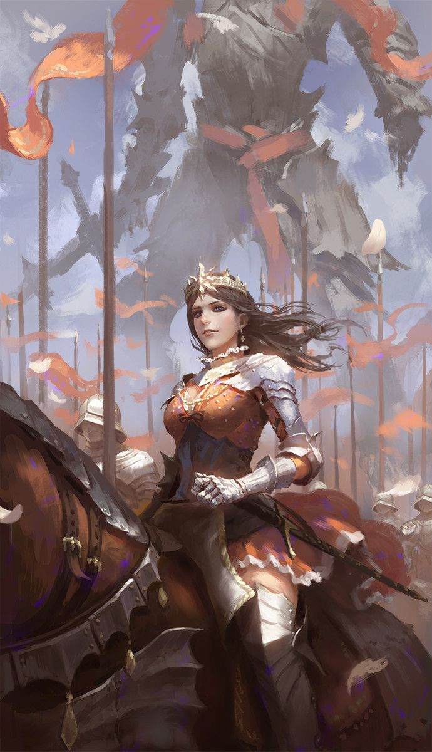
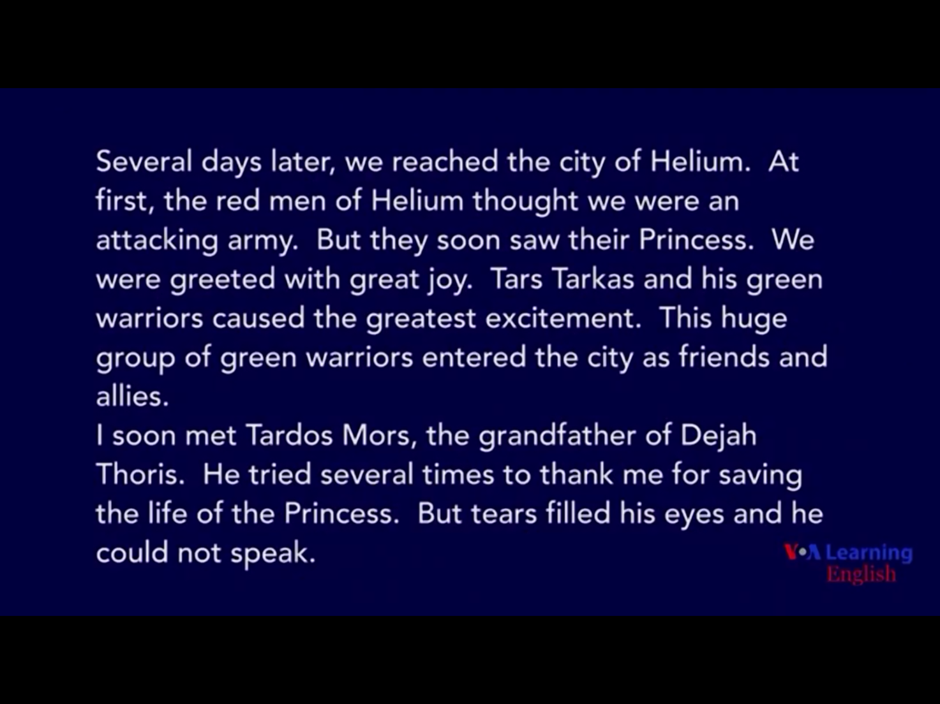

Answer Sheet – A Princess of Mars Part 4

Exercise One
- What’s the name of the city that green warriors go?
City of Helium
- What is the name of the grandfather of Dejah Thoris?
Tardos Mors
- Why did the grandfather of Dejah Thoris try to thank Tars Tarkas?
Because he saved his daughter.
- How were they greeted with?
They were greeted with great joy.

Exercise Two
- Why did the red men of Helium greet them instead of fighting them?
At first, the red men of Helium thought they were an attacking army. However, they soon saw their princess. Therefore they greeted them instead of fighting them.

- Why wasn’t Tardos Mors able to properly speak and thank Tars Tarkas?
Tardos Mors tried several times to thank him for saving his life of the princess. However, his eyes were filled with tears and so happy to have his princess back with him. This is why he couldn’t speak properly and thank properly.

Instructor’s Comments and Assessment
Pros
Cons
Change
Overall Comments
Grade
Above Standard 85%-100% | Standard 70%-84% | Below Standard 69%-0%
Instructor | Student Signature | Date
Taute, David

