Background Information Sheet
Name | Class | Date | Lesson Type | Plan type | Length
Banhyo Jeong | TESOL 220wk | 24/04/2021 | Listening | PPP | 30 min
Lesson
Topic | A Princess From Mars
Main Aim | Students will practice their listening comprehension using an integrated listening model.
Secondary Aim | Students will practice their speaking fluency.
Materials and References
https://www.youtube.com/watch?v=sD1UsOdLMKA ; worksheet; board pens; P.C and audio equipment

Student Profile
Level | Upper Intermediate
Age | Teens | Number of Students | 4
Detail | This is a general English class and students are highly motivated learners. The students are all Koreans, and enjoy science fiction. They are accustomed to pair work, but still need to be relaxed before they will open up to communicate freely. Their overall English skills are good, but auditory learning still needs developing. Students are the first to hear this story.
Anticipated Classroom Management Difficulties and their Solutions
The audio equipment could fail → bring a set of portable speakers to use with my smartphone; print an A4 size picture of my PPT.
Nervousness at the start of the lesson → check the equipment is working; to start the lesson, sit down and follow the planned teacher talk.

My Personal Aim
What I aim to demonstrate is the ability to write out a complete, detailed lesson plan.

Stage Name: Lead-in
Purpose of this stage: It is a time to give students a chance to speak before starting a class. The teacher introduces the topic to the student. Students relax by talking about topic related.

Materials: PPT1
Time | Interaction | Procedure
30 sec  2 min  1 min | T  S-S  T-S | Organize seating arrangements, so everyone has a partner. Making 2 groups of 2 each and all can easily see the screen. Show PPT 1.  Hello guys, look at this picture and talk to your partner. Guess how many planets in this picture and what the planets name are. Plus, guess ​​whether life is living on each planet.  Gesture for students to begin talking to their partners.  Students talk to their partners. Monitor for any use of keywords.  Feedback. Ask each group. – “Tell me about your ideas”

Stage Name: Presentation
Purpose of this stage: To offer any needed help which students may need in order to comprehend the text more easily. This includes teaching from 1 to 3 key words using the C.C.C technique, and asking a guiding question which will allow students the opportunity to think of and share ideas they are likely to encounter when listening. This encourages the use of their schema when comprehending a text.

Materials: PPT2, 3, 4, 5, 6, 7
Time | Interaction | Procedure
1 min  1 min  1 min  10 sec  2 min  1 min | T-S  T-S  T-S  T  S-S  T-S | Pre-teach keywords: reach; strange; atmosphere  Elicit – Point to PPT 2. What does she do? (She is reaching out to the shelf.)  CCQ – Does she stretch out a hand? (Yes)  Does she far away from the jam? (No)  If someone reach out, does he/she get closer or farther away? (Get closer)  Drill – Listen and repeat 3 times together. (Gesture.)  Nominate 2 individually.  Board - How many syllables? (1) Mark with a blue pen.  Where is the stress? (1st) Mark with a red pen.  What is the form of this word? (verb) Mark with a green pen.  Elicit – Point to PPT 3. What does he look like? (strange)  CCQ – Is it difficult to explain his face? (Yes)  Does he look like a normal person? (No)  Point to PPT 4,5,6.  Which picture is the strangest? (Picture No.5)  Drill – Listen and repeat 3 times together. (Gesture.)  Nominate 2 individually.  Board – How many syllables? (1) Mark with a blue pen.  Where is the stress? (1st) Mark with a red pen.  What is the form of this word? (adjective) Mark with a green pen  Elicit – Point to PPT 7. (Point out) What do you call it in this part? (atmosphere)  CCQ – Is the earth surrounded by air? (Yes)  Is your room surrounded by smoky gas? (No)  What is Mars surrounded by? (Gas)  Drill – Listen and repeat 3 times together. (Gesture.)  Nominate 2 individually.  Board – How many syllables? (3) Mark with a blue pen.  Where is the stress? (1st) Mark with a red pen.  What is the form of this word? (noun) Mark with a green pen.  .  Guiding Question  T : Talk to your partners. What is the difference between the earth and Mars?  Students discuss the question with a partner.  Feedback. Nominate a few students to share their ideas.

Stage Name: Practice - Literal Comprehension Listening
Purpose of this stage: For students to listen for the first time in order to get the facts. This may include the overall idea or topic of the text; to notice who the speakers are; where they are; and perhaps why they are speaking. The responses are short, objective, and are only a surface understanding. This is an accuracy focused stage.

Materials: Worksheet
Time | Interaction | Procedure
1 min  2 min  1 min  2 min | T  S  S-S  T-S | Instructions. Set the purpose for listening. Hand out worksheets.  Hand out the worksheet.  Now it’s time to listen to a story about a Princess from mars.  As you listen you must answer these questions in exercise one only.  When you catch the answer, write it down next to the question.  Don’t do exercise 2.  I.C.Q – Do you need to write your answers? (Yes)  Do we need to read the questions for exercise 2? (No)  Do you have a pen or pencil ready? (Yes)  Students listen for the 1st time, and write answers on the worksheet.  Pair check. Compare your answers with your partner. Monitor.  Feedback to check accuracy. Ask students for answer, checking if others have the same or different answers. If there are students with different opinions, ask why they think so.
Stage Name: Practice - Interpretive Comprehension Listening
Purpose of this stage: Students listen a second time, more carefully, to infer or interpret meaning of the literal facts. This is still an accuracy focused stage – answers need to be checked for accuracy. Students are required to think about the why in order to support their answers. They may need to focus on things like the overall situation, tone of voice, multiple pieces of information, or a single statement to explain the unspoken, intended meaning.

Materials: Worksheet
Time | Interaction | Procedure
1 min  4 min  2 min  2 min | T  S  S-S  T-S | Listen again, This time, answer exercise 2.  These questions are more difficult, but if you listen carefully and think about what you know, you can find the answers.  Write your answers next to the questions.  I will give you time afterwards to think and write.  I.C.Q – Do you need to rush to answer these questions? (No, we will have time afterwards to write.) Read the questions aloud for the students.  Students listen for the 2nd time and write their answers.  Pair check. Monitor. If students need, then replay the audio a 3rd time.  Feedback to check accuracy.

Stage Name: Production - Applied Comprehension Speaking
Purpose of this stage: For students to practice their speaking fluency. Therefor this stage should be no less than 5 minutes to allow students to practice. Give them a few questions to help them communicate without intervention from the teacher. This is a fluency focused stage.

Materials: worksheet
Time | Interaction | Procedure
1 min  5 min  1 min | T  S-S  T-S | Now, turn over your worksheets.  Talk to your partner about these questions.  You should talk freely, and remember to listen and ask questions to your partner.  You have 5 minutes.  I.C.Q – do you need to write anything? (No)  Students discuss. Monitor from a distance.  Feedback. Students share their ideas with the class.

Stage Name: Wrap-up
Purpose of this stage: To end the lesson on positive note. This will give students a sense of accomplishment, encourage students to continue progressing, and realize how to improve in future. A teacher may also get valuable feedback from students regarding the activities used in the lesson.

Materials: Note (If necessary)
Time | Interaction | Procedure
2 min | T | Lesson feedback. Tell the class what they did well, and what needs to improve.  Set homework. For homework, listen to the entire story and summarizing it by writing no more than 100words. I will let you know the link of this audio in the class chatroom.  Inform students about the topic for the next lesson. Take time to share each summary next week.  Dismissed

<NO.1>
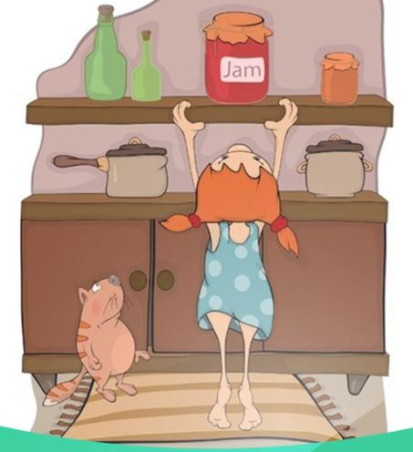

<NO.2>

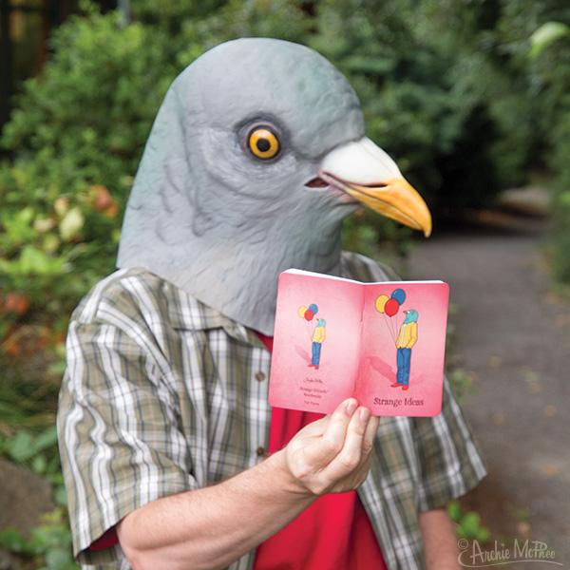

<NO.3>

<NO.4> <NO.5> <NO.6>

<NO.7>

Transcript

Time : 2 min

Workers were trying to enter. I tried to help. With a great effort I opened a hole.
I grew very weak. I asked one of the workers if he could start the engines. He said he would try. I fell asleep on the ground.

It was dark when I opened my eyes again. My clothing felt stiff and strange. I sat up. I could see light from an opening. I walked outside. The land looked strange to me. I looked up to the sky and saw the Red Planet Mars. I was once again on Earth in the desert of Arizona. I cried out with deep emotion.

Did the worker reach the machines to renew the atmosphere? Did the air reach the people of that planet in time to save them? Was my Princess Dejah Thoris alive or did she lie cold in death?

For ten years now, I have watched the night sky, looking for an answer. I believe she and our child are waiting there for me. Something tells me that I shall soon know.

WorkSheet1 – A Princess of Mars

Exercise One: Listen and write the answer next to the question.

a) To whom did he ask to turn on the engine?

b) What was there when he opened his eyes and looked up at the sky?

c) Where on Earth was he when he woke up?

d) For how long did he look up the sky to find the answer?

Exercise Two: Listen carefully, think, and write your answer.

a) Why did he think that The land looked strange to him?

b) Why didn’t he know whether Dejah Thoris was alive or not?

Exercise Three: Talk to your partner freely about any of the questions below.
No writing!

a) Do you think life is living on another planet in the vast universe?

b) Have you ever been away from people you loved for a long time?

Answer Sheet – A Princess of Mars

Exercise One

a) To whom did he ask to turn on the engine? (Worker)

b) What was there when he opened his eyes and looked up at the sky? (The red planet Mars)

c) Where on Earth was he when he woke up? (on Earth in the desert of Arizona)

d) For how long did he look up the sky to fine the answer? (10 years)

Exercise Two

a) Why did he think that The land looked strange to him?

Because he spent a long time on another planet, he felt the land looked strange.

b) Why didn’t he know whether Dejah Thoris was alive or not?

Because something happened to him and when he woke up, he was not on Mars anymore. Dejah Thoris was on Mars and He was on the earth so he didn’t know whether Dejah Thoris was alive or not.
Instructor’s Comments and Assessment
Pros
Cons
Change
Overall Comments
Grade
Above Standard 85%-100% | Standard 70%-84% | Below Standard 69%-0%
Instructor | Student Signature | Date
Taute, David

