Background Information Sheet
Name | Class | Date | Lesson Type | Plan Type | Length
AJ | 220th WK | 05/15/21 | Grammar | PPP | 25min

Lesson
Topic | T-shirt is the cheapest among all.
Main Aim | Students will learn the superlative form and used it in a sentence.
Secondary Aim | Students will practice their speaking fluency and grammar.

Materials and References
Printed materials, Board, colored markers and worksheets.

Student Profile
Level | Lower Intermediate
Age | 6-12 yrs. old | Number of Students | 4
Detail | The students are Elementary students that can understand simple learned phrases  and knows some familiar vocabulary. Their speech is characterized by frequent pauses  and repetition.
Assumptions about students’ knowledge as required for this lesson:
- Students know about target language.
- Students have idea about the superlative form.
- Students know how to make the negative form using ‘isn’t’
What language difficulties to expect when presenting, and how to deal with it:
1. Meaning: Students might confuse about the differences of superlative form to comparative form. Explain the
differences, Make a C.C.Q.

2. Form: Students may still have problem of constructing a sentence and confuse about structure. Make a simple structure and explain it well.

3. Pronunciation: Students may pronounce incorrect and stressing wrong words in a sentence. Listen to the
teacher how they pronounce and drill several times.
Anticipated Classroom Management Difficulties and their Solutions:
Some instructions weren’t clear for students and students have few vocabularies to speak to the topic.
For this lesson I will make a clear instructions and practice new vocabulary. Monitor and motivate the students
with amazing marks and praises.
My Personal Aim
My personal aim is to let students clearly understand the lesson, and to manage my time properly.

Page 1 of 4

Stage Name: Lead-in
Purpose of this stage: To relax both the teacher and students. To focus attention on the lesson. Create a situation
for students to experience or think about, and then to elicit the target language.
Materials: Printed materials
Timings |  | Interactions | Procedure
3mins |  | T-S | Hello everyone, I went to the mall yesterday and I bought something.  (Show the items that you buy)  Talk about the price. “On this simple t-shirt how can you compare to these  two items I bought yesterday? Look at the price. “Call students to answer.  (t-shirt is the cheapest among all.)
Stage Name: Presentation
Purpose of this stage: Make the students think about the situation. To clarify the meaning, form, and
pronunciation features of the target language.
Materials: Board, colored marker and eraser.
 | Timings | Interactions | Procedure
 | 1min  1min  3mins  1min | T  T-S  T-S  T-S | Board the model sentence (if students are unable to tell you,  just board it).  CCQ  1. Does the price of a t-shirt gives a positive situation? (yes)  2. Does the t-shirt price is low? (yes)  3. Is it a problem? (no)  Form  + Subject T-shirt Be verb is Adj. The cheapest Object Among all  - T-shirt isn’t The cheapest Among all  Can we say “T-shirt the cheapest is among all’? (no)  Can we say “The cheapest t-shirt is among all’? (no)  Why? Because adj. should be placed after the (be)verb.  How do we make this into negative sentence? (T-shirt isn’t the  cheapest among all.)  Drill  Ss Listen. (Read the sentence)  Which words are stressed? (t-shirt, cheapest) mark the stress with a  red marker.  Which words are unstressed? (Is, the, among all) mark the unstress  with a blue marker.  Listen and repeat 3 times (T-shirt is the cheapest among all.)  Conduct the drill 3 times with gestures.  Select individual drilling 3 times  Select again another individual.
Page 2 of 4
Stage Name: Controlled Practice
Purpose of this stage: students practice working with the form (scrambled sentences, split sentences,
select the correct form of the verb, correct incorrect sentences, and change one form into another form).
Accuracy must be checked.
Materials: Worksheet
Timings | Interactions | Procedure
30sec  2mins  1min  2mins | T  S  S – S  T - S | Instructions. Carry the worksheet, point to exercise A  Unscramble the sentences. I’ll give you 2 minutes to answer the sheet.  Students do exercise A  Pair check  Feedback. Check accuracy and talk the answers.
Stage Name: Less Controlled Practice
Purpose of this stage: students practice working with the meaning (match a timeline to sentences,
choose the sentence that matches a picture, gap-fill a paragraph). Accuracy must be checked.
Materials: Worksheet
Timings | Interactions | Procedure
30sec  2min  1min  2min | T  S  S-S  T-S | Instruction.  Turn over your worksheet. Answer exercise B.  Students do the worksheet.  Pair check  Feedback to check accuracy
Stage Name: Production – Freer Practice
Purpose of this stage: is to get students to practice the grammar communicatively.
Materials: no materials needed
Timings | Interactions | Procedure
30 sec  3mins | T  S-S | Instructions. (Visual.)  Ask the students to give another sentence with the target language  ‘the cheapest’  Students discuss

Page 3 of 4

Stage Name: Wrap-up
Purpose of this stage: is to end the lesson on a positive note so that students feel they have achieved progress.
Materials: no materials needed
Timings | Interactions | Procedure
30sec  1min | T – S  T  T | Lesson feedback.  I’m very glad that every one of you did the great part today, and  as I see the lesson is all about  the superlative form and hopefully, we can use it in our daily speaking  language to improve more into our next lesson.  Set homework.  Inform students about the topic for the next lesson.

Instructor’s Comments and Assessment
Pros
Cons
Change
Overall Comments
Grade
Above Standard 85%-100% | Standard 70%-84% | Below Standard 69%-0%
Instructor | Student Signature | Date
Taute, David

Page 4 of 4

EXERCISE A

Unscramble the sentence

SAMPLE: Among all, T-shirt, the cheapest, is
Ans: T-shirt is the cheapest among all.

1. Is, the cheapest, The bus, fare
• _________________________.

2. flight?, How, I, do, find, the cheapest
• ______________________________.

3. The cheapest, price, of, was, the, a, bike
• ________________________________.

4. Soup, heartiest, and, was, the cheapest
• _________________________________.

Exercise B

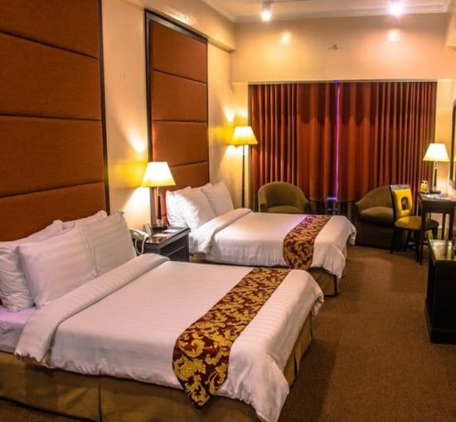
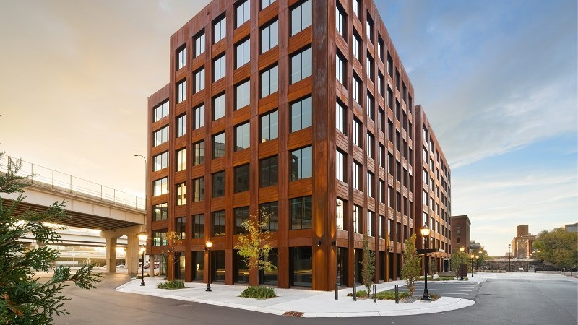
- What do you think is the cheapest to rent?

Building Apartment Hotel

2. In the 3 items, which is the cheapest?
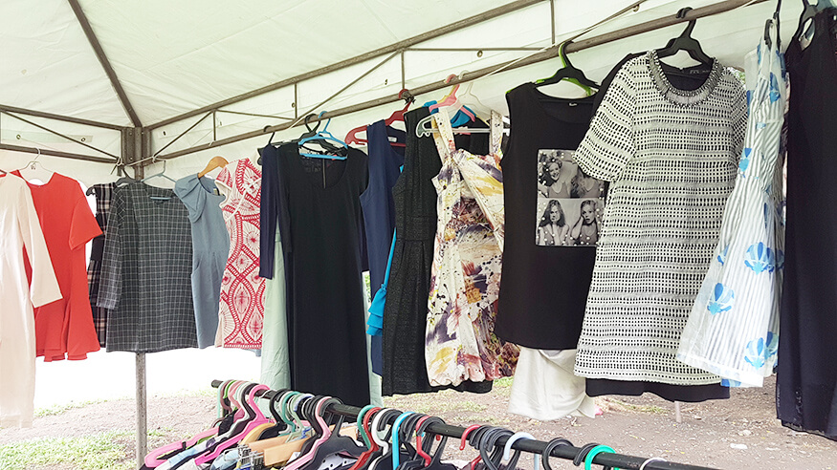
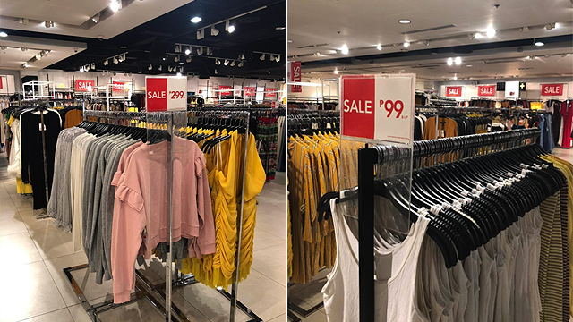
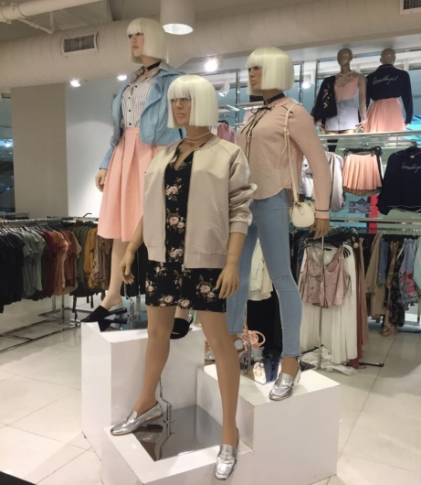
Brand New Clothes Discounted Clothes Used Clothes

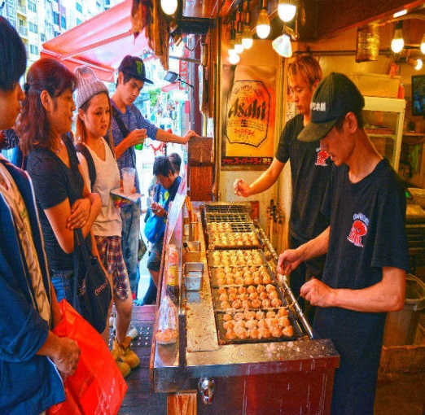
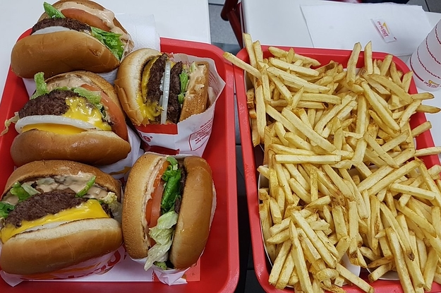
3. What do you think is the cheapest food?
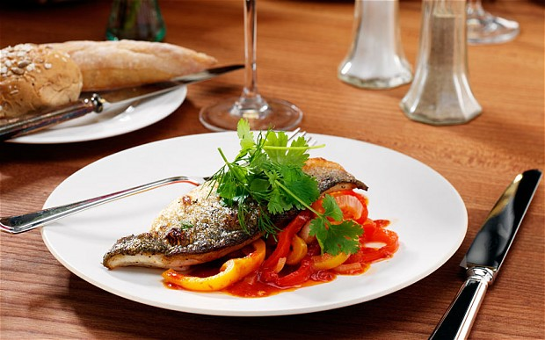
Food in Restaurant Fast Food Street Food

4. Which brand of cellphone is the cheapest?
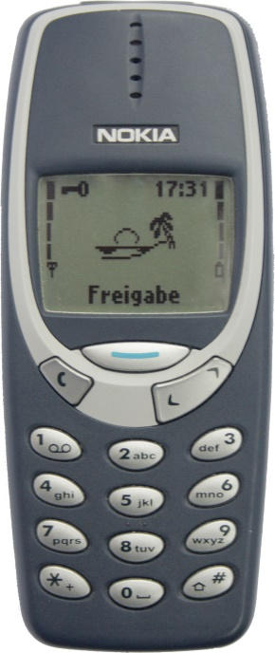
Nokia 3310 Iphone 12Pro Samsung Galaxy A32

Answer Sheet:

Exercise A.

- The bus is the cheapest fare.
- How do i find the cheapest flight?
- The cheapest was the price of a bike.
- Soup was the cheapest and heartiest.

Exercise B.
- Apartment
- Used Clothes
- Street Food
- Nokia 3310

