Background Information Sheet
Name | Class | Date | Lesson Type | Plan type | Length
Ceci | TESOL | 20/05/2021 | Listening | PPP | 30 min
Lesson
Topic | Meeting an old friend
Main Aim | Students will practice their listening comprehension using an integrated listening model.
Secondary Aim | Students will practice their speaking fluency.
Materials and References
Http://learnenglish.britishcouncil.org/skills/listening/intermediate-b1/meeting-an-old-friend
https://www.youthrights.org/blog/time-flies-when-youre-having-fun-and-drags-when-youre-young/
Worksheet, SOS Activity, board pen, P.C and audio equipment.

Student Profile
Level | Intermediate
Age | Adults | Number of Students | 6
Detail | This is an English class full of smart and mature adults. They are all Korean and want to learn conversational English. They work better in groups but still not familiar with each other. Once they become relaxed, they begin to talk openly with each other. They improve well through visuals and kinesthetic learning but need hep developing auditory skills. They enjoy learning about different English expressions.
Anticipated Classroom Management Difficulties and their Solutions
If audio equipment is not present or not working- bring my own mini projector, speakers and check them before class starts. If that does not work, I will have big A4 size print outs of my ppts and will read the audio out loud for students.

If nervous read teacher talk off my lesson plan and sit if necessary.
My Personal Aim
What I aim to demonstrate is the ability to write out a complete, detailed lesson plan.

Stage Name: Lead-in
Purpose of this stage: to make students and teacher relax. Also, to increase student talk by sharing their ideas and experiences.
Introduce the topic of lesson or something topic related.

Materials: PPT1
Time | Interaction | Procedure
30 sec  1 min  1 min | T  T-S/S-S  T-S | Hello everyone, look here at this picture it’s a picture of two people who haven’t seen each other in a long time. Do you have a friend you have not seen in a while? Talk to your partner and tell them about your friend. How long has it been since you have seen them and how long have you known that person? You have 1mins.  Use gestures to show them to start talking.  As the students brainstorm/talk to a partner, the teacher monitors and listens for any keywords they might use.  Feedback if appropriate ask Is there anyone would like to share about their experience?

Stage Name: Presentation
Purpose of this stage: To offer help to students who need help comprehending the text more easily. This involves teaching 1-4 key words using C.C.C technique, along with asking a guiding question to help the student to think and share ideas they are likely to encounter while listening. This allows students to use their schema when comprehending the text.

Materials: PPT1, PPT2
Time | Interaction | Procedure
1min  1min  1min  10 sec  1 min  1min | T-S  T-S  T-S  T  S-S  T-S | Pre-teach keywords: been ages; dream job; time flies.  Elicit – look at this picture (PPT1) what can we say when it’s been a long time seeing someone?  (It’s been ages) if they don’t know- we can say it’s been ages.  CCQ – does ages mean a short period of time? (No)  Drill- listen and repeat after me 3 times. (Use gestures)  Gesture for individual pronunciation. (2 or 3 students)  Board- write it’s been a while on left side of the board focus on the word age. (Use black pen)  How many syllables in the word ages? (2) use blue pen  Where is the stress? (2nd)  Elicit- now think about a job that is perfect for you. Does anyone know another way we can call the perfect job? (Dream job) if they don’t know- we can call it a dream job.  CCQ- is a dream job a job that that is imaginary? (no)  Is a dream job a good job you have always wanted? (yes)  Is a dream job a job you work hard for? (yes)  Drill- listen and repeat after me 3 times. (Use gestures)  Gesture for individual pronunciation. (2 or 3 students)  Board- write on left side of the bord and focus on the word dream. (Use black pen)  How many syllables? (1) use blue pen.  Where is the stress? (1st) use red pen.  Elicit- look at this picture we see a watch with wings does anyone know any expression that comes to mind? (Time flies)  CCQ- Does it mean you notice the time going by? (no)  Does it mean time is going by quickly or slowly? (quickly)  Drill- listen and repeat after me 3 times. (Use gestures)  Gesture for individual pronunciation.  Board- focus on the word time. (Use black pen)  How many syllables? (1) use blue pen.  Where is the stress? (1st) use red pen.  Guiding Question  What are your goals in life? talk to your partner tell them what your goals are and why. You have 1 min.  Students discuss the question with a partner. Monitor closely.  Feedback. Nominate a few students to share their ideas, if necessary.
Stage Name: Practice - Literal Comprehension Listening
Purpose of this stage: For the students to listen for the first time in order to get the facts. This may include the overall idea or topic of the text; to notice who the speakers are; where they are; and perhaps why they are speaking. The responses are short, objective, and are only a surface understanding. This is an accuracy focused stage.

Materials:
Time | Interaction | Procedure
1 min  3 min  30 sec  1 min | T  S  S-S  T-S | Instructions. Set the purpose for listening. Hand out worksheets.  Show worksheet to students by holding it up so they can see.  Everyone we are going to listen to a conversation between two old friends.  As you listen you must answer these questions in exercise 1 only  When you hear the answer, write it next to the question.  You will be working alone.  Don’t do exercise 2.  I.C.Q- Do you need to write your answers? (Yes)  Do you answer the questions on exercise 2? (No)  Do you work alone? (Yes)  Quickly read each question before starting audio, then hand out worksheet.  Students listen for the 1st time and write answers on the worksheet.  Pair check. Compare your answers with your partner. Monitor  Gesture for them to work together.  Feedback to check accuracy. Ask students for answer. Check if others had same or different answers. Are there any other answers? Does everyone agree with this answer?

Stage Name: Practice - Interpretive Comprehension Listening
Purpose of this stage: students listen a second time, more carefully, to infer or interpret meaning of the literal facts. This is still focused on accuracy therefore answers need to be checked for accuracy. Students must think about the why in order to support their answers. They might need to focus on things like the overall situation, tone of voice, multiple pieces of information, or a single statement to explain the unspoken, intended meaning.

Materials:
Time | Interaction | Procedure
30 sec  4 min  50 sec  3 min | T  S  S-S  T-S | Instructions. Set the purpose for listening. Hand out worksheets.  Let’s listen again but this time we will answer questions from exercise 2.  These questions are more difficult so listen carefully and use what you know to find the answers.  Write the answers next to the question.  You will have time after to think and write your answer.  I.C.Q- Do you answer questions from exercise 2? (Yes)  Should you listen carefully? (Yes)  Should you answer quickly? (No), you will have time after to write your answer.  Read the questions to the students out loud.  Students listen for the 2nd time.  Pair check. Monitor. If students need, then replay the audio a 3rd time.  Feedback to check accuracy.  Call on two or three students to give their answers.

Stage Name: Production - Applied Comprehension Speaking
Purpose of this stage: students will practice their speaking fluency. Therefore, this stage should be no less than 5 minutes to allow students to practice. Give them a few questions to help them communicate without intervention from the teacher. This is a fluency focused stage.

Materials:
Time | Interaction | Procedure
30 sec  6 min  1 min | T  S-S  T-S | Instructions. Give students a question to discuss in pairs or groups.  Make 2 groups of 3 students.  Everyone turn over your worksheets to exercise 3.  I want you to turn and talk to your partner and ask these questions. Find out as much as you can from each other. You have 5 mins.  I.C.Q- Do you need to write the answer? (No)  Who do you talk to? (Your partner)  Students discuss.  Monitor from a distance or sit in chair to monitor.  Feedback. Students share their ideas with the class.  Choose one person from one or two groups.

Stage Name: Wrap-up
Purpose of this stage: to end the lesson positively. This will make students feel accomplished and encourage students to continue progressing. Also realize how to improve in the future. A teacher can also get feedback from the students about the activities from the lesson.
Materials:
Time | Interaction | Procedure
1 min | T | Lesson feedback. Tell the class what they did well, and what needs to improve.  Keep them feeling encouraged and positive.  Set homework.  I want you to think of an old friend you have not seen in a while and write a conversation between you and that person. Write how you think that conversation would happen. Make it a funny or positive. I will send you home with the sample conversation we listened to today.  Inform students about the topic for the next lesson.  Next time we will continue our listening lesson and share our funny and positive conversations together.  Dismissed.

PPT1
http://learnenglish.britishcouncil.org/skills/listening/intermediate-b1/meeting-an-old-friend

PPT2
https://www.youthrights.org/blog/time-flies-when-youre-having-fun-and-drags-when-youre-young/
Transcript
Time: 1 min 57 seconds
Selina: Patrick? Is that you?
Patrick: Selina! Hello!
Selina: Well, well. Patrick Eastwood. How have you been?
Patrick: Good. Great, actually. How are you? I haven't seen you for ... how long?
Selina: It's been ages. At least fifteen years. Wow.
Patrick: Yeah. Wow.
Patrick and Selina: So, what are you doing here?
Selina: Sorry, you go first.
Patrick: OK. What are you doing here? I thought you'd moved to London.
Selina: I was in London for a couple of years. But it didn't work out.
Patrick: Oh, I'm sorry to hear that. Are you ... OK?
Selina: I'm fine! The dream job wasn't really a dream, you know? Um ... and London is great but it's so expensive. I mean, just the rent on a flat is ... uh … crazy expensive.
Patrick: I see.
Selina: So, I came back. I've been back now for almost five months. Living back home with Mum and Dad. Which is err ... interesting. Um ... but anyway, what about you?
Patrick: Me? Oh, nothing new. You know me – 'Patrick the predictable'. I never left here.
Selina: Oh. And is that ...?
Patrick: Oh, I'm very happy. I'm married now. We've just celebrated our tenth anniversary.
Selina: No way! You? Married? To …?
Patrick: I don't think you know her. Her name's Marigold. And we've got two kids. They're five and eight years old.
Selina: Married and with two kids? Wow!
Patrick: Don't look so surprised!
Selina: No, no … I'm just amazed how time flies! I'm happy for you. I really am.

Worksheet 1 - Meeting an old friend.
Exercise one: listen and write the answer next to the question.
- What is Patrick’s last name?
- How long has it been since Patrick and Selina seen each other?
- 10 years
- 3 years
- 15 years
- Where did Selina move to?

- True or false Patrick is married?

Exercise two: listen carefully, think, and write your answer.
Why did Selina’s dream jobs not work out?

Why is Selina amazed at how time flies?

Exercise three: talk to your partner freely about any of the questions bellow. No writing!

- What is your dream job and why?

- If your dream job could be anywhere in the world, where would it be and why?

- What are the steps to getting that dream job?

- Do you think getting your dream job would make you happy? Why?

Answer sheet – meeting an old friend.
Exercise one: listen and write the answer next to the question.
- What is Patrick’s last name? Eastwood

- How long has it been since Patrick and Selina seen each other?

- 10 years
- 3 years
- 15 years*

- Where did Selina move to? London

- True or false Patrick is married? Ture

Exercise two: listen carefully, think, and write your answer.
Why did Selina’s dream jobs not work out?
- Her dream job in London did not work out because it ended up being not what she expected. She did not make a lot of money and in the conversation, she tells Patrick that living in London is crazy expensive.

- Why is Selina amazed at how time flies?
-Because while she talked with Patrick, she sees all that he has done with his life like getting married and starting a family. She sees all she did was chase her dream job which failed and now lives with her parents.

SOS Activity

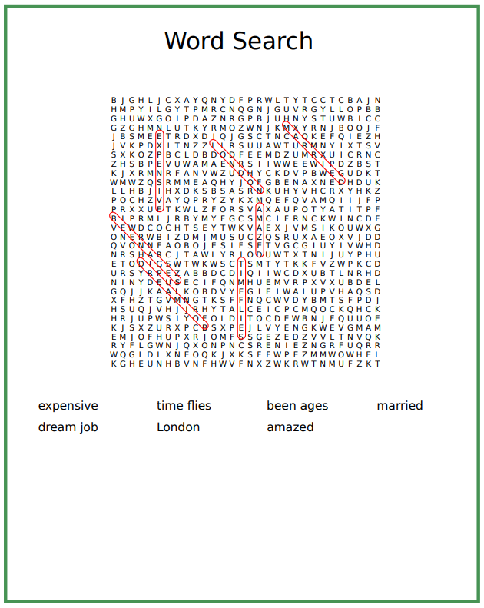

Instructor’s Comments and Assessment
Cons
Change
Overall Comments
Grade
Above Standard 85%-100% | Standard 70%-84% | Below Standard 69%-0%
Instructor | Student Signature | Date
Taute, David

