Background Information Sheet

|  |  |  |  |  |  |
| --- | --- | --- | --- | --- | --- |
| **Name** | **Class** | **Date** | **Lesson Type** | **Plan type** | **Length** |
| Ceci | TESOL | 6/9/2021 | Reading | PPP | 25 min |

|  |  |
| --- | --- |
| **Lesson** | |
| **Topic** | Family |
| **Main Aim** | Ss practice their reading comprehension. |
| **Secondary Aim** | Ss practice their speaking fluency. |

|  |
| --- |
| **Materials and References** |
| **PPt1: https://www.wimpykidclub.co.uk/book/the-getaway/,** |

|  |  |  |  |
| --- | --- | --- | --- |
| **Student Profile** | | | |
| **Level** | Lower intermediate | | |
| **Age** | 10-14 | **Number of Students** | 5 |
| **Detail** | My students are very smart middle school students who listen very well. They are a little shy but they love to laugh and have fun. | | |

|  |
| --- |
| **Anticipated Difficulties and their Solutions:** |
| In the case of 1 student is absent they will be put into 2 groups of 2. I will have printed picture incase the tv is not working for the class. |

|  |
| --- |
| **My Personal Aim** |
| What I hope most to demonstrate in this lesson is the ability to reduce my teacher talk, give better instructions and use appropriate time management during the class. |

|  |  |  |
| --- | --- | --- |
| **Stage Name:** Lead-in  **Purpose of this stage:** To relax both the teacher and students. To focus attention on the lesson. To lead in to the topic, activating background knowledge – this will help to contextualize the text. This is a BEFORE READINING stage. | | |
| **Materials:** List all materials that will be needed in this stage. | | |
| **Timing** | **Interaction** | **Procedure** |
| 30 sec  2 min | T    T-S/S-S | Hello everyone, how are you today?  Please put away everything on your desk all you need is a pencil.  Look at this picture of a boy and his family.  I want you to talk to your partners about your family.  How big is your family and what is your family like?  For example: My family was a small family. It used to be just my mom, dad, me and my younger brother but now my brother is married and so am I. so we are a family of 6 now.  Your turn (gesture for them to talk).  Brainstorm/talk to a partner.    **PPt1:** [**https://www.wimpykidclub.co.uk/book/the-getaway/**](https://www.wimpykidclub.co.uk/book/the-getaway/) |

|  |  |  |
| --- | --- | --- |
| **Stage Name:** Presentation  **Purpose of this stage:** To pre-teach keywords if necessary, and answer a guiding questions (such as a predicting task, or a specific question). These steps provide extra help for students to comprehend the text. This is a BEFORE READINING stage. | | |
| **Materials:** List all materials that will be needed in this stage. | | |
| **Timing** | **Interaction** | **Procedure** |
| 1min  1min  1min  10 sec  1 min | T-S  T  S-S | **Keywords:**  **Let’s look at this picture what do we see? (Listen to their response)**  **Yes, we see a cooking show on TV! There is a brother and sister racing each other to make the best food for the grand prize.**  **Does anyone know what we can say to describe this? (Wait for response)**  **-yes, or we can say they are going head-to-head**  **CCQ-**   1. **Are they in a race or competition? (yes)** 2. **Can we say their going head-to-head if its only one person? (no)**   **Drill- repeat after me 3 times (use hand gestures) Head-to-head.**  **Don’t forget individual pronunciation.**  **Board- How many syllables? 3**  **Where is the stress? 1st and 3rd**  **Logic-**  **Dismantle-**    **Guiding Question**  E.g., Students discuss the question with a partner. |

|  |  |  |
| --- | --- | --- |
| **Stage Name:** Practice – Literal Comprehension  **Purpose of this stage:** is to get students to practice reading for literal detail. They will also practice fast reading (skimming and scanning). This is a WHILE READINING stage. | | |
| **Materials:** List all materials that will be needed in this stage. | | |
| **Timing** | **Interaction** | **Procedure** |
| 30 sec  2 min  30 sec  1 min | T  S  S-S  T-S | **Instructions: I am going to give you a worksheet. (Hold up worksheet)**  **We will do exercise A do not look at exercise B.**  **I want you to answer the questions from the text I give you. (Point to the questions)**  **You will work alone.**  **ICQ-**   1. **will you work on exercise A? (yes)** 2. **are you going to answer the questions? (yes)** 3. **are you working alone or with your partner? (alone)**     **you will have 2 min and you can start when you get the worksheet.**  **Students read the whole text for the 1st time, and write answers on the worksheet.**  **Pair check:**  **Okay, turn to you partners.**  **check and compare your answers.**  **See if they are the same.**  **Feedback to check accuracy. Now let’s check together**  What day is it? **(Tuesday)**  What is the boy super good at? **(Video games)**  Who is a pretty smart guy? **(Dad)**  What does his dad want to dismantle? **(Game system)** |

|  |  |  |
| --- | --- | --- |
| **Stage Name:** Practice – Interpretive Comprehension  **Purpose of this stage:** is to get students to get students to practice interpreting a text correctly This will require more detailed, careful reading, and thinking time to arrive at the correct answer. This is a WHILE READINING stage. | | |
| **Materials:** List all materials that will be needed in this stage. | | |
| **Timing** | **Interaction** | **Procedure** |
| 30 sec  3 min  1 min  2 min | T  S  S-S  T-S | **Instructions: now let’s move to exercise B (hold up worksheet)**  **I want you to read and think carefully then answer these two questions.**  **Again, you will work alone.**  **I will give you 3 mins**  **ICQ-**   1. **will you work on exercise B? (yes)** 2. **will you work alone? (yes)** 3. **how many mins will you have? (3min)**   **(Gesture for them to begin)**  **Students read for the 2nd time. Students write their answers down.**  **Pair check. Monitor.**  **Okay, turn to you partners.**  **check and compare your answers.**  **Feedback to check accuracy.**   1. Why does his dad not want him in the house?  * **His dad does not want him in the house because he wants him to stop wasting his time playing video games all day. Instead, he wants his son to be more like him when he was young and play sports outside with other kids.**  1. Why is it so hard for his dad to dismantle the game system?  * **It’s hard for his dad to dismantle the game because he is not familiar with technology. When he was young, he did not have those kinds of systems so he never had a chance to use them.** |

|  |  |  |
| --- | --- | --- |
| **Stage Name:** Production - Applied Comprehension  **Purpose of this stage:** is for students to practice their speaking fluency and is related to the lesson topic. This is an AFTER READINING stage. | | |
| **Materials:** List all materials that will be needed in this stage. | | |
| **Timing** | **Interaction** | **Procedure** |
| 30 sec  5 min  1 min | T  S-S  T-S | **Instructions. Give students a question to discuss in pairs or groups.**  **I want you to talk to your partners about the best family vacation you have been on.**  **If you have not gone on a family vacation you can make one up.**  **Talk about:**   1. **Where you went?** 2. **What you and your family did together?** 3. **Would you go again with your family?**     **I will give you 5 mins (gesture for them to talk)**  **Back up question:**  **Talk about your dream family vacation**  **Students discuss.**  **Feedback. Students share their ideas with the class.**  **Does anyone want to share what you talked about? (Choose 1 from each group)** |

|  |  |  |
| --- | --- | --- |
| **Stage Name:** Wrap-up  **Purpose of this stage:** is to end the lesson on a positive note so that students feel they have achieved progress. This is an AFTER READINING stage. | | |
| **Materials:** List all materials that will be needed in this stage. | | |
| **Timing** | **Interaction** | **Procedure** |
| 1 min  20 sec | T  T | **Lesson feedback. Tell the class what they did well, and what needs to improve.**  **Offer delayed corrections to the previous stage.**  Set homework. **I want you guys to write your own ending to this story what do you think his dad does? Does he break his game or leave it alone?**  Inform students about the topic for the next lesson. **Next week we will read the rest of this story and find out what the father does to the video game.** |

PPt1: https://www.wimpykidclub.co.uk/book/the-getaway/

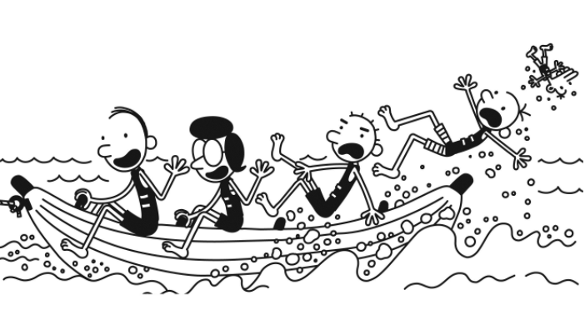

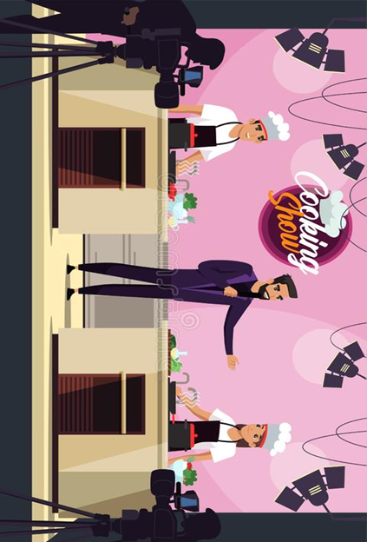**PPT:2** **https://www.dreamstime.com/illustration/cooking-competition.html**

**Transcript:**

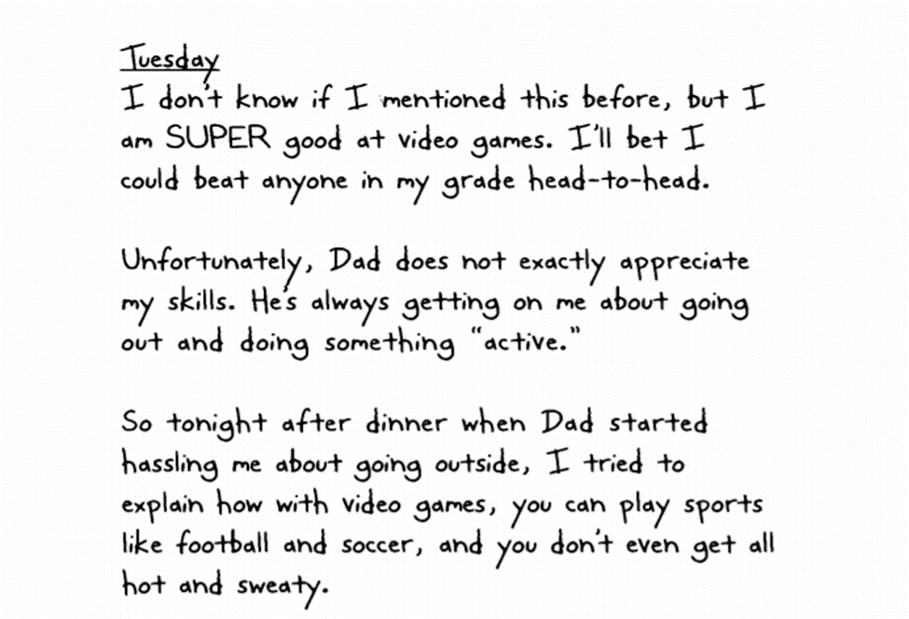

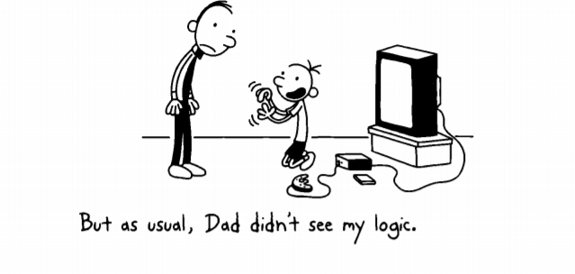

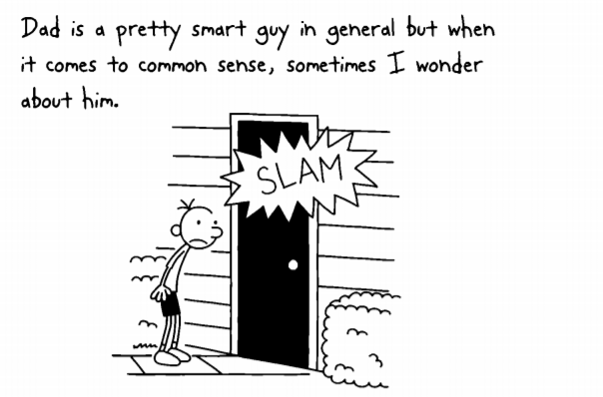





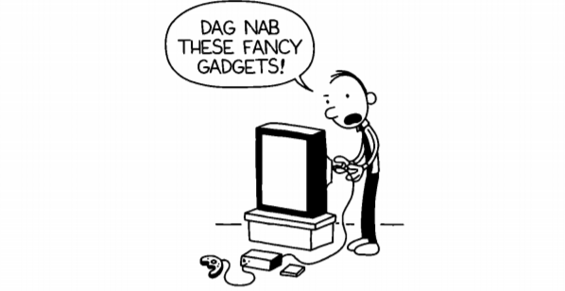

https://psv4.userapi.com/c848036/u303879260/docs/d6/905247ad68cd/Diary_of_a_Wimpy_Kid.pdf?extra=xHjw4kdDnsMMSKgwSop1RVgHrz4yHVOFCBI8IaPJQNOa1f5NbQdarWg4elb4xwJXCXiXjkV_hzHyygF9iZL1AVwvqqp8A8h7w4q77JdYLSb3L_ZrrUnD4dKkwwiGJcQeGZfQyuQYiVwbpUMCsA

Worksheet

Exercise: A

answer these questions from the text.

1. What day is it?
2. What is the boy super good at?
3. Who is a pretty smart guy?
4. What does his dad want to dismantle?

Exercise: B

Read and think carefully then write your answer.

1. Why does his dad not want him in the house?
2. Why is it so hard for his dad to dismantle the game system?





**Instructor’s Comments and Assessment**

|  |  |  |
| --- | --- | --- |
| **Pros** | | |
|  | | |
| **Cons** | | |
|  | | |
| **Change** | | |
|  | | |
| **Overall Comments** | | |
|  | | |
| **Grade** | | |
| **Above Standard 85%-100%** | **Standard 70%-84%** | **Below Standard 69%-0%** |
| **Instructor** | **Student Signature** | **Date** |
| **Taute, David** |  |  |