Background Information Sheet
Name | Class | Date | Lesson Type | Plan type | Length
Seri Park | TESOL | 06/09/21 | Reading | PPP | 25 min

Lesson
Topic | Coca-Cola tests a paper bottle (news article)
Main Aim | Students practice their reading comprehension.
Secondary Aim | Students practice their speaking fluency.

Materials and References
News article, board, markers, visual pics and worksheets

Student Profile
Level | Intermediate
Age | Adults | Number of Students | 5
Detail | This is a general English class and the students are highly motivated learners. Majority of the students are native Korean and speak Korean as their first language. The students are accustomed to teaming up for them to work, but they need to be relaxed for them to open up and communicate freely. Overall, their communication skills and reading skills are fairly good. All the students are eager to learn and develop their skills in English.

Anticipated Difficulties and their Solutions:
Capturing the students’ attention during the entire lesson: The students need to be engaged during the entire lesson – provide short reading material, prepare a backup plan.

My Personal Aim
What I hope most to demonstrate in this lesson is the ability to
- write out a complete, detailed lesson plan
- manage lesson time properly
- be an involver type teacher

Stage Name: Lead-in
Purpose of this stage: To relax both the teacher and students. To focus attention on the lesson. To lead in to the topic, activating background knowledge – this will help to contextualize the text. This is a BEFORE READINING stage.
Materials: List all materials that will be needed in this stage.
Timing | Interaction | Procedure
30 sec  2 min  30 sec | T  S-S  T-S | Instructions  Organize seating arrangements for all students to have partners, with one group of 2 and 3 sitting together, and all can easily see the board and the pictures.  Greet  Hello, everyone. How are you today?  In this 21st century, lots of pollution is happening. I want you to talk to your partners about what are some types of pollution? What can you do to help prevent pollution?  T- You can share your ideas with your partner.  You have 2 minutes  Students talk  Students share their ideas.  Feedback  Nominate the students to share ideas.

Stage Name: Presentation
Purpose of this stage: To pre-teach keywords if necessary, and answer a guiding questions (such as a predicting task, or a specific question). These steps provide extra help for students to comprehend the text. This is a BEFORE READINING stage.
Materials: List all materials that will be needed in this stage.
Timing | Interaction | Procedure
2 min  10 sec  1 min  30 sec | T-S  T  S-S  T-S | Pre-teach keywords: packaging and sustainable  Elicit – Demonstrate a picture.  What do you see?  We can see a transparent glass, can, and plastic bottle containing Coca-Cola soda.  Point to the pictures and theses are called packaging.  CCQ – Is packaging the material used to wrap goods for sale? (Yes)  Is packaging can help to sell products? (Yes)  Drill – Listen and repast 3 times together. (Gesture)  Individual drilling for correct pronunciation.  Board – Write on the left of the board.  How many syllables? (3, pack/ag/ing) Mark with a blue pen.  Where is stress? (packaging) Mark with a red pen.  What part of speech is? (noun)  Elicit – A luxury champagne company began using potatoes as part of their packaging. (instead of plastic)  What word can we describe that packaging is? Sustainable packaging.  CCQ – Is sustainable products in a way that does not harm the environment? (Yes)  Drill – Listen and repast 3 times together. (Gesture)  Nominate 2 or 3 individually for correct pronunciation.  Board – Write on the left of the board.  How many syllables? (4, sus/tain/a/ble) Mark with a blue pen.  Where is stress? Sustainable Mark with a red pen.  What part of speech is? (adjective)  Guiding Question  How serious is the plastic pollution problem nowadays?  Pair works  Students discuss the question with a partner.  Feedback  Choose a few students to share their narratives, if necessary.

Stage Name: Practice – Literal Comprehension
Purpose of this stage: is to get students to practice reading for literal detail. They will also practice fast reading (skimming and scanning). This is a WHILE READINING stage.
Materials: List all materials that will be needed in this stage.
Timing | Interaction | Procedure
30 sec  2 min  30 sec  1 min | T  S  S-S  T-S | Instructions. Set the purpose for reading.  Hold up the news article and worksheet.  I want you to read this article and do exercise A.  I.C.Q. – Are you going to work on exercise A or B? (A)  You will have 2 minutes and you can start when you get it.  Hand out the reading material and worksheet.  Individual work  Students read the whole text for the 1st time, and write answers on the worksheet.  T – Monitor from a distance.  Say times up when the time is finished.  Pair checks  Compare your answers with your partner.  Feedback to check accuracy  Let’s check together. Go over the answers.

Stage Name: Practice – Interpretive Comprehension
Purpose of this stage: is to get students to get students to practice interpreting a text correctly This will require more detailed, careful reading, and thinking time to arrive at the correct answer. This is a WHILE READINING stage.
Materials: List all materials that will be needed in this stage.
Timing | Interaction | Procedure
30 sec  3 min  1 min  2 min | T  S  S-S  T-S | Instructions  Read again. This time, turn to next page and answer exercise B.  I want you to read and think carefully then answer the question.  I will give you  I.C.Q. – Did I ask you, to think carefully and respond to the questions? (Yes)  How many minutes do you have? ()  You may start. (Gesture)  Individual work  Students read for the 2nd time. Students write their answers down for exercise B.  Pair checks  Students compare their answer with their partner.  T – Monitor from a distance.  Say times up when the time is finished.  Feedback to check accuracy.  Ask students for answers and checking whether they have similar answers.

Stage Name: Production - Applied Comprehension
Purpose of this stage: is for students to practice their speaking fluency and is related to the lesson topic. This is an AFTER READINING stage.
Materials: List all materials that will be needed in this stage.
Timing | Interaction | Procedure
30 sec  6 min  1 min | T  S-S  T-S | Instructions  Check the exercise C Talk to your partner freely for 6 minutes.  What can we use instead of plastic?  What do you think of paper bottles?  How much extra would you pay for a paper bottle?  Students discuss.  Students discuss freely with their partner.  T – Monitor from a distance.  Say times up when the time is finished.  Feedback  Ask the students to share what they talked about.

Stage Name: Wrap-up
Purpose of this stage: is to end the lesson on a positive note so that students feel they have achieved progress. This is an AFTER READINING stage.
Materials: List all materials that will be needed in this stage.
Timing | Interaction | Procedure
1 min | T | Lesson feedback. Tell the class what they did well, and what needs to improve.  Everyone did a great job. Students have successfully paired and discussed on today’s exercise.  Offer delayed corrections to the previous stage.  Set homework  Make a poster about paper bottles. Share your work to your classmates in the next lesson.  S.O.S activity (If the time is still left for lesson then do it)  Plastic products: Rank these together as a whole class. Put the most useful plastic products number next to it.  • Bottles • Pens • Plates • Toys • Bags • Cutlery • Furniture • Masks

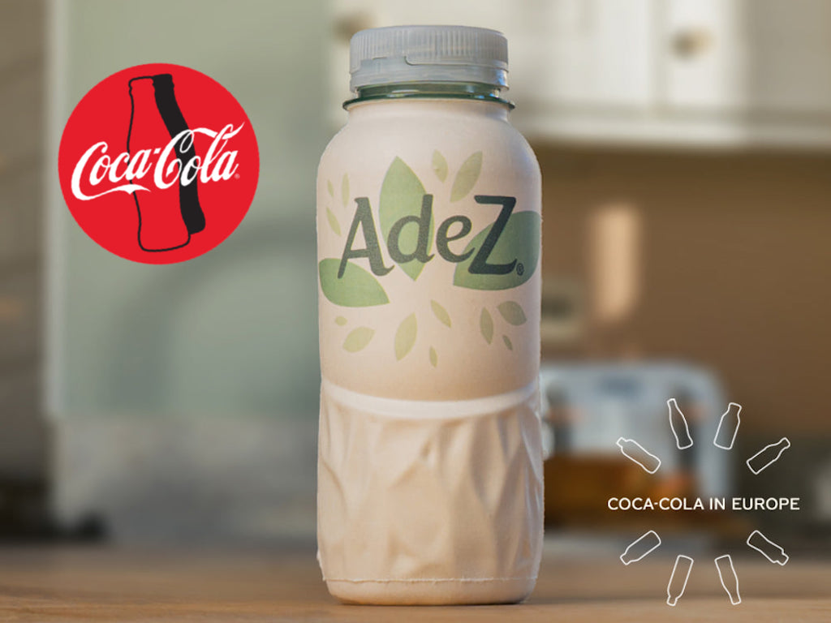

Coca-Cola tests a paper bottle
Plastic is a big problem for the world. It is causing a lot of damage to our environment. It is polluting rivers and oceans and harming and killing wildlife. Plastic is a growing problem because it takes hundreds of years to break down. Many companies around the world are trying to replace plastic with other things. Coca-Cola has teamed up with a Danish start-up called the Paper Bottle Company ("Paboco" for short) to make a paper bottle. Coca-Cola hopes to completely stop using plastic for its drink’s bottles. It was ranked as the world's number one plastic polluter in 2019. In one year, it uses around three million tons of plastic packaging. A lot of this is not recycled.
Paboco asked us to: "Imagine that all plastic packaging in your store has disappeared." Coca-Cola executives are imagining this. One Coca-Cola exec. said: "Our vision is to create a paper bottle that can be recycled like any other type of paper. A paper bottle opens up a whole new world of packaging possibilities. We are convinced that paper packaging has a role to play in the future." He added that he hopes Coca-Cola will one day use only packaging from renewable sources that are recyclable. He said: "This is all part of our journey to find the most sustainable packaging solutions for people to enjoy our drinks in a way that is right for them, and that is right for our planet."

Worksheet

Exercise A
Read the questions below and circle the correct answer.

- What does the article say plastic is killing?

- rubber
- the earth
- wildlife
- trees

- How does the article say it takes for plastic to break down?

- hundreds of years
- thousands of years
- tens of thousands of years
- hundreds of thousands of years

- How much plastic packing does Coca-Cola use on one year?

- just less than 3 million tons
- exactly 3 million tons
- over 3 million tons
- around 3 million tons
- A Coca-Cola executive said paper packaging has no role in the future. T / F

- A Coca-Cola executive wants to journey to a packaging factory. T / F

Exercise B
Write the answer below the question.
What are the possible challenges that Coca-Cola and Paboco could face in phasing out plastic packages and implementing paper packaging? What solutions could you suggest for these foreseen problems?

Exercise C
Talk to your partners freely. Don’t have to write the answer.
- What can we use instead of plastic?
- What do you think of paper bottles?
- How much extra would you pay for a paper bottle?

Answer sheet

Exercise A

1. c, wildlife
2. a, hundreds of years
3. d, around 3 million tons
4. F
5. F

Exercise B

Coca- Cola will probably have to incur additional costs associated with changing to paper packaging. The company probably has already heavily invested in the necessary infrastructure for plastic packaging and a shift to paper packaging will probably increase the cost of production before the company can break even.

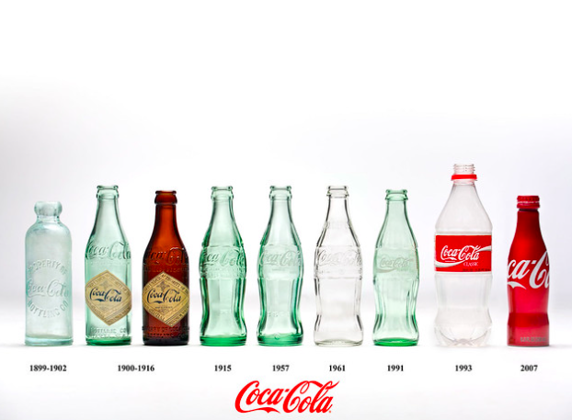

Packaging pic

Instructor’s Comments and Assessment
Pros
Cons
Change
Overall Comments
Grade
Above Standard 85%-100% | Standard 70%-84% | Below Standard 69%-0%
Instructor | Student Signature | Date
Taute, David

