Background Information Sheet
Name | Class | Date | Lesson Type | Plan type | Length
Cathryn | TESOL | 20/05/2021 | Listening | PPP | 30 min
Lesson
Topic | Meeting an old friend
Main Aim | Students will practice their listening comprehension using an integrated listening model.
Secondary Aim | Students will practice their speaking fluency.
Materials and References
www.youtube.com/watch?v=eq96cCPmZm0
PPT; http://learnenglish.britishcouncil.org/skills/listening/intermediate-b1/meeting-an-old-friend; transcript; worksheet and answer sheet; board pens; PC and audio equipment.

Student Profile
Level |  |  | Intermediate
Age |  |  | Adults | Number of Students | 6
Detail |  |  | This is a general English class and students are highly motivated learners. The students are all Koreans who work in an office. They learned English through traditional Korean style teaching(focused on grammar, vocabulary, reading, etc.), so they could have difficulty in idiomatic phrases. They are accustomed to pair work, but still need to be relaxed before they open up to communicate freely. They tend to feel comfortable with visuals and reading materials. They still need to develop auditory learning skills.
Anticipated Classroom Management Difficulties and their Solutions
The youtube link could fail → Find a music source of “Time flies - Dempsey Hope” in case the youtube link fails.
The audio link and equipment could fail → Download the audio file to my cell phone before lesson. Check equipment is working before class. Brink a portable speakers to use with my cell phone.
The screen does not work → Print an A4 size picture of my PPT.
My Personal Aim
What I aim to demonstrate is the ability to write out a complete, detailed lesson plan.
Stage Name: Lead-in
Purpose of this stage: To relax both the students and the teacher; to increase student talk through the sharing of ideas or experiences; to introduce the topic, or something topic-related.

Materials: www.youtube.com/watch?v=eq96cCPmZm0
Time | Interaction | Procedure
30 sec  1 min  30 sec | T  S-S  T-S | Before the class begins, turn on the music from the youtube link(“Time flies” by Dempsey Hope) but don’t show the video. Only let the music play.  Arrange desks in horseshoe arrangement and pair them so that there would be three groups.  Computer  BOARD  Screen  1  4  3  5  6  2  (Stop the music and get attention)  Good morning, everyone.  Let’s start with sharing your own experience of leaving your hometown or safe place. It could be when you left because of school, or when you left for a new adventure. How did you feel to leave somewhere and start a new thing? Or maybe you’ve never left to somewhere. Why did you choose to stay?  You have 1 minute.  Gesture for students to begin talking to their partners.  Students talk to their partners. Monitor for any use of key words.  Feedback. Gesture to a few group and ask – “Share us about your partner’s experience.”

Stage Name: Presentation
Purpose of this stage: To offer any needed help which students may need in order to comprehend the text more easily. This includes teaching from 1 to 4 keywords using the C.C.C. technique, and asking a guiding question which will allow students the opportunity to think of and share ideas they are likely to encounter while listening. This encourages the use of their schema when comprehending a text.

Materials: PPT1, PPT2, PPT3
Time | Interaction | Procedure
1 min  1 min 30 sec  1 min  1 min  10 sec  1 min  30 sec | T-S  T-S  T-S  T-S  T  S-S  T-S | Pre-teach keywords/phrases : time flies, It’s been ages, flat, work out  Elicit – Point PPT1.  When you are working in office, how does the time go? Does it go fast? (No. Slowly)  Then what about your lunch time? How does time go? (So fast)  So, in lunch time, how would you say the time goes?  The picture on the PPT is a hint. Fill in the blank.  For another hint, think of the song that was played at the beginning of the class. (time flies.)  CCQ – If time flies, does the time go slowly? (No)  If you’re doing something interesting or fun, does time fly? (Yes)  Drill – Listen and repeat 3 times together. “time flies” (Gesture 1,2,3)  Nominate 2 or 3 individually and check the pronunciation.  Board – Write “time flies” on the left of the board with black pen.  How many syllables for time flies? (1/1)  Elicit – Point to PPT2.  How can we say “Long time no see” in other words? There are other examples below as well.  Anybody knows what the blank is? (ages)  The expression we are going to learn is, “It’s been ages.”  CCQ – If it’s been ages, does it mean it’s been a short time? (No)  Does “ages” mean a long period of time? (Yes)  If someone left ages ago, does it mean that person left a long time ago? (Yes)  Drill – Listen and repeat 3 times together. “It’s been ages.” (Gesture 1,2,3)  Nominate 2 or 3 individually and check the pronunciation.  Board – Write “It’s been ages” on the left of the board with black pen.  How many syllables for ages? (2) Mark with blue pen.  Where is the stress? (1st) Mark with red pen.  Elicit – Point to PPT3. How do call one of these places? (flat)  CCQ – Does a flat have many floors? (No)  Is flat one of the residence within a larger building with many more residences? (Yes)  Is it similar to apartment? (Yes)  Drill – Listen and repeat 3 times together. “flat” (Gesture 1,2,3)  Nominate 2 or 3 individually and check the pronunciation.  Board – Write “flat” on the left of the board with black pen.  How many syllables for flat? (1)  What part of speech? (noun) Write with green pen.  Elicit – Suppose your manager wanted to get a contract of a big project. He prepared for a long time and really put his effort into it. But at the end, the other competitor got the opportunity.  How could you express this situation? (It didn’t work out)  CCQ – Was your manager successful in getting the contract? (No)  Did the manager put a lot of time and energy to get the project? (Yes)  If something works out, did somebody succeed in doing something with difficulty? (Yes)  Drill – Listen and repeat 3 times together. “work out” (Gesture 1,2,3)  Nominate 2 or 3 individually and check the pronunciation.  Board – Write “work out” on the left of the board with black pen.  How many syllables for work out? (1/1)  What part of speech? (phrasal verb) Write with green pen.  Guiding Question  You met your old friend accidently on the road. You haven’t seen her for long time. What would you say? What would you talk about? Talk to your partners.  Students discuss the question with a partner.  Feedback. Nominate a few students to share their ideas. Draw out ideas that they would share greetings and talk about how they have been recently.

Stage Name: Practice - Literal Comprehension Listening
Purpose of this stage: For students to listen for the first time in order to get the facts. This may include the overall idea or topic of the text; to notice who the speakers are where they are; and perhaps why they are speaking. The responses are short, objective, and are only a surface understanding. This is an accuracy focused stage.

Materials: Worksheet, Answer sheet
Time | Interaction | Procedure
30 sec  2 min  1 min  1 min | T  S  S-S  T-S | Instructions. Set the purpose for listening. Hand out worksheets.  Hold up the worksheet.  Now it’s time to listen to a dialogue between two friends.  As you listen, you must answer these questions in exercise one only.  When you catch the answer, write it down next to the question.  Don’t do exercise 2.  I.C.Q. – Do you need to speak up your answers when you hear the audio? (No.)  Do you need to read the questions for exercise 2? (No.)  Students listen for the 1st time, and write answers on the worksheet.  Play the audio from 0’5’’ to 1’58’’ (audio duration: 1 min 54 sec)  Pair check. Compare your answers with your partner. Monitor.  Feedback to check accuracy. Ask students for answer, checking if others have the same or different answers. Does anyone else have a different answer? Why do you think so?

Stage Name: Practice - Interpretive Comprehension Listening
Purpose of this stage: Students listen a second time, more carefully, to infer or interpret meaning of the literal facts. This is still an accuracy focused stage – answers need to be checked for accuracy. Students are required to think about the why in order to support their answers. They may need to focus on things like the overall situation, tone of voice, multiple pieces of information, or a single statement to explain the unspoken, intended meaning.
Materials: Worksheet, Answer sheet
Time | Interaction | Procedure
30 sec  3 min  2 min  2 min | T  S  S-S  T-S | Listen again. This time, answer exercise 2.  These questions are more difficult, but if you listen carefully and think through the context, you can find the answers.  Write your answers next to the questions.  I will give you time afterwards to think and write.  I.C.Q. – Are we going to check the answers right away when the audio finishes?  Students listen for the 2nd time and write their answers.  Play the audio from 0’35’’ to 1’23’’ (audio duration: 48 sec)  Pair check. Monitor. If students need, then replay the audio a 3rd time.  Feedback to check accuracy.

Stage Name: Production - Applied Comprehension Speaking
Purpose of this stage: For students to practice their speaking fluency. Therefore this state should be no less than 5 minutes to allow students to practice. Give them a few questions to help them communicate without intervention from the teacher. This is a fluency focused stage.

Materials: PPT4
Time | Interaction | Procedure
30 sec  6 min  1 min | T  S-S  T-S | Show PPT4.  Now, talk with your partner about these questions.  You should talk freely, and remember to ask the questions to your partner.  You have 6 minutes.  Students discuss. Monitor from a distance.  Feedback. Students share their ideas with the class.

Stage Name: Wrap-up
Purpose of this stage: To end the lesson on a positive note. This will give students a sense of accomplishment, encourage students to continue progressing, and realize how to improve in future. A teacher may also get valuable feedback from students regarding the activities used in the lesson.

Materials:
Time | Interaction | Procedure
2 min | T  T | Lesson feedback. Tell the class what they did well, and what needs to improve.  Set homework. For homework, make 1 sentence each for the keywords you learned today. You learned “time flies”, “It’s been ages”, “flat”, “work out” today. I will text the homework in the class chatroom.  I.C.Q. – In total, how many sentences will you make for homework? (four)  Dismissed.  * SOS Activity:  What was your nickname when you were young?  Nominate 2-3 students for their stories. If more time left, go for all of them.

PPT 1
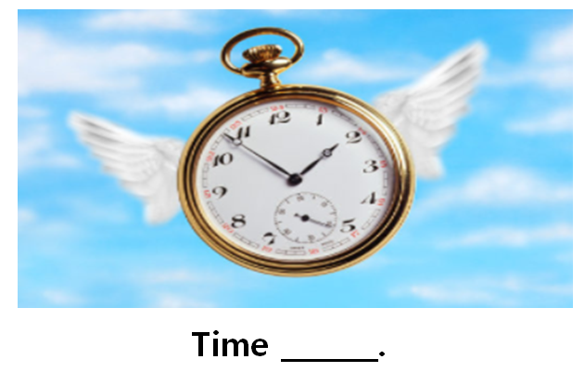
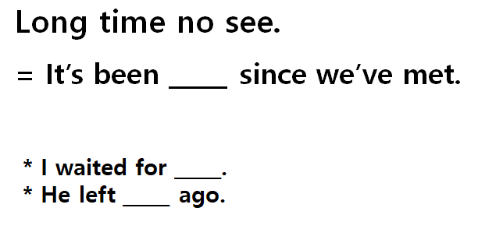
PPT 2
PPT 3

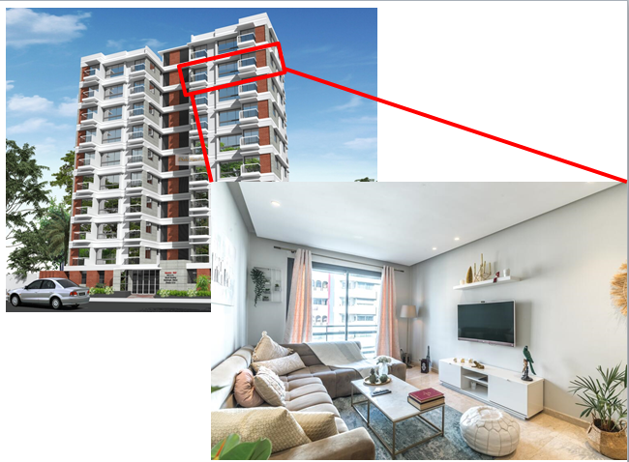
Transcript
Time: 1 min 54 seconds
http://learnenglish.britishcouncil.org/skills/listening/intermediate-b1/meeting-an-old-friend
Selina: Patrick? Is that you?
Patrick: Selina! Hello!
Selina: Well, well. Patrick Eastwood. How have you been?
Patrick: Good. Great, actually. How are you? I haven’t seen you for…. how long?
Selina: It’s been ages. At least fifteen years. Wow.
Patrick: Yeah. Wow.
Patrick and Selina: So, what are you doing here?
Selina: Sorry, you go first.
Patrick: OK. What are you doing here? I thought you’d moved to London.
Selina: I was in London for a couple of years. But it didn’t work out.
Patrick: Oh, I’m sorry to hear that. Are you… OK?
Selina: I’m fine! The dream job wasn’t really a dream, you know? Um… and London is great but it’s so expensive. I mean, just the rent on a flat is ... uh … crazy expensive.
Patrick: I see.
Selina: So, I came back. I’ve been back now for almost five months. Living back home with Mum and Dad. Which is err … interesting. Um … but anyway, what about you?
Patrick: Me? Oh, nothing new. You know me – ‘Patrick the predictable’. I never left here.
Selina: Oh. And is that …?
Patrick: Oh, I’m very happy. I’m married now. We’ve just celebrated out tenth anniversary.
Selina: No way! You? Married? To …?
Patrick: I don’t think you know her. Her name’s Marigold. And we’ve got two kids. They’re five and eight years old.
Selina: Married and with two kids? Wow!
Patrick: Don’t look so surprised!
Selina: No, no… I’m just amazed how time flies! I’m happy for you. I really am.
Patrick: Thanks.
Worksheet – Meeting an old friend

Exercise One : Listen and write the answer next to the question.
- How long did they not see each other?
- Where did Selina stayed for a couple of years?
- How long has she been back?
- Did Patrick move to somewhere else during these years?
- How long has Patrick been married?

Exercise Two : Listen carefully, think, and write your answer.
- What does Selina mean when she says, “The dream job wasn’t really a dream”?

- What could you infer about the phrase, “Patrick the predictable”?

Answer sheet – Meeting an old friend

Exercise One : Listen and write the answer next to the question.
- How long did they not see each other? At least for 15 years
- Where did Selina stayed for a couple of years? London
- How long has she been back? Almost 5 months
- Did Patrick move to somewhere else during these years? No
- How long has Patrick been married? 10 years

Exercise Two : Listen carefully, think, and write your answer.
- What does Selina mean when she says, “The dream job wasn’t really a dream”?
She actually had the job she wanted but found out that it wasn’t really as nice and perfect as she thought. She was disappointed with the job.

- What could you infer about the phrase, “Patrick the predictable”?
Patrick doesn’t really try out new things. He stays within expected boundaries. He makes predictable choices.

PPT 4

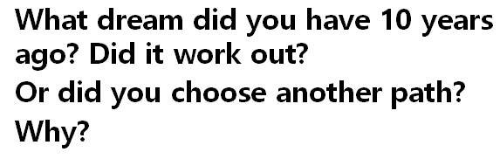
Instructor’s Comments and Assessment
Pros
Cons
Change
Overall Comments
Grade
Above Standard 85%-100% | Standard 70%-84% | Below Standard 69%-0%
Instructor | Student Signature | Date
Taute, David

