Background Information Sheet
Name | Class | Date | Lesson Type | Plan type | Length
Ha Young | TESOL 222WK | 6/26/2021 | Listening | PPP | 35 min
Lesson
Topic | A Princess From Mars
Main Aim | Students will practice their listening comprehension using an integrated listening model.
Secondary Aim | Students will practice their speaking fluency.
Materials and References
PPT; https://youtu.be/sD1UsOdLMKA (7:46 – 8:40); worksheet; P.C and audio equipment; board pen

Student Profile
Level | Intermediate
Age | Teens (age of 13-16) | Number of Students | 3
Detail | This is a general English class and students have just finished listening to the first part of the story. They enjoy short stories and look forward to the next episode. The class size is very small so the majority of interaction is intimate between the teacher and the rest of the students. Students are active in delivering their ideas openly in front of their classmates. They treat each other with respect and listen while other students are talking. Because of small number of students, the teacher can listen to individual student and monitor their comprehension level in detail.
Anticipated Classroom Management Difficulties and their Solutions
Technical problems
- audio : print out the transcript and read it aloud or use my smartphone to play the audio
- PPT : print out the pictures

My Personal Aim
What I aim to demonstrate is the ability to write out a complete, detailed lesson plan.

Stage Name: Lead-in
Purpose of this stage: To relax both the students and the teacher; to increase student talk through the sharing of experiences; to introduce the topic, or something topic-related.

Materials: -
Time | Interaction | Procedure
30 sec  2 min  30 sec | T  T-S  T | Organize seating arrangement in one big semi-circle. 3 students can easily see the board and each other.  Hello class!  Have you ever had help in your life? (Yes)  Think of the most memorable person who helped you in your life.  Who is it and what did that person do for you?  Let’s share some of our experience!  Gesture individual student to share one’s experience with the class.  Feedback after everyone is finished talking.

Stage Name: Presentation
Purpose of this stage: To offer any need help which students may need in order to comprehend the text more easily. This includes teaching key words using the C.C.C. technique, and asking a guiding question which will allow students the opportunity to think of and share ideas they are likely to encounter when listening. This encourages the use of their schema when comprehending a text.

Materials: board, board pen, PPT 1, picture printout
Time | Interaction | Procedure
1 min  1 min  1 min  30 sec  2 min  1 min | T-S  T-S  T-S  T  S-S  T-S | Pre-teach keywords: ①greet; ②ally; ③save  Elicit – Demonstrate ‘greet’ by saying “hello” to students. What did I just do? (greet)  CCQ – Do you greet people when you first see them? (Yes)  Do you greet people kindly or unkindly? (Kindly)  Is greeting like welcoming someone? (Yes)  Can you show me how you would greet people?  (SS demonstrate by waving hands or shaking hands with each other)  Drill – Listen and repeat 3 times together (Greet)  Individual drilling  Board – Write ‘greet’ on the right of the board.  What is the part of speech of ‘greet’? (Verb) Write (v) next to the word.  Elicit – On the board, draw an outline of Korean Peninsula and divide South/North Korea.  Continue asking students questions as I draw on the board.  What am I drawing? (Korean Peninsula)  What part of Korea is this? (South)  What part of Korea is this? (North)  What country is friendly with South Korea? USA or Russia? (USA)  What country is friendly with North Korea? USA or Russia? (Russia)  What is the relationship between South Korea and USA? (ally)  CCQ – Can countries be allies? (Yes)  Do allies help each other? (Yes)  Do allies share different purpose? (No)  Do countries have benefits by making allies? (Yes)  Are allies united by treaty or agreement? (Yes)  Drill – Listen and repeat 3 times together (Ally)  Let each student take turn to say the word. (Gesture)  Monitor for correct pronunciation.  Board – Write ‘ally’ on the right of the board.  What is the part of speech of ‘ally’? (Noun) Write (N) next to the word.  Elicit – Show and point to PPT1  What is Superman doing? (saving people)  CCQ – If you save someone, do you stop someone from getting hurt or killed? (yes)  Is saving someone’s life easy? (No)  Drill – Listen and repeat 3 times together (Save)  Individual drilling  Board – Write ‘save’ on the right of the board.  What is the part of speech of ‘save’? (Verb) Write (v) next to the word.  Guiding Question  How would you show your gratitude to someone who saved your life?  Students share their ideas with each other. Monitor  Feedback. Students present their ideas.  Draw out ideas that one acts friendly to people who saved his or her life.  Details may vary but one shows gratitude through warm words and kind gestures.

Stage Name: Practice - Literal Comprehension Listening
Purpose of this stage: For students to listen for the first time in order to get the facts. This may include the overall ideas or topic of the text; to notice who the speakers are; where they are; and perhaps why they are speaking. The responses are short, objective, and are only a surface understanding. This is an accuracy focused stage.

Materials: https://youtu.be/sD1UsOdLMKA (7:46 – 8:40), exercise worksheet, transcript
Time | Interaction | Procedure
1 min  1 min  1 min  1 min | T  S  S  T-S | Instructions. Set the purpose for listening before handing out worksheets.  Hold up the worksheet.  Now we will listen to the next part of the story from ‘a Princess of Mars’.  As you listen, you must answer 4 questions in exercise one.  Write down your answers. Don’t do exercise 2 yet.  I.C.Q. – Do you have to write down your answers? (Yes)  How many questions do you have to answer? (4)  Do we need to read or answer questions for exercise 2? (No)  Read each question aloud for the students. Hand out the worksheet.  Students listen for the 1st time, and write answers on the worksheet.  Group Check. Students compare answers with each other. Monitor.  Feedback to check accuracy.  Let’s go around and check the answers together.  Go around and ask students for answer, checking if others have the same or different answers.

Stage Name: Practice - Interpretive Comprehension Listening
Purpose of this stage: Students listen a second time, more carefully, to infer or interpret meaning of the literal facts. This is still an accuracy focused stage – answers need to be checked for accuracy. Students are required to think about the reason in order to support their answers. They may need to focus on things like the overall situation, tone of voice, multiple pieces of information, or a single statement to explain the unspoken, intended meaning.
Materials: https://youtu.be/sD1UsOdLMKA (7:46 – 8:40), exercise worksheet, transcript
Time | Interaction | Procedure
30 sec  3 min  2 min  1~2 min | T  S  S-S  T-S | Listen again. This time, answer exercise 2 only.  These questions are more difficult, but if you listen carefully, and think about what you know, you can find the answer.  Write down your answers as you listen.  You will have some time afterwards to think and write.  I.C.Q. – Do you need to rush to answer these questions? (No, we will have time afterwards to write.)  Read the questions aloud for the students.  Students listen for the 2nd time and write their answers.  Group Check. Students compare answers with each other. Monitor.  Feedback to check accuracy. Pick a student whose answer is closest to the sample answer.  If none of the students wrote down the acceptable answer, replay the audio a 3rd time.  If students have different answers, ask questions to draw out the answer.

Stage Name: Production - Applied Comprehension Speaking
Purpose of this stage: For students to practice their speaking fluency. Therefore this stage should be no less than 5 minutes to allow students to practice. Give them a few questions to help them communicate without intervention from the teacher. This is a fluency focused stage.

Materials: exercise worksheet
Time | Interaction | Procedure
1 min  8 min  1 min | T  S-S  T-S | Talk with your classmates about one of the two questions.  You should talk freely and remember to listen and ask questions to your partners.  Remember, everyone has to say something.  You have 8 minutes.  I.C.Q. – Do you need to write anything? (No)  Students discuss. Monitor.  Students present their ideas. Feedback.

Stage Name: Wrap-up
Purpose of this stage: To end the lesson on a positive note. This will give students a sense of accomplishment, encourage students to continue progressing, and realize how to improve in future. A teacher may also get valuable feedback from students regarding the activities used in the lesson.

Materials: -
Time | Interaction | Procedure
2 min  1 min | T-S  T | Lesson feedback. Ask the students what was interesting about today’s class. Also ask about the most challenging part of today’s lesson. After listening to students’ feedback, comment on what they did well and what they need to improve on.  Set homework. Predict the next part of the story, which is the ending. Draw your prediction on a piece of paper. Tomorrow, everyone will show their drawing and see if they guessed the ending correctly.  Inform students about the topic for the next lesson. Tomorrow we will read the final part of ‘a Princess of Mars.’  Dismissed.

PPT 1

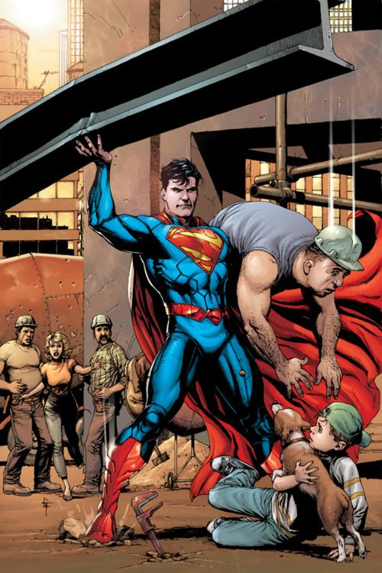

Transcript

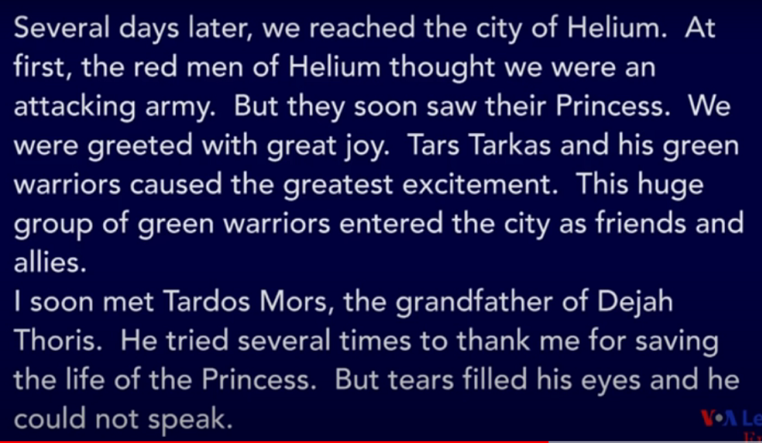

Worksheet - A Princess of Mars Part 4

Exercise One: Listen and write the answer next to the question.

Q1) Tars Tarkas and his green warriors were welcomed at first in the city of Helium. (True/False)

Q2) What made red men change their attitude towards Tars Tarkas and his green warriors?

Q3) Who is Tardos Mors?

Q4) Why did Tardos Mors cry?
- Tardos cried because he wanted to thank John Carter for saving the princess.
- Tardos cried because he was grieving for the dead princess

Exercise Two: Listen carefully, think, and write your answer.

Q1) Why did Tars Tarkas and his green warriors cause the greatest excitement among the people of Helium?

Q2) What do the tears of Tardos Mors imply about his relationship with the princess?

Exercise Three: Talk freely about the question below. (No writing)

Question 1)
Have you ever changed your attitude towards someone because of what he or she did to you? Explain in detail.

Question 2)
Would you live as:
- a superhero with power to save the lives of people
- a villain with freedom to do anything without thinking of others

Choose one and give specific reasons.

Answer Sheet - A Princess of Mars Part 4

Exercise One: Listen and write the answer next to the question.

Q1) Tars Tarkas and his green warriors were welcomed at first in the city of Helium. (True/False)

Q2) What made red men change their attitude towards Tars Tarkas and his green warriors?
-The princess

Q3) Who is Tardos Mors?
-He is the grandfather of the princess

Q4) Why did Tardos Mors cry?
- Tardos cried because he wanted to thank John Carter for saving the princess.
- Tardos cried because he was grieving for the dead princess

Exercise Two: Listen carefully, think, and write your answer.

Q1) Why did Tars Tarkas and his green warriors cause the greatest excitement among the people of Helium?
- Tarkas and his green warriors caused the greatest excitement because there was a change in their relationship. Green warriors were once an enemy of the red men. But they surprised the people of Helium by saving their princess. Their unexpected act of kindness suggests the beginning of the new friendship between green warriors and the red men.

Q2) What do the tears of Tardos Mors imply about his relationship between the princess?
- The tears of Tardos Mors show how deeply he cares about the princess. He cherishes the princess very much. When he found out that his granddaughter was alive, his eyes were filled with tears with gratitude and relief.

Exercise Three: Talk freely about the question below. (No writing)
Question 1)
Have you ever changed your attitude towards someone because of what he or she did to you? Explain in detail.

Question 2)
Would you live as:
- a superhero with power to save the lives of people
- a villain with freedom to do anything without thinking of others

Choose one and give specific reasons.
Instructor’s Comments and Assessment
Pros
Cons
Change
Overall Comments
Grade
Above Standard 85%-100% | Standard 70%-84% | Below Standard 69%-0%
Instructor | Student Signature | Date
Taute, David

