Background Information Sheet
Name | Class | Date | Lesson Type | Plan type | Length
Nicole Ha | 222WK | 10/07/2021 | Grammar | PPP | 25 min

Lesson
Topic | Guess who they are in a Halloween party!
Main Aim | Students will learn “must be/can’t be/could be”.
Secondary Aim | Students will practice their speaking fluency.

Materials and References
PPT, board pens, worksheets

Student Profile
Level |  | Lower Intermediate
Age |  | 9 years old |  | Number of Students | 3
Detail |  | This is a general English class in an international school, and the students are all 3 Koreans having high motivation. They can satisfy very routine social demands and understand simple learned phrases and some new simple phrases spoken slowly with frequent repetition.
Assumptions about students’ knowledge as required for this lesson:
- Students know the vocabulary used in this lesson
- Students have learned some formal grammar like past simple-sentences and verb+ing=adjective before a noun.
- Students have learned about the main parts of speech such as subject, verb, adjective, noun, and their relationship.
- Students can guess and catch the meaning of some new simple phrases containing familiar vocabulary.
What language difficulties to expect when presenting, and how to deal with it:
- Meaning: 1) They may not come to say the target language even though they understand their certainty level. I’ll have to just say it without trying and waiting too much. 2) When learning “could be” grammar, students may confuse it with the past format. They can understand its meaning after I elicit and convey its concept through CCQs.

- Form: At first, students would get confused with the exact difference of 3 target languages. They will understand their scale of certainty after CCQs.

- Pronunciation: Students may not know where to put natural sentence stress. Drill several times chorally and then individually check will help.

Anticipated Classroom Management Difficulties and their Solutions:
If the computer doesn’t work to show my PPT, I’ll hand out the hard copies to the students.
If the desks are not arranged suitably for 3 students’ discussion together, horseshoe typed desk arrangement before the class; Since the number of students is odd and small, I’ll have all 3 students talk to and debate with one another (all together).
My Personal Aim
What I focus on is the time management by making a detailed time plan and the comprehensive inputs by using as easy and familiar words and expressions as possible.

Stage Name: Lead-in
Purpose of this stage: To relax both the teacher and students. To focus attention on the lesson. Create a situation for students to experience or think about, and then to elicit the target language.
Materials: PPT
Timings | Interactions |  | Procedure
3 min | T-S |  | Good morning! How are you? (I’m fine, thank you and you?)  I’m ok too. Are you ready for today class? Tone up with big gesture. (Yeah~~~)  Eye contact to draw attention  Do you know Halloween party? (Yeah), Ok, great, then, now you are at a Halloween party. You meet this girl. Can you guess who she is? (she must be Snow White princess/she is Snow White princess). Great! / Are you sure? Isn’t she a sleeping princess? (No, I think she is Snow White princess.) Then you can say “it must be the Snow White princess, because you are almost sure. Now, you see this girl. Who do you think she is? (Hmm… I don’t know, is she an Elf or a bird? / She could be an Elf or a bird.) Great, in this case, you can say “She could be an Elf or a bird. / Bingo! Next, look at this girl. What do you think? (No, she can’t be Elsa / No, she is not Elsa.) Bingo! / Are you sure, then who is she? (Yes, I’m sure, but I don’t know who she is.) Then you can say “She can’t be Elsa” because you are almost sure.
Stage Name: Presentation
Purpose of this stage: Make the students think about the situation. To clarify the meaning, form, and pronunciation features of the target language.
Materials: Board pens
Timings | Interactions |  | Procedure
1.5 min  4 min  1.5 min | T-S  T-S  T-S |  | Write down the model sentences (She must be a Snow White princess/She could be a bird/She can’t be Elsa).  CCQs;  - Do you use them when you are 100% sure? (No)  - Are we talking about the past? (no, now)  - When you are almost sure it is not something, how can you say? (can’t be)  - When you are not sure or when you don’t know about something, what do you use? (could be)  - You are almost sure about something, then how can you say? (must be)  Form  We are talking about the guess. Look at these sentences. What words tell you this is about the guess? (must, can’t, could).  Right. What is the subject? (She) Write down “subj” above “she”.  What comes after the subject? (verb) Write down “verb” above “must, could, can’t”.  Great, then do you think these words are verb? (yes)  How about this case? (There are 2 verbs.)  Right! These words, we call them “modal verbs”, write down “Modal” on the board. These modal verbs always come with another verb, but a verb in the base form. Strange but interesting, isn’t it? (Yes) That is why you are here to learn!  Then what comes after the “be” verb? (noun) Write it down above “Snow/bird/Elsa”.  Can you find another strange thing here? (no “s” after must and could)  You are right! We don’t say “musts” or “coulds”. (Why?) Well, this is the rule.  Ok, good job! Let’s find more words in this table. (you, they, it, busy) If they don’t say “busy”, I’ll ask “any word adjective?” (busy)  Subject Modal verb + b.f of a verb Noun/Adj  She must be could be can’t be a Snow White princess  You a bird  They Elsa  It busy  Drill  Now, listen; Hold it and say each model sentence.  Where is the stress here? (must, could, can’t) Mark the stress with a red pen.  Is the sound going up? Or down? (down) Draw an arrow to down.  Now, don’t look at the board and listen one more time and repeat 3 times. Say the first model sentence and conduct the drill together 3 times with gestures and check individual drilling.  Then, say the second model sentence, conduct the drill together 3 times with gestures, and check individual drilling.  Last one is said, and conduct the drill together 3 times with gestures, and check individual drilling.
Stage Name: Controlled Practice
Purpose of this stage: students practice working with the form (scrambled sentences, split sentences, select the correct form of the verb, correct incorrect sentences, and change one form into another form). Accuracy must be checked.
Materials: Worksheet-Exercise A
Timings | Interactions |  | Procedure
20 sec  2 min  40 sec  30 sec | T  S  T  S – S  T - S |  | Instructions.  Hold up the worksheet, point to Exercise A.  Worksheet A says to choose a right answer and write it down to fill in the blank.  ICQ.  How many answers you choose? (one)  Do you write it down? (yes)  Hand out.  Students do the worksheet exercise A.  Ok, guys, check your answers with your classmates, and take turn.  Students check their answer together.  Feedback to check accuracy.
Stage Name: Less Controlled Practice
Purpose of this stage: students practice working with the meaning (match a timelines to sentences, choose the sentence that matches a picture, gap-fill a paragraph). Accuracy must be checked.
Materials: Worksheet-Exercise B
Timings | Interactions |  | Procedure
20 sec  2.5 min  1 min  1 min | T  S  T  S – S  T - S |  | Instructions.  Turn over your worksheet. Exercise B says to talk about the picture and make a sentence with the words in the next of the picture.  ICQ.  How many sentences do you make? (one)  Do you have to use the words next to the picture? (yes)  Students do the worksheet B.  Ok, guys, check your answers with your classmates.  Students check their answer together.  Feedback to check accuracy.
Stage Name: Production – Freer Practice
Purpose of this stage: is to get students to practice the grammar communicatively.
Materials: N/A
Timings | Interactions |  | Procedure
20 sec  5 min | T  S-S  T |  | Instructions.  Do you like Everland? How do you choose rides? And why?  Talk to your classmates. You also listen to the others and ask questions. You have 5 minutes.  [Back-up question]  Do you like a place with lots of game machines? How do you choose game machines to play with?  ICQ.  How long do you talk? (5 minutes)  Does only one person talk? (No)  Students do a productive task which requires natural communication.  Write down some mistakes and errors on the board.
Stage Name: Wrap-up
Purpose of this stage: is to end the lesson on a positive note so that students feel they have achieved progress.
Materials: Board pens
Timings | Interactions |  | Procedure
1 min  10 sec  10 sec | T – S  T  T |  | Offer delayed corrections to the previous stage.  Look at the board. Here are some sentences I heard. Tell me how to correct them.  Set homework.  You’ll make a short dialogue between A and B with the words that you learned today.  One short story per each (must be/could be/can’t be)  Inform students about the topic for the next lesson.  Next week, you will learn about your wish.

Worksheet

Exercise A:
Please choose a right answer and write it down to fill in the blank.

Answer: must be, can’t be, could be

- You passed the exam! You ___________ happy.
- Look at this turtle. It ______ fast.
- He has a big house. He _____ poor.
- He lives in France. He _______ French.
- Tom is with a little girl. Tom _______ her father.
- It is dark outside, and I see an animal. It _______ a dog or a cat.
- This stone is very big. It ______ heavy.
- Helen is absent today. She ________ be at home.
- I see a ghost. It _________ true.

Worksheet B

Exercise B:
Look at the pictures. Talk about the picture and make a sentence with the words in the next of the picture and the words that you learned today.

Example)
crying, hungry

Best Answer: This crying baby must be hungry.

Question# 1.
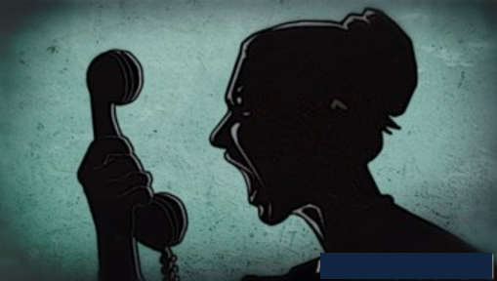 yelling, angry

Best Answer: _____________________________________________

Question# 2.
thinking, angry

Best Answer: ______________________________________________

Question# 3.
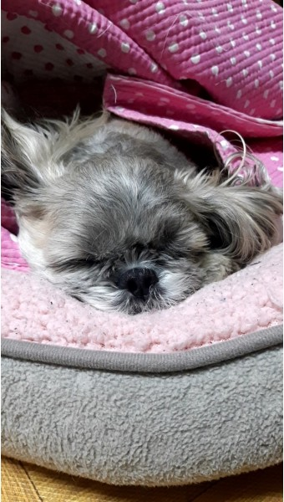 sleeping, monster

Best Answer: _____________________________________________
Question# 4.
dog, wolf, cat

Best Answer: ________________________________________________

Question# 5.
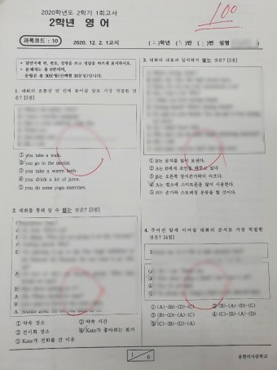 get(verb), proud

Best Answer: ____________________________________________
Answer sheet

Exercise A:
Please choose a right answer and write it down to fill in the blank

Answer: must be, can’t be, could be

- You passed the exam! You ___________ happy. (must be)
- Look at this turtle. It ______ fast. (can’t be)
- He has a big house. He _____ poor. (can’t be)
- He lives in France. He _______ French. (must be)
- Tom is with a little girl. Tom _______ her father. (could be)
- It is dark outside, and I see an animal. It _______ a dog or a cat. (could be)
- This stone is very big. It ______ heavy. (must be)
- Helen is absent today. She ________ be at home. (could be)
- I see a ghost. It _________ true. (can’t be)

Answer sheet

Exercise B:
Look at the pictures. Talk about the picture and make a sentence with the words in the next of the picture.

Example)
crying, hungry

Best Answer: This crying baby must be hungry.

Question# 1.
yelling, angry
Best Answer: This yelling woman must be angry.

Question# 2.
thinking, angry
Best Answer: This thinking cat can’t be angry.

Question# 3.
sleeping, monster
Best Answer: This sleeping dog can’t be a monster.

Question# 4.
dog, wolf, cat
Best Answer: This animal/it could be a dog or a wolf, but it can’t be a cat.

Question# 5.
get(verb), proud

Best Answer: I got 100 and my parents must be proud.

Instructor’s Comments and Assessment
Pros
Cons
Change
Overall Comments
Grade
Above Standard 85%-100% | Standard 70%-84% | Below Standard 69%-0%
Instructor | Student Signature | Date
Taute, David

