Background Information Sheet
Name | Class | Date | Lesson Type | Plan type | Length
Jihyeon Im | 223th WD | 04 / 08 / 2021 | Grammar | PPP | 25 min

Lesson
Topic | Zero Conditional
Main Aim | Students will learn the ‘zero conditional’
Secondary Aim | Students will practice their speaking fluency

Materials and References
Board; Board pens; Worksheets; Pens; PPT; Computer with a screen

Student Profile
Level |  | Lower Intermediate
Age |  | Adults |  | Number of Students | 3
Detail |  | Students can make simple sentences, but still need to understand a lot more vocabulary. However, since it is made up of adults, they will be able to understand the class comparatively easily.
Assumptions about students’ knowledge as required for this lesson
Students can make simple sentences, but don’t know well how to make the ‘if’ conditional sentences.
What language difficulties to expect when presenting, and how to deal with it
- Meaning: Students may only understand the concept of ‘condition’ and ‘result’ in the conditional sentence
- Give a clear explanation about the concept of ‘zero conditional’ and make C.C.Q
- Form: Students may confuse how to use the if-clause
- Mainly explain using ‘when-clause’ instead and also try to help students understand ‘if-clause’
- Pronunciation: Students may not know where to put natural sentence stress
- Drill for pronunciation practice and board to highlight the stress
Anticipated Classroom Management Difficulties and their Solutions:
- Some students may take longer time to understand how to do a lesson activity
Give a clear instruction and try to make sure if everyone understands it or not
- Not all students can hear the teacher’s voice clearly or see the board well Rearrange seats
- Computer/Screen malfunction Use the printed paper
My Personal Aim
What I aim to demonstrate is the ability to write out a complete, practical lesson plan.
Stage Name: Lead-in
Purpose of this stage:
- To make students talk themselves more freely and improve the confidence to interact with a teacher and other students
- To introduce the topic
Materials: Board; Board pens
Timings | Interactions |  | Procedure
2 min | T-S |  | Organize seating arrangements so everyone can see the board well.  Mime or draw a picture on the board, which elicit the language using the ‘zero conditional’ rule.  Hello everyone! Tell a sentence after watching what I am doing.  (when you push the cup, the cup falls)  Draw a picture on the board, which shows ice is melting under the sun.  (when ice is under the sun, it melts)

Stage Name: Presentation
Purpose of this stage:
- To present the language in a meaningful context
- To help students know some relevant vocabularies and/or grammar
Materials: Board; Board pens
Timings | Interactions | Procedure
20 sec  30 sec  4 min  1 min | T  T-S  T-S  T-S | Board the model sentence. (when ice is under the sun, it melts)  CCQ  - Is it talking about a situation which is always true? ------- (Yes)  - Is it possible ice does not melt under the sun? --------------(No)  Form – clarify the affirmative, negative, question. Substitution tables may be of use.  - Identify sentence / clause structure  “Zero conditional sentence is basically structured like this.  'when or if' plus condition should come first. then, result comes after”  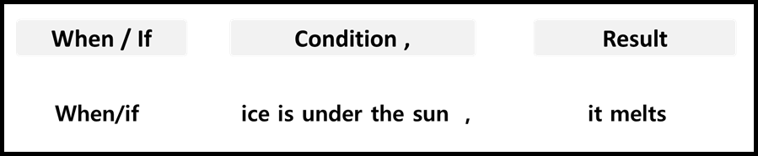  - Highlight the grammar structure  “Condition and result should be ‘present simple’ form”  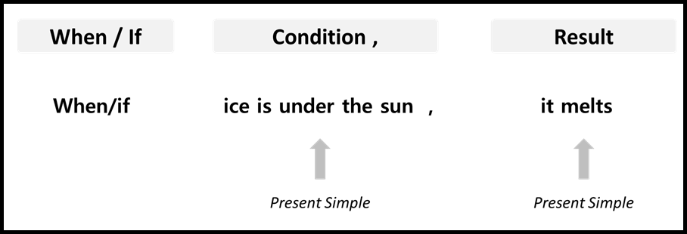  - Make other example sentences  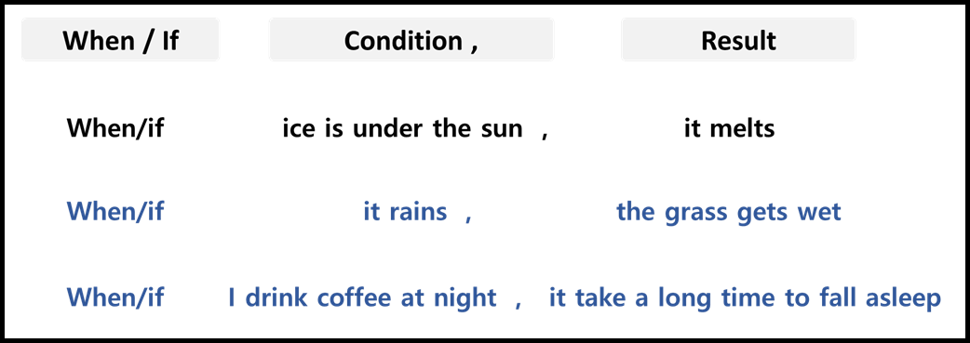  - Make other forms of sentences – negative, question  “You can put ‘not’ after verb for the negative form. And, to make a question form, do/does should come first. Result comes after. When/if-clause comes after the result”  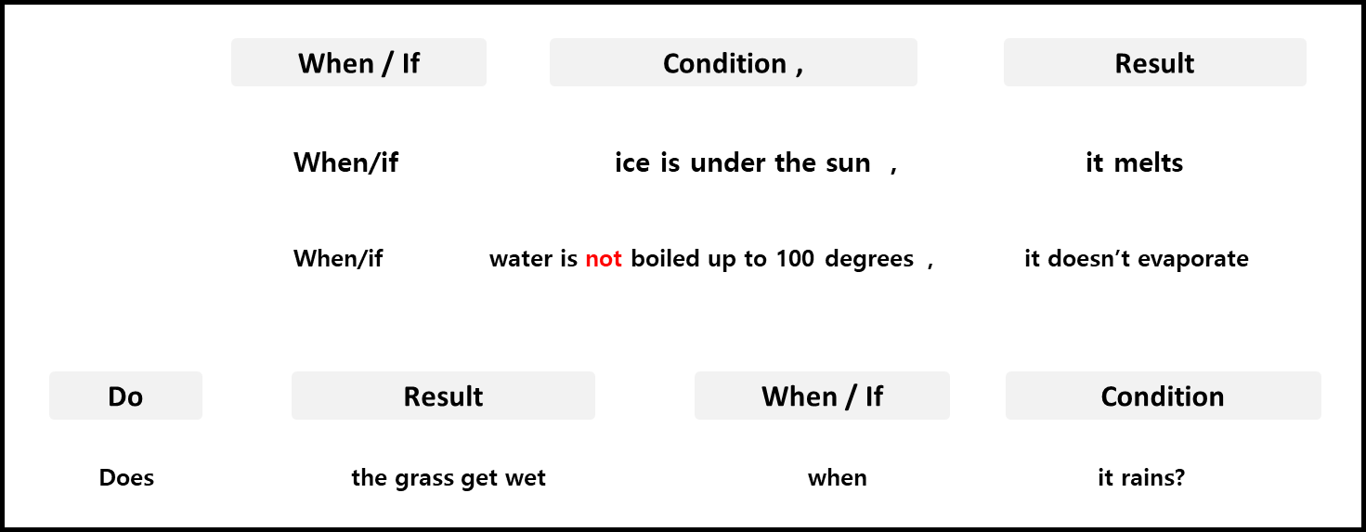  Drill – drill the spoken form, focusing on contractions, stress and intonation.  - Say and gesture  “Listen and repeat five times. when ice is under the sun, it melts”  - Drill using natural intonation and stress  - Make special pronunciation features visible on the board, using colour.  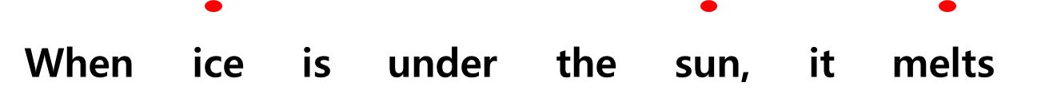

Stage Name: Controlled Practice
Purpose of this stage:
- To make sure students understand correctly about the form
Materials: Worksheets; Pens
Timings | Interactions | Procedure
30 sec  2 min  1 min | T  S  T-S | Give a clear instruction. Hand out worksheet A.  Now, we are going to do worksheet ‘A’  You need to answer for the worksheet ‘A’  Worksheet ‘A’ only! You have two minutes to answer for it.  I.C.Q. – which worksheet should we answer? ----------- (worksheet A)  Students answer for the worksheet A.  Students take turns telling the answers.  Teacher corrects any wrong answer. Feedback if necessary.

Stage Name: Less Controlled Practice
Purpose of this stage:
- To make sure students understand correctly about the meaning
Materials: Worksheets; Pens
Timings | Interactions | Procedure
30 sec  3 min  2 min | T  S  T-S | Give a clear instruction. Hand out worksheet B.  This time, you need to answer for the worksheet ‘B’  I will give you few minutes to answer.  I.C.Q. – Which worksheet should we answer this time? - (Worksheet B)  Students answer for the worksheet B.  Students take turns telling the answers.  Teacher corrects any wrong answer. Feedback if necessary.

Stage Name: Production – Freer Practice
Purpose of this stage:
- To help students use the grammar fluently as possible
Materials: PPT
Timings | Interactions | Procedure
1 min  5 min  1 min | T  S-S  T-S | Give a clear instruction. Hand out worksheet C.  Look at the screen. Now, you need to describe the pictures using zero conditional.  Here are three of you. when person A say ‘if ice is under the sun”, person B will say “it melts”. Then, person B continue to talk to person C “if we eat unhealthy food”. And, person C answer for it. These processes will be repeated for some minutes. Let’s start from Student A.  Students do the activity together. Teacher monitor in a distance.  Feedback if necessary.

Stage Name: Wrap-up
Purpose of this stage:
- To help students reconsider what they have learned
Materials: -
Timings | Interactions | Procedure
1 min  10 sec | T – S  T | Tell the students what they did. If necessary, offer delayed corrections to the previous stage.  Set homework.
Instructor’s Comments and Assessment
Pros
Cons
Change
Overall Comments
Grade
Above Standard 85%-100% | Standard 70%-84% | Below Standard 69%-0%
Instructor | Student Signature | Date
Taute, David
Worksheet A
Q1. Put ‘when/if’ in a right place.
  - _______ people eat too much, ______ they get fat
  - ______ you mix hydrogen and oxygen, _______ you get water

Q2. Read the sentences and choose the correct form
  - If it ______ cold, I put on a coat
(1) was (2) will (3) is
  - If you _____ your homework, your teacher gets very angry
(1) will not do (2) don’t do (3) did

Q3. Change the sentence into the question form
  - If there is no air, wood doesn't burn
_____________________________________________________________

Worksheet B
Q1. Fill in the blanks
  - When I have long hair, ____________________________________
  - If it rains, ______________________________________
  - If we drink too much, _______________________________

Q2. Write answers for the questions using the zero conditional
  - What happens if you eat unhealthy food?
________________________________________________________________

  - what happens if you don't charge your phone?
____________________________________________________________

Pictures in PPT

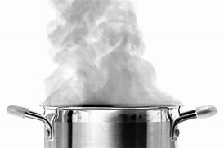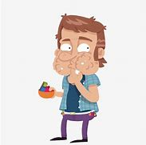

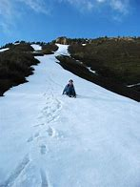

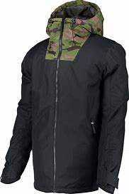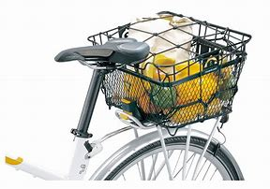

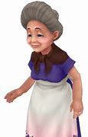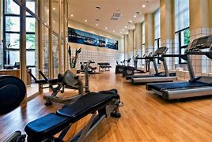

Answer Sheet A
Q1. Put ‘when/if’ in a right place.
  - When/if people eat too much, ______ they get fat
  - When/if you mix hydrogen and oxygen, _______ you get water

Q2. Read the sentences and choose the correct form
  - If it ______ cold, I put on a coat
(1) was (2) will (3) is

  - If you _____ your homework, your teacher gets very angry
(1) will not do (2) don’t do (3) did

Q3. Change the sentence into the question form
  - If there is no air, wood doesn't burn
Doesn’t wood burn if there is no air?

Answer Sheet B
Q1. Fill in the blanks
  - When I have long hair, you can tie it up
  - If it rains, the grass gets wet
  - If we drink too much, you get drunk

Q2. Write answers for the questions using the zero conditional
  - What happens if you eat unhealthy food?
If you eat unhealthy food, you get sick

  - what happens if you don't charge your phone?
If you don't charge your phone, your phone turns off

