Background Information Sheet
Name | Class | Date | Lesson Type | Plan type | Length
Ericka | 225WD | Oct. 06, 2021 | Listening | PPP | 35 min
Lesson
Topic | Meeting an old friend
Main Aim | Students will practice their listening comprehension using an integrated listening model.
Secondary Aim | Students will practice their speaking fluency.
Materials and References
https://learnenglish.britishcouncil.org/skills/listening/intermediate-b1/meeting-an-old-friend; worksheet; board; board pens; P.C. and audio equipment
Student Profile
Level | Intermediate
Age | Adult | Number of Students | 10
Detail | This is an evening English class and students join the class after work. The Students were just promoted to intermediate level from last month. They are all passionate to learn English and used to pair work. They mostly like kinesthetic & visual learning, but weak on auditory learning. They need more practice focused on listening skills.
Anticipated Classroom Management Difficulties and their Solutions
The audio equipment could fail → prepare the transcript or bring a set of portable speakers to use with my smartphone; print an A4 size picture of my PPT.
Nervousness at the start of the lesson → check the equipment is working; to start the lesson, sit down and follow the planned teacher talk.

My Personal Aim
What I aim to demonstrate is the ability to write out a complete detailed lesson plan.

Stage Name: Lead-in
Purpose of this stage: To relax both the students and the teacher; to increase student talk through the sharing of ideas or experiences; to introduce the topic; or something topic-related.

Materials: n/a
Time | Interaction | Procedure
30 sec  1 min  1 min | T  S-S  T-S | Organize seating arrangements so everyone has a partner, with one group of 2 sitting together, and all can easily see the board and the screen.  Hello everyone, what do you like to do with your friends? Talk to your partner. You have 1 minute.  Gesture for students to begin talking to their partners.  Students talk to their partners. Monitor.  Feedback. Gesture to a group and ask “Tell me about your ideas.” Ask all groups.

Stage Name: Presentation
Purpose of this stage: To offer any needed help which students may need in order to comprehend the text more easily. This includes teaching from 1 to 4 keywords using C.C.C technique, and asking a guiding question which will allow students the opportunity to think of and share ideas they are likely to encounter when listening. This encourages the use of their schema when comprehending a text.

Materials: Picture 1-3, board, board pen
Time | Interaction | Procedure
1 min  1 min  1 min  10 sec  1 min  1 min | T-S  T-S  T-S  T  S-S  T-S | Pre-teach keywords: flat; predictable; swap  Elicit – Point to picture 1. What is it? (An apartment) Any other word? (A flat)  CCQ – Is this a building? (Yes)  Is this a room or a group of related rooms designed for living? (Yes)  Does this building have only 1 floor? (No)  Drill – Everyone together, please listen and repeat 3 times. A flat. (Gesture)  Nominate 3 or 4 individually to check their pronunciation.  Board – Write flat in the middle of the board.  What type of word? (noun) Write with a red pen.  Elicit – Point to picture 2. Please look at the picture above. Now look at the picture below. What kind of bowl will Taco have? (little) How did you know this? (We can guess from the picture above.) What is the adjective which describes this situation? (predictable)  CCQ – Is this something expected? (Yes)  Is this something you cannot think of? (No)  If something is predictable, can you be prepared? (Yes)  If something is predictable, is this based on previous behavior or information? (Yes)  Drill – Everyone together, please listen and repeat 3 times. Predictable. (Gesture)  Nominate 3 or 4 individually to check their pronunciation.  Board – Write predictable in the middle of the board.  How many syllables? (4) Mark with a blue pen.  Where is the stress? (2nd) Mark with a green pen.  What type of word? (adjective) Write with a red pen.  Elicit – Point to picture 3. What is happening? (Exchange) Any other word? (…..) It’s called swap.  CCQ – Is this to exchange one thing for another? (Yes)  If you swap something, do you get something new or different? (Yes)  Can you swap something without agreement? (No)  Drill – Everyone together, please listen and repeat 3 times. Swap. (Gesture)  Nominate 3 or 4 individually to check their pronunciation.  Board – Write swap in the middle of the board.  What type of word? (verb) Write with a red pen.  Guiding Question  If you meet an old friend, what will you ask? Talk to your partners.  Students discuss the question with a partner.  Feedback. Nominate a few students to share their ideas. Write down the ideas on the board and let the students have a quick look at the board.

Stage Name: Practice - Literal Comprehension Listening
Purpose of this stage: For students to listen for the first time in order to get the facts. This may include the overall idea or topic of the text; to notice who the speakers are; where they are; and perhaps why they are speaking. The responses are short, objective, and are only a surface understanding. This is an accuracy focused stage.

Materials: Worksheet, audio equipment
Time | Interaction | Procedure
1 min  2 min 10 sec  1 min  1 min | T  S  S-S  T-S | Instructions. Set the purpose for listening. Hand out worksheets.  Hold up the worksheet.  Now it’s time to listen to the audio.  As you listen, you must answer these questions in exercise 1 only.  When you catch the answer, write it down next to the question.  Don’t do exercise 2.  I.C.Q – Do you need to write your answers? (Yes)  Do we need to answer questions in exercise 2? (No)  Do you have a pen or pencil ready? (Yes)  Read each question aloud for the students. Hand out the worksheet.  Students listen for the 1st time, and write answers on the worksheet.  Now, listen to the audio.  Pair check. Monitor.  Compare your answers with your partner.  Feedback to check accuracy.  Ask students for answer, checking if others have the same or different answers. Does anyone else have a different answer? Who agrees with this answer? How did you know whether Selina worked in London or not?

Stage Name: Practice - Interpretive Comprehension Listening
Purpose of this stage: Students listen a second time, more carefully, to infer or interpret meaning of the literal facts. This is still an accuracy focused stage – answers need to be checked for accuracy. Students are required to think about the why in order to support their answers. They may need to focus on things like the overall situation, tone of voice, multiple pieces of information, or a single statement to explain the unspoken, intended meaning.

Materials: Worksheet, audio equipment
Time | Interaction | Procedure
1 min  4 min 10 sec  1 min  2 min | T  S  S-S  T-S | Instructions. Set the purpose for listening. Hand out worksheets.  Listen again. This time, answer exercise 2.  These questions are more difficult, but if you listen carefully and think about what you know, you can find the answers.  Write your answers next to the questions.  I will give you time afterwards to think and write.  I.C.Q – Do you need to rush to answer these questions? (No, we will have time afterwards to write)  Read the questions aloud for the students.  Students listen for the 2nd time, and write their answers.  Now, listen again to the audio.  Pair check. Monitor. If students need, then replay the audio a 3rd time.  Compare your answers with your partner.  Feedback to check accuracy.  Ask students for answer, checking if others have the same or different answers. Ask students to explain their reason.

Stage Name: Production - Applied Comprehension Speaking
Purpose of this stage: For students to practice their speaking fluency. Therefore this stage should be no less than 5 minutes to allow students to practice. Give them a few questions to help them communicate without intervention form the teacher. This is a fluency focused stage.

Materials: Worksheet
Time | Interaction | Procedure
1 min  10 min  1 min | T  S-S  T-S | Instructions. Give students a question to discuss in pairs or groups.  Change partners. Wait for students to move.  Now, turn over your worksheet.  Talk to your partner about any of these questions.  You should talk freely, and remember to listen and ask questions to your partner.  You have 10 minutes.  I.C.Q – Do you need to write anything? (No)  Students discuss.  Monitor from a distance.  Feedback. Students share their ideas with the whole class.

Stage Name: Wrap-up
Purpose of this stage: To end the lesson on a positive note. This will give students a sense of accomplishment, encourage students to continue progressing, and realize how to improve in future. A teacher may also get valuable feedback from students regarding the activities used in the lesson.

Materials: n/a
Time | Interaction | Procedure
2 min | T | Lesson feedback. Tell the class what they did well, and what needs to improve.  Offer delayed corrections to the previous stage.  Set homework if any.  Check student’s feedback.  Did you like today’s lesson? Was it easy or difficult? Should we do it again next time?  Inform students about the topic for the next lesson.  Tomorrow we will do a speaking lesson about agreeing and disagreeing.  Dismissed.

Picture 1

Picture 2

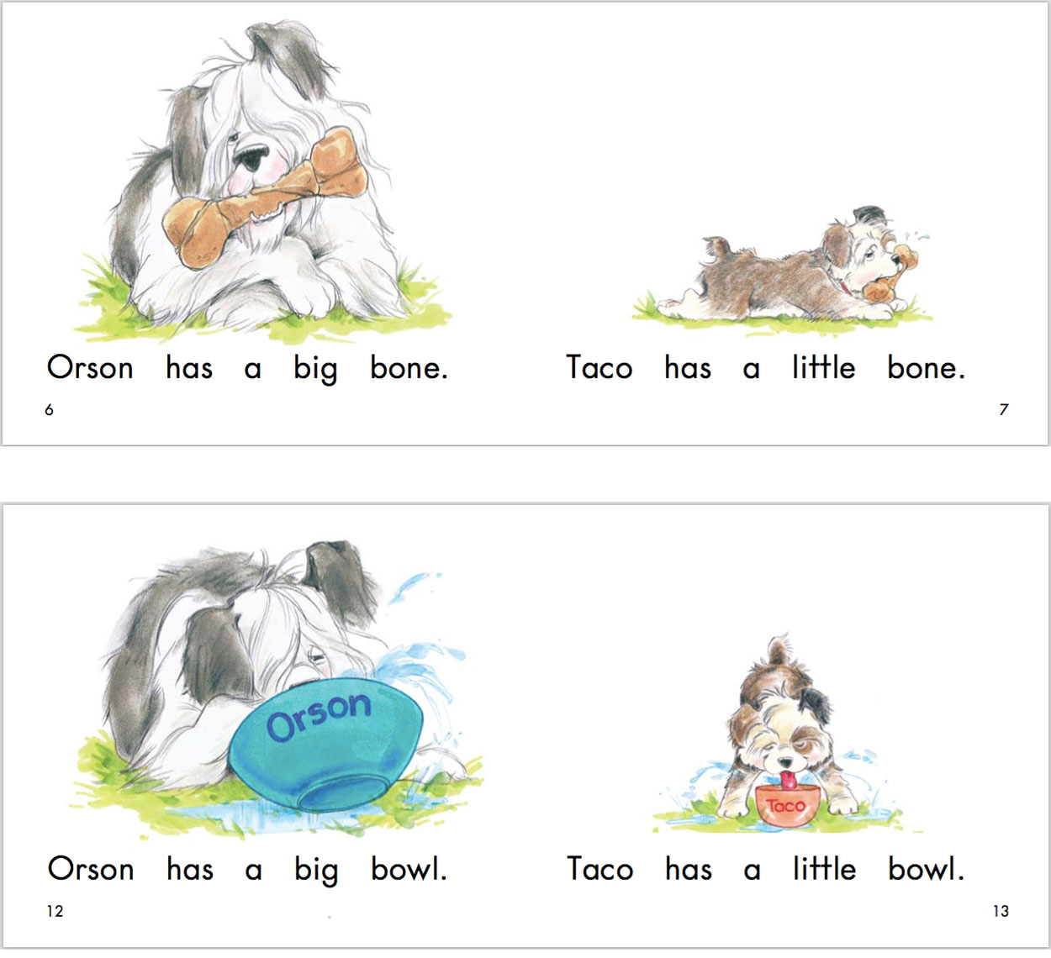

Picture 3

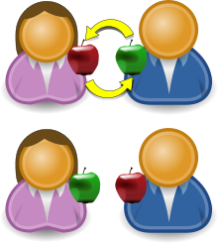

Transcript
Time: 2min 05seconds

Selina: Patrick? Is that you?
Patrick: Selina! Hello!
Selina: Well, well. Patrick Eastwood. How have you been?
Patrick: Good. Great, actually. How are you? I haven't seen you for ... how long?
Selina: It's been ages. At least fifteen years. Wow.
Patrick: Yeah. Wow.
Patrick and Selina: So, what are you doing here?
Selina: Sorry, you go first.
Patrick: OK. What are you doing here? I thought you'd moved to London.
Selina: I was in London for a couple of years. But it didn't work out.
Patrick: Oh, I'm sorry to hear that. Are you ... OK?
Selina: I'm fine! The dream job wasn't really a dream, you know? Um ... and London is great but it's so expensive. I mean, just the rent on a flat is ... uh … crazy expensive.
Patrick: I see.
Selina: So, I came back. I've been back now for almost five months. Living back home with Mum and Dad. Which is err ... interesting. Um ... but anyway, what about you?
Patrick: Me? Oh, nothing new. You know me – 'Patrick the predictable'. I never left here.
Selina: Oh. And is that ...?
Patrick: Oh, I'm very happy. I'm married now. We've just celebrated our tenth anniversary.
Selina: No way! You? Married? To …?
Patrick: I don't think you know her. Her name's Marigold. And we've got two kids. They're five and eight years old.
Selina: Married and with two kids? Wow!
Patrick: Don't look so surprised!
Selina: No, no … I'm just amazed how time flies! I'm happy for you. I really am.
Patrick: Thanks. You should really come round to the house one day.
Selina: That would be great. Let's swap numbers and ...

Worksheet – Meeting an old friend

Exercise 1: Listen and write the answer next to the question.
- How long did they not see?
- Did Selina work in London?
- What is expensive in London?
- Is Patrick married?

Exercise 2: Listen carefully, think, and write your answer.
- What kind of person do you think Patrick is referring to the statement ‘Patrick the predictable’?

- Why did they swap numbers?

Exercise 3: Talk to your partner freely about any of the questions below. No writing!
- Would you like to work abroad?

- Until when do you want to live with your parents?

Answer sheet – Meeting an old friend

Exercise 1:
- How long did they not see? At least 15 years.
- Did Selina work in London? Yes.
- What is expensive in London? Rent on a flat.
- Is Patrick married? Yes.

Exercise 2
- What kind of person do you think Patrick is referring to the statement ‘Patrick the predictable’?
Patrick doesn’t like to take risks when doing things. So he didn’t move to any other place for new things, and just stayed in the same place for years.

- Why did they swap numbers?
Patrick suggested to invite Selina to his house someday. So they need numbers to get in contact and check their schedule to meet again.

Instructor’s Comments and Assessment
Pros
Cons
Change
Overall Comments
Grade
Above Standard 85%-100% | Standard 70%-84% | Below Standard 69%-0%
Instructor | Student Signature | Date
Taute, David

