Background Information Sheet
Name | Class | Date | Lesson Type | Plan type | Length
Ericka | 225WD | Oct. 27, 2021 | Reading | PPP | 30 min

Lesson
Topic | Christmas
Main Aim | Students will practice their reading comprehension.
Secondary Aim | Students will practice their speaking fluency.

Materials and References
https://learnenglish.britishcouncil.org/general-english/magazine-zone/christmas; PPT; worksheet; board; board pens

Student Profile
Level | Upper Intermediate
Age | Adult | Number of Students | 1
Detail | The student is a Chinese-Korean student who is trilingual in Mandarin, Korean and English. She has a cheerful personality with lots of imagination and energy. She speaks English fluently, but only had a few reading lessons. She needs to practice her reading skills.

Anticipated Difficulties and their Solutions:
The student is not used to skimming and scanning clear instructions to be given at stage 3

Nervousness at the start of the lesson check your materials; to start the lesson, follow the planned teacher talk.

My Personal Aim
What I hope most to demonstrate in this lesson is the ability to lessen my nervousness during the lesson.

Stage Name: Lead-in
Purpose of this stage: To relax both the teacher and students. To focus attention on the lesson. To lead in to the topic, activating background knowledge – this will help to contextualize the text. This is a BEFORE READINING stage.

Materials: Picture 1
Timing | Interaction | Procedure
20 sec  2 min | T  T-S | Organize seating arrangement so that the student can easily see the board and the screen.  Good morning!  Show picture 1 in PPT. Please look at the picture.  When can you see these? (On Christmas)  Can you tell me how people decorate their house and Christmas tree?  How about you? Do you decorate your house or office?  Student talks to the teacher.

Stage Name: Presentation
Purpose of this stage: To pre-teach keywords if necessary, and answer a guiding questions (such as a predicting task, or a specific question). These steps provide extra help for students to comprehend the text. This is a BEFORE READINING stage.

Materials: Picture 2-3, board, board pens
Timing | Interaction | Procedure
1 min  1 min  30 sec  1 min  30 sec  10 sec  2 min | T-S  T-S  T-S  T  T-S | Pre-teach keywords: fairy lights, nativity, frantic  Elicit – Point to the lights in picture 2. Do you know what these are? (Lights) What kind of lights? (Colored lights??) It’s called fairy lights.  CCQ – Are these small colored electric bulbs strung together? (Yes)  Are these used to decorate the house or Christmas tree? (Yes)  Drill – Please listen and repeat 3 times. Fairy lights (Gesture)  Check student’s pronunciation.  Board – Write fairy lights in the middle of the board.  What type of word? (noun) Write with a red pen.  Elicit – Point to the baby in picture 3. Do you know who the baby is? (He is Jesus Christ.) Do you know what this kind of picture is called? (…..) It’s called nativity.  CCQ – Is this a picture of the baby Jesus Christ and the place where he was born? (Yes)  Can you see these pictures in the park? (No)  Can you see these pictures at church? (Yes)  Drill – Please listen and repeat 5 times. A nativity (Gesture)  Check student’s pronunciation.  Board – Write nativity in the middle of the board.  How many syllables? (4) Mark with a blue pen.  Where is the stress? (2nd) Mark with a green pen.  What type of word? (noun) Write with a red pen.  Elicit – Teacher says “I think I lost my keys” and is looking everywhere to find a key. How am I searching for the keys? (Searching in a hurry?) How do we describe this kind of search? (….) It’s called a frantic search.  CCQ – Is this very busy or done in a hurry? (Yes)  Is this done in a way very well organized? (No.)  Are frantic attempts required to rescue people from accidents? (Yes)  Drill – Please listen and repeat 5 times. Frantic (Gesture)  Check student’s pronunciation.  Board – Write frantic in the middle of the board.  How many syllables? (2) Mark with a blue pen.  Where is the stress? (1st) Mark with a green pen.  What type of word? (adj.) Write with a red pen.  Guiding Question  When is the peak season for retailers in Korea? How about China?  Why? What do you buy?  Student talks to the teacher.

Stage Name: Practice – Literal Comprehension
Purpose of this stage: is to get students to practice reading for literal detail. They will also practice fast reading (skimming and scanning). This is a WHILE READINING stage.

Materials: Worksheet
Timing | Interaction | Procedure
1 min  2 min  1 min | T  S  T-S | Instructions. Set the purpose for reading. Hand out worksheets & reading material.  Hold up the worksheet.  Read the questions first and underline your answers in the text.  You must answer the questions in exercise A only.  Don’t do exercise B.  I.C.Q – What should you do when you find the answers? (Underline the text)  Do you need to answer questions in exercise B? (No)  Do you have a pen or pencil ready? (Yes)  Hand out the worksheet & reading material.  Student reads the whole text for the 1st time, and underline answers in the text.  Feedback to check accuracy.  Ask the student for answers.

Stage Name: Practice – Interpretive Comprehension
Purpose of this stage: is to get students to get students to practice interpreting a text correctly This will require more detailed, careful reading, and thinking time to arrive at the correct answer. This is a WHILE READINING stage.

Materials: Worksheet
Timing | Interaction | Procedure
1 min  2 min  30 sec  1 min | T  S  T-S | Instructions.  Now, turn over your worksheet.  Read the text again. This time, answer exercise B.  These questions are more difficult, but if you read carefully and think about what you know, you can find the answers.  Write your answers next to the questions.  I.C.Q – Do you need to write your answers? (Yes)  Student reads for the 2nd time and write answers in the worksheet.  Feedback to check accuracy.  Ask the student for answers.

Stage Name: Production - Applied Comprehension
Purpose of this stage: is for students to practice their speaking fluency and is related to the lesson topic. This is an AFTER READINING stage.

Materials: N/A
Timing | Interaction | Procedure
1 min  10 min | T  T-S | Instructions. Give students a question to discuss in pairs or groups.  Now, you can talk freely about the questions. You don’t need to write anything.  Here is the question.  - If you were Santa Claus, to whom would you like to give a present? What is the present and why? Is there a present you want to have?  - Do you have a favorite Christmas movie or carol?  - Do you have any experience of taking part in a ‘Secret Santa’ group?  Students talks to the teacher.

Stage Name: Wrap-up
Purpose of this stage: is to end the lesson on a positive note so that students feel they have achieved progress. This is an AFTER READINING stage.

Materials: N/A
Timing | Interaction | Procedure
2 min | T-S | Lesson feedback. Tell the student what was good, and what needs to improve.  Offer delayed corrections to the previous stage.  Check student’s feedback.  Did you like today’s lesson? Was it easy or difficult? Should we do it again next time?  Inform students about the topic for the next lesson.  Tomorrow we will do a writing lesson about a letter of complaint.  Dismissed.  See you tomorrow!

Picture 1

Picture 2

Picture 3
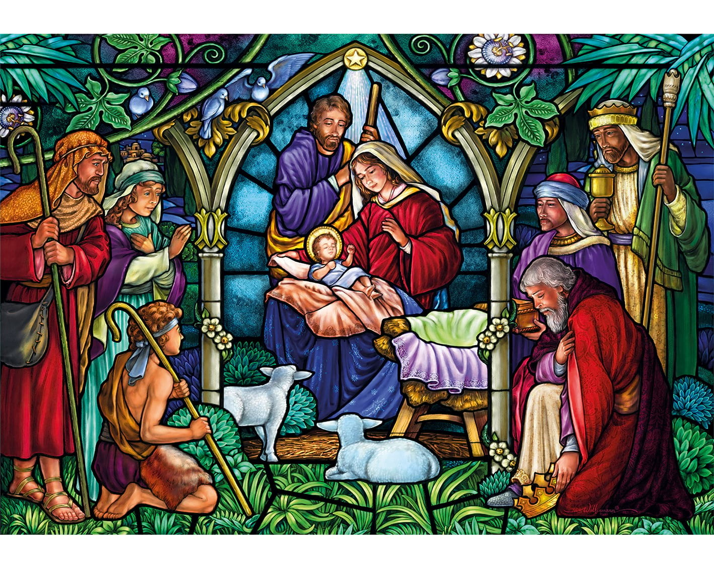

Worksheet

Exercise A
Read the questions first and underline your answers in the text.

- In December, what cover buildings and streets?
- What is the most famous decoration?
- Why do people travel to their hometown?
- When people take part in a ‘Secret Santa’ group, is the identity revealed?
- Does Santa Claus leave presents for all the kids in the house?

Exercise B
Read the text again carefully, think, and write your answer.

- What does ‘occasional family tension’ mean?

- Why is Christmas the most wonderful time of the year for retailers?

Answer sheet

Exercise A

- In December, what cover buildings and streets?
(Coloured lights, red ribbons and smiling Santa Claus faces)

- What is the most famous decoration?
(Christmas tree)

- Why do people travel to their hometown?
(To be with parents, siblings, cousins, old friends)

- When people take part in a ‘Secret Santa’ group, is the identity revealed?
(Never)

- Does Santa Claus leave presents for all the kids in the house?
(Yes)

Exercise B

- What does ‘occasional family tension’ mean?
(When family gather and ask about work, marriage, and children to those who are not in a good situation, they will get stressed or feel uncomfortable. In the end, this can lead to a conflict.)

- Why is Christmas the most wonderful time of the year for retailers?
(People will spend money to buy presents, decorations, clothes, food, and cakes.)

Reading material

Christmas

It's the time of year for Santa Claus, fairy lights and all the best pop songs. What are the essential elements of Christmas in the UK?

Decorations
From huge cities to tiny villages, the month of December sees buildings and streets covered in coloured lights, red ribbons and smiling Santa Claus faces. People also decorate their houses (and sometimes their gardens) for the Christmas period. The most famous decoration is, of course, the Christmas tree – a pine tree covered in little shiny decorations and fairy lights. Some people put a nativity scene in their house. This is a collection of little figures who represent the birth of Jesus in Bethlehem.

Family and friends
Christmas is a time to be with the people you love. Often, this involves travelling to your hometown to be with parents, siblings, cousins, old friends, etc. For some households, it's the only time of the year when all the family is together. In the UK, this is usually a time for chats, cups of tea and watching Christmas films together. However, it can also lead to occasional family tension. But don't worry: there are plenty of impossibly cheerful pop songs to help everyone relax!

Presents
Christmas is certainly the most wonderful time of the year for retailers! The days and weeks before Christmas are characterized by frantic shopping for presents. Many groups of friends or workmates take part in a 'Secret Santa' group. This is where each person buys a small present for one other person in the group, but the identity of the giver is never revealed. In many countries, Christmas Eve is a night for kids to go to bed early before their house is visited by Santa Claus, a magic man in a red suit who leaves presents for all the kids in the house.

Instructor’s Comments and Assessment
Pros
Cons
Change
Overall Comments
Grade
Above Standard 85%-100% | Standard 70%-84% | Below Standard 69%-0%
Instructor | Student Signature | Date
Taute, David

