Listening Lesson Plan

Red in the face.

Instructor:
Lim Ye Eun (April)
Level:
Elementary
Students:
12
Length:
50 minutes

Materials:
- Listening CD and CD player
- Listening worksheet (1 copy each)
- Idiom worksheet(1 copy each).
- drawing for idioms and dialogue
- board and marker
- answer worksheet.

Aims:
- To listen and understand well.
- To learn idioms.
- To promote the skill of speaking by discussing with group members.
- To apply what they have learned about in the class to real life.

Language Skills:
- Reading : listening worksheet.
- Listening : CD and CD player
- Speaking : guessing, discussion and repeating.
- Writing : making examples by using idioms.

Language Systems:
- Lexis : idioms in the dialogue.
- Function : showing them drawing related to the dialogue and let them discuss it.
- Structure : Usage of preposition.
- Phonology : pronunciation and intonation from the CD.

Assumptions:

Students already know:
- their level
- length (of what? Class?)
- The teacher’s style of teaching and the pace of the course.

Anticipated Errors and Solutions:

- Students may need more time to guess idioms and discuss a general idea.
→ let them have more time and then instead of having students write examples by using idioms on the board, just let them say it.
- Students may not be able to pick up details from the listening
→ Chunk the listening (pause-play-pause-play)
- If time is short
→ Cut post-activity short and let them volunteer 2~3students to share their opinions with the class
- If students may not be able to know idioms.
→ Instead of letting them have more time to guess it, just try to give them some examples including the idioms.
-

References:
- Can you believe it? (stories and idioms from real life) - Jann Huizenga. (You should add a chapter number here too)

Lead-In
Materials : Board and marker.
Time  3 min | Set Up  Whole Class | Procedure:  Hello everyone, how are you today?  Have you ever had the experiences that you are so embarrassed because of misunderstanding?  (Elicit the experiences and write them on the board.)  OK, so today, we will listen to one woman’s embarrassing experience. But first, we will learn some idioms the speakers use.

Pre-Activity
Materials : Board and marker, Idiom worksheet(1 copy each) and drawings for idioms and dialogue.
Time  10 min  2 minute | Set Up  Groups.  Whole class | Procedure:  (distribute idiom worksheets and attach the drawing for it to the board)  I. Idiom  Instruction  We will work together. Please make 3 groups with 4 people each. And guess the meaning of idioms on your worksheet through the pictures on the blackboard.  (let them guess the meaning of idioms with group members together)  CCQ  - Can any group tell me what this idiom’s meaning is?  - Can you write some examples by using idioms on the board?  - Is the idiom interesting for you?(not a CCQ question)  - When are you going to use the idiom?  (explain the meaning if necessary)  II. Prediction  (attach the drawings for dialogue to the board)  Instructions  Look at this drawing. These are 6 drawings that you will imagine from listening. What do you think of what happened to her? Where do you think they are?  What can you see in the picture?  (Elicit idioms that they learned.)
Main Activity
Materials: CD & CD player, Listening Worksheet, drawing for the dialogue, Board and marke, Answer worksheet.
Time  10 min  18 min | Set Up  Whole Class  Whole Class  Individually  Groups  Whole Class | Procedure:  1. Listening for the main idea. (I think that the dialogue is too hard for beginner level. Words like shocked, Victoria and cafeteria would have to be pre-taught in my opinion)  Instructions  We will listen to the dialogue. You can take a note. Listen what they are talking about. What happened to her?  Listen for the general feeling of it.  CCQ  Can you take notes?  What are you supposed to think about?(good)  (play the dialogue without stopping)  Do you want to listen again?  - Yes → Have them listen one more time.  - No → Have them share their thoughts.  (Ask them)  What do you think of her?  What do you think of him?  What is your general feeling of it?  (Let the students answer. Then compare with their thought from the prediction and let them notice the differences.)  2. Listening for Details  Instructions  Now listen to the dialogue one by one. I am going to pause 6 times along the drawing on the board. You can take a note.  Work individually.  CCQ  Are you working along?  What are you going to do?  (Play the dialogue.)  Do you need to listen again?  - Yes → Play again.  - No → Move on.  (distribute answer worksheet)  Now compare the story what you listened to with your group members. When you have agreement, send a representative up front and have them tell the story using as many idioms as you can along the drawing on the board.  Demonstration  During other group announcing, Answer the worksheet.  (Distribute the listening worksheet. Then let them read the dialogue by themselves. And give them some lecture about usage of preposition in the dialogue (Some lecture? The lesson plan is here so the lecture should also be included. How would another teacher know what to do at this part?). After that play the tape again and let them say the dialogue out loud with the speaker.)  (Ask detailed questions)  - What happened to her?  - Where they are?  - What did the women do?  - How did the man react to her?  - How was her feeling changed to

Post-Activity
Materials: ---
Time  7 min | Set Up  Whole Class  Whole Class | Procedure:  I. Free Production  Instructions  In this dialogue, because of the misunderstanding, she was red in the face. Do you have any idea to avoid this situation?  And what do you think of what she did after the situation in the dialogue?  CCQ  What was my question?  Can you answer this?  .  II. Conclude lesson  (Elicit today’s idioms)  Good job today. See you guys tomorrow!
April,

Generally you lesson plan is good but I am worried about the level you are teaching. I think this activity is too hard for beginner level. The script has too many difficult words such as Victoria, shocked and cafeteria which they might not understand. How would you deal with this? Also your post-activity is too short. 7 minutes is so short and it’s only a whole class activity. Try to think of an activity that would use group/pair work. Overall I am happy with it but with a few changes you can get on very well.

David Moroney

Listening worksheet

Red in the face

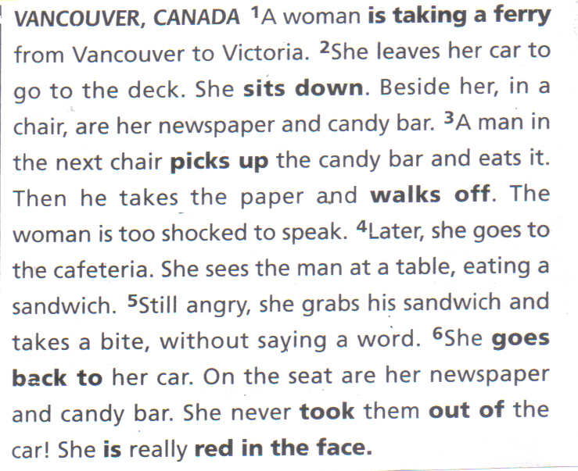

Drawing for dialogue.

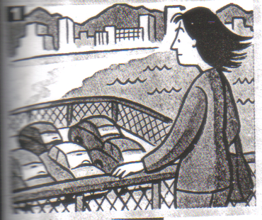

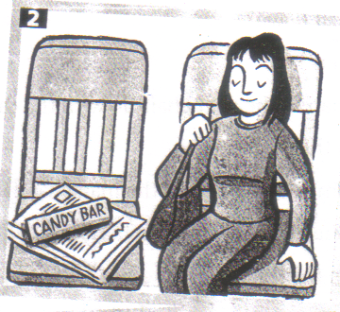

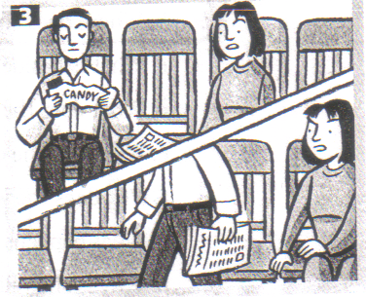

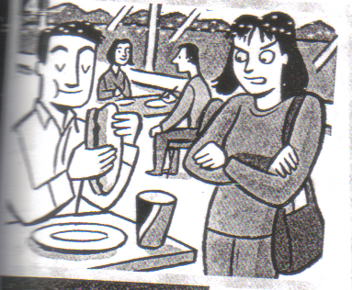

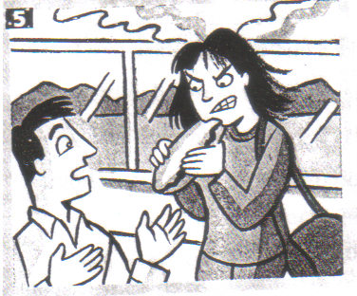

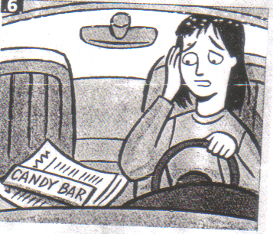

Idiom worksheet

1. be red in the face

2. take a ferry(a bus, a train, a plane)

- sit down.

- pick something up.

- walk off

- go back(to a place)

- take something out(of a place)

Drawing for idioms

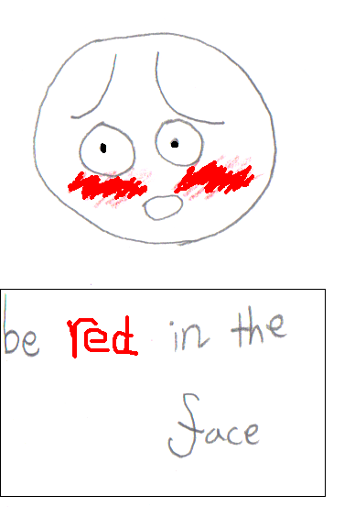

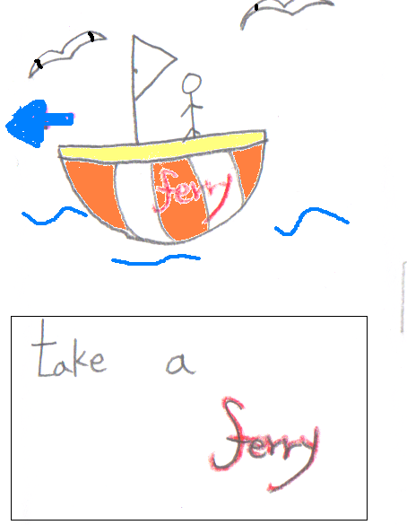

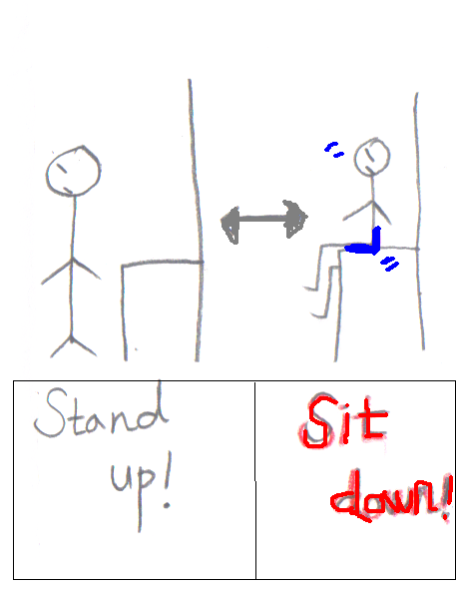

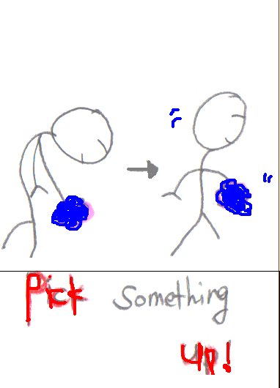

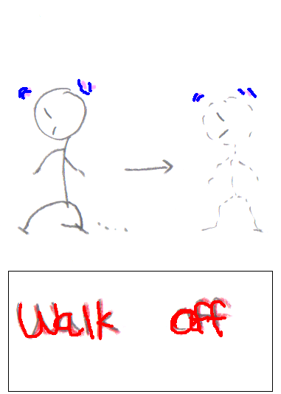

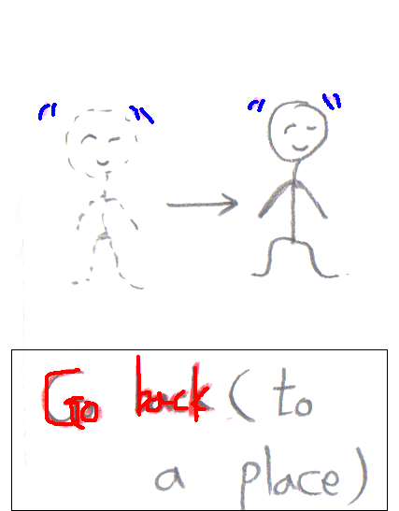

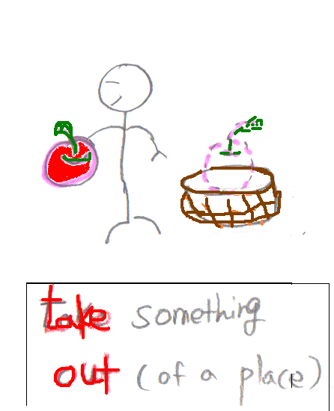

Answer worksheet.

About the story.

- How Is the woman getting to Victoria?

- Where does she sit down?

- What is beside her?

- What does the man in the next chair do with the candy bar?

- What does he do then?

- Why does the woman take a bite of the man’s sandwich?

- What happens when she goes back to her car?

h. Why is she red in the face?

