Listening Lesson Plan

“Brave” : Jennifer Lopez

Instructor:
A Reum HAN
( Ellie )
Level:
High Intermediate
Students:
16
Length:
60 minutes

Materials:

- Board and board markers
- Worksheet #1 , 2 and full script (16 copies each)
- Prediction : picture (4 copies )
- Listening CD & CD player

Aims:

- To acquire new vocabulary throughout the pop song
- To practice and learn the pop song
- To improve Ss intensive listening skill: what the story is
- To speak about Ss experience related to the song

Language Skills:

- Intensive listening : listen to the song several times from CD and fill in the blanks

- Speaking : 1) guess and tell what happen to next (picture)
2) Talk about Ss experience such as a song

- Reading : worksheets, pop song transcription

- Writing : summarize song’s main idea and Ss ideas

Language Systems:

- Lexis : key vocabulary (evident, refuse, benevolent, assume, etc.)
- Function : to express preference
- Discourse : group discussion and presentation, pair talking,
and individual speech

Vo
Anticipated Errors and Solutions:

Students may not know other vocabulary words throughout pop song
→ Encourage Ss to guess from context
→ If not, let Ss find the words in the dictionary

Students do not understand the meaning of vocabulary:
→Ss to interact with each other what the exactly meaning
→If not, give students more examples

Students may have difficulties listening to the song
→ Allow Ss more minutes and listen to the song several times

Students may finish listening earlier than expected.
→ Let Ss check their answers with each other
→ Talk students each other about Jennifer Lopez’s information
→ Give homework

Assumptions:

- Adult high intermediate class: They already know some sorts of expressions in relate to their ordinary life // every ice breaker is related on today’s topic
- interest in the pop song
- exposure in this class/seats/style of lessons/pace of lesson
- Ss are very close to each other and enthusiastic attitude

References:
- Picture extracted from : http://cafe.naver.com/lemonterrace/2251717
- Lyric by :http://blog.naver.com/caesar55/150027070218
- Vocabulary definition : Collins COBUILD Advanced Learner's English Dictionary" 4th edition published in 2003 ⓒ HarperCollins Publishers 1987, 1995, 2001, 2003
“Collins Gem Thesaurus” published 2004 ⓒ HarperCollins Publishers 2001, 2004

Lead In
Materials: Board (Write down on the board: Brave – Jennifer Lopez), Picture

Time  5 min. | Set Up  Whole class  Group  Whole class | Procedure:  [Greet students]  T: Hi, guys! How are you today? Good!  [Ice breaker]  T: ok, today’s ice breaker is prediction.  Throughout this picture, and guess what is happen to next.  Talk to each other and talk about your best ideas.  **CCQ  Do you work in pairs? (Y)  How much time do you have?  (Each team leader will tell about it)  Well-done, everybody!  [Introduction: today’s topic ]  Today we are going to learn about J-Lo’s new song [Brave]. Before listening to this, we will learn new vocabulary in the lyric.  **CCQ  Have you heard about this song?  Do you like Jennifer Lopez?

Pre-Activity
Materials: Worksheet #1 for vocabulary, board & markers

Time  10 min. | Set Up  Whole class  Pair  Whole class | Procedure:  [Vocabulary]  Give Ss words definition sheet.  T: You guys read it, and acquire these.  If you don’t understand some meaning, you can look up  Words in the dictionary. If you get all words, check what you know about each other.  **CCQ  Do you work in pairs? (Y)  How much time do you have?  (Monitor to Ss. If some students want T to help, T gives some examples.)  T: Any questions on the vocabulary here? Now, let’s listen to the song together!
Main Activity
Materials: CD & CD player, Worksheet#2 for blank script, and full script of the song,
(16 copies each) ,board & markers
Time  10 min  20 min | Set Up  Whole class  Individual  Pair | Procedure:  [Listening]  Listen to the song twice. Ss need to listen more,  Play again.  T: Listen for the general feeling of it.  **CCQ  How many times do you listen?  What do you think about this song?  [Listening for the Details]  Fill-in-the-blanks  Give Ss worksheet#2, Ss do fill-in-the-blanks as Ss listen.  Monitor Ss listen and fill out the blanks. After this, Ss compare their sheet with the full script.  T: I will give you the worksheet. Please fill in the blanks on the worksheet as you listen. First, do it by yourself.  And then, I will give you a full-script, check your answer.  (After that) How was it? Difficult? Any question about this? Let’s move another activity.  **CCQ  How much time do you have?  What are you supposed to do?(to fill in the blanks)  Have you done?  Find the Main Idea and summary  Ss listen carefully and find the main idea what singer sings about. Moreover, while Ss listening, Ss should summarize the song. Pair works.  T: We will listen to the song again. This turn, you should listen carefully, find and write down the main ideas.  You also summarize what story is.  After that, talk to your partner and do present small presentation.  **CCQ  What are you supposed to do?  How much time do you have?  What should you do?  How many sentences do you make?  (Monitor what Ss think about)

Post-Activity
Materials: Homework sheet
Time  5 min  10min | Set Up  Whole class  Whole class | Procedure:  [Discussion]  To share about Ss experience each other.  T: We learned about the pop-song, right? Was it fun?  By the way, are you a brave person or not in front of  Love? If you have some experience, talk to your friends.  (Monitor Ss/ Take 3~4 volunteers if Ss done)  T: Here is a situation. If you fall in love someone.  Do you have any idea what you should do?  After that, to share Ss’ opinions.  (Tell Ss idea one by one like a small talk)  **CCQ  Do you work in pairs? (Y)  How much time do you have?  What should you do?  [Homework]  Write one sentence for each word Ss learned today.  T: Here is homework. Furthermore, use today’s words as much as possible. Excellent job, today. See you guys!

[Ice Breaker- Prediction]

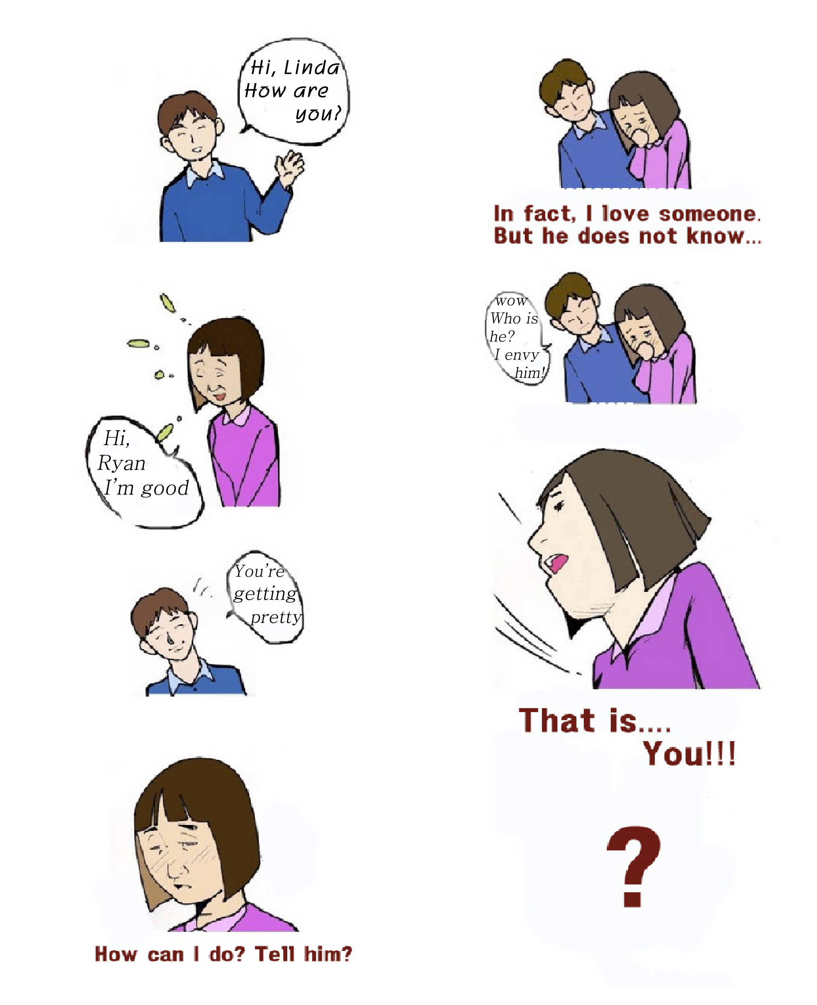

[Worksheet#1] Vocabulary Definition

Evident : If something is evident, you notice it easily and clearly.

Hesitant: If you are hesitant about doing something, you do not do it quickly or immediately, usually because you are uncertain, embarrassed or worried.

Confident: If you are confident about something, you are certain that it will happen in the way you want it to.

Common sense: Your common sense is your natural ability to make good judgments and to behave a practical and sensible way.

Benevolent: If you describe a person in authority as benevolent, you mean that they are kind and fair.

Assume: If someone assumes power or responsibility, they take a power or responsibility.

Straddle: If you straddle something, you put or have one leg on either side of it.

Adamant: If someone is adamant about something, they are determined not to change your mind about it.

Brand new: A brand new object is completely new.
[Worksheet#2] Fill-in-the-blanks

It’s a new day, new day and it’s _________ you must’ve been heaven-sent

Sometimes we shouldn’t be _________ but I’m not at all

Just feeling more _________ Just using my __________

Just trust in it, I’m lovin’ it

I can’t ______ an offer so benevolent

Can’t ________ he is gonna use me and after it, he’ll never call again

Don’t be afraid, Don’t be afraid. This is your day, This is your day

It’s time to be brave. Say “I’m not afraid” not anymore

I used to be cold, now the temperature’s changed, It just ain’t the same

I’m not afraid, I’m not afraid. It’s time to become brave

As the light of day straight into a cave to show me the way that I might be safe.

Now I’m turning the page. Thanks to the power of love

I can love because I am brave

I’m brave I’m brave

I heard him say this thing moving too fast for him

It’s a feeling I was _________ foolishly ________ him.

But it’s all in his eyes really wish he would let me in

Cause the same way I’m scared of him

He’s scared of being hurt again

It’s time to let go Let go of your heart

It’s time for a __________ start.

Never know we might never part

[Full Script- Jennifer Lopez “Brave”]
It’s a new day, new day and it’s evident you must’ve been heaven-sent

Sometimes we shouldn’t be hesitant but I’m not at all

Just feeling more confident Just using my common sense

Just trust in it, I’m lovin’ it

I can’t refuse an offer so benevolent

Can’t assume he is gonna use me and after it, he’ll never call again

Don’t be afraid, Don’t be afraid

This is your day, This is your day

It’s time to be brave. Say “I’m not afraid” not anymore

I used to be cold, now the temperature’s changed, It just ain’t the same

I’m not afraid, I’m not afraid. It’s time to become brave

As the light of day straight into a cave to show me the way that I might be safe.

Now I’m turning the page. Thanks to the power of love

I can love because I am brave

I’m brave I’m brave

I heard him say this thing moving too fast for him

It’s a feeling I was straddling foolishly adamant him

But it’s all in his eyes really wish he would let me in

Cause the same way I’m scared of him

He’s scared of being hurt again

It’s time to let go Let go of your heart

It’s time for a brand new start

Never know we might never part

Baby, don’t be afraid, Don’t be afraid

This is your day, This is your day

It’s time to be brave. Say “I’m not afraid” not anymore

I used to be cold, now the temperature’s changed, It just ain’t the same

I’m not afraid, I’m not afraid. It’s time to become brave

As the light of day straight into a cave to show me the way that I might be safe

Now I’m turning the page

Thanks to the power of love

I can love because I am brave

I couldn’t take back anything that I’ve gonna through

I pray for strength for anything that I’m gonna do whether it’s joy or it’s pain

I’m still okay ( I’m still okay)

I’ll be alright cause I am brave

It’s time to be brave. Say “I’m not afraid” not anymore

I used to be cold, now the temperature’s changed, It just ain’t the same

I’m not afraid, I’m not afraid. It’s time to become brave

As the light of day straight into a cave to show me the way that I might be safe

Now I’m turning the page

Thanks to the power of love

I can love because I am brave

I am brave

