Listening Lesson Plan

Topic: Tips for traveling: How to judge a Hotel

Instructor:  Ai. L Maeng (Liz) | Level:  High Intermediate | Students:  9 | Length:  50 minutes

Materials:
- 1 video clip Worksheets I, II.
- Using a Board, Pens.

Aims:
- To learn information and vocabularies for understanding the tips.
- To practice listening to understand content and solve the cloze.
- To practice speaking by discussing with group members.

Language Skills:
- Reading: Transcript and vocabularies in worksheets.
- Listening: a short announcement from “About.com”.
- Speaking: discuss answers of outline worksheet within groups.
- Writing: work on making outline of the transcript.

Language Systems:
- Lexis: Vocabulary using and making the content by student self.
- Phonologic: Understanding the announcement.

Assumption:

Students already know:
- How the class is set up and run (there will be 3 student groups at each table).
- Most students have not heard this information.

Anticipated Errors and Solutions:
- Students may not be able to follow the passage easily.
→ Let them listen to the track again until they get the gist of the content.
- Students may not be able to understand content stream.
→ Concentrate on outline work.
- Students may need more time to work on the idioms.
→ If it takes longer than 5 minutes, cut answer-checking short by verbally sharing the answers.

References:
- : http://video.about.com/honeymoons/Judge-a-Hotel-by-its-Website.htm

Lead-In
Materials: None
Time  3 minute | Set Up  Whole Class | Procedure:  Hi! Everyone. How are you doing today?  Asking a few students their summer plan during vacation.  And check them how to select a hotel usually.

Pre-Activity
Materials: Worksheet I, Board
Time  3 minutes  7 minutes | Set up  CCQ  A Pair work  T-Ss | Procedure  How do you choose your hotel?  Does anyone know a useful web-site?  Grouping Ss  (Worksheet I)  - How do you choose your hotel?  - What feature is the most important to decide?  - Price, Rood size, Location, Clean and so on?  - Does anyone know a useful web-site?  Discussion and share the answers.

Main Activity
Materials:, Transcript, Board
Time  2 minutes  5 minutes  3 minutes  7 minutes  5 minutes  10 minutes | Set Up  Play a Video  Play a Video  Grouping  Presentation  Hand out  Separating  Play a video  T-Sss | Procedure:  CCQ  Please, listen to this clip carefully and try to know what he say, how the man’s tone was? And Mood? And what is he trying to say us? And how many tips are given to us? Finally, how many tips were introduced?  Activity I  (1st time)  “How to judge a hotel by its web-site?”  CCQ  How was his voice? What were the tips? And How many were the tips in this clip?  (2nd time)  “How to judge a hotel by its web-site?”  CCQ M : Ask strong students  How many tips were provided?  Is the man explaining very well?  Tell us the keywords that you found.  Activity II  3 people, 3 groups  Ask them to summarize of what they heard from the video.  Make sure each group has a strong student and he/she can lead the group to summarize it as well.  Each group will present their summary.  CCQ F  You can acquire the tips that you just missed by listening of other group spoken.  What was it?  Activity III  Worksheet II  Now, I will give you a transcript of the video clip. It’s a cloze. So check it out by yourself.  Individual work  (3nd time)  “How to judge a hotel by its web-site?”  Check up the answers.

Post Activity
Materials: None
Time  5 minutes | Set Up  Whole Class | Procedure:  Conclusion  Elicit the outline verbally.  Give homework  Review tips and vocabularies worksheet what you learned today.  I hope you enjoyed this class. See you next class.

Work Sheet I

- How do you choose your hotel?

- What feature is the most important to decide?

- Price, Rood size, Location, Clean and so on?

- Does anyone know a useful web-site?

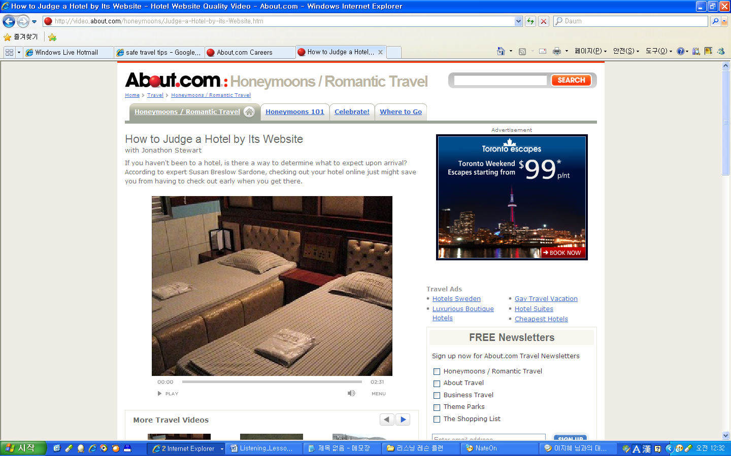
Work Sheet II - Teacher

Transcript: How to Judge a Hotel by Its Website
Hey guys - Jonathon Stewart here for About.com. Gone are the days of trip tiks and flipping through the yellow pages to find a hotel for your vacation, here today are the internets! Hopping online and looking for accommodations is the way most of us do it now, but can you really tell what you're getting into from a website? Honeymoon expert Susan Breslow Sardone says yes. Check it out.

Note the Hotel Website Quality
Website quality. Pay close attention to how navigable a hotel's website is as you surf. Are there dead links or outdated prices or advertisements? Does the page look like it was designed in 1997? Lack of attention to detail on the web just might translate into lack of detail during your stay.

Read Between the Website's Lines
You should also pay very close attention to descriptions of the hotel on the site. "A short walk to the beach" means the hotel is definitely not on the beach, "convenient airport location" means you might be in earshot of the terminal, and "complimentary continental breakfast from six to seven in the lobby" generally means a styrofoam cup of coffee and a stale danish.
When you look at the pictures the hotel has selected for its site, what do you see? Lots of children? Be prepared that this is likely what you'll actually encounter when you arrive. Likewise, if you see shot after shot of businesslike conference rooms, be ready to blend in with suits and attache cases.
Watch out for certain buzzwords as well, that just might be misleading. "Charming" can be a nice way to describe "old," and "cozy" nearly always just means "small." Cozy and charming in the same sentence in New York City means you're probably looking at a flip down Murphy bed and a Gideon's Bible.

Judge the Hotel's Pictures
Finally, keep an eye out for telltale details like floral bedspreads and plastic balcony furniture which probably equate to outdated and cheap, and be wary of hotels that have few or no pictures at all. Check out other travelers' reviews, as well as those sponsored by independent travel companies. Always be sure to call the hotel directly and verify any of your concerns over the phone, and book with an actual reservationist when you're ready to commit.
Thanks for watching! To learn more, visit us on the Web at About.com.

Work Sheet II-Student

Transcript: How to Judge a Hotel by Its Website

Hey guys - Jonathon Stewart here for About.com. Gone are the days of trip tiks and flipping through the yellow pages to find a hotel for your vacation, here today are the internets! Hopping online and looking for ( ) is the way most of us do it now, but can you really tell what you're getting into from a website? Honeymoon expert Susan Breslow Sardone says yes. Check it out.
Website quality. Pay close attention to how ( ) a hotel's website is as you surf. Are there dead links or outdated prices or advertisements? Does the page look like it was designed in 1997? Lack of attention to detail on the web just might translate into ( of ) during your stay.

You should also pay very close attention to descriptions of the hotel on the site. "A short walk to the beach" means the hotel is definitely ( ) on the beach, "convenient airport location" means you might be in earshot of the terminal, and "complimentary continental breakfast from six to seven in the lobby" generally means a ( ) cup of coffee and a stale ( ).
When you look at the pictures the hotel has selected for its site, what do you see? Lots of children? Be prepared that this is likely what you'll actually encounter when you arrive. Likewise, if you see shot after shot of businesslike conference rooms, be ready to blend in with suits and attache cases.
Watch out for certain buzzwords as well, that just might be ( ). "Charming" can be a nice way to describe "old," and "cozy" nearly always just means "small." Cozy and charming in the same sentence in New York City means you're probably looking at a flip down Murphy bed and a Gideon's Bible.
Finally, keep an eye out for telltale details like floral bedspreads and plastic balcony furniture which probably equate to outdated and cheap, and be wary of hotels that have few or no pictures at all. Check out ( ), as well as those sponsored by independent travel companies. Always be sure to call the hotel directly and verify any of your concerns over the phone, and book with an actual ( )when you're ready to commit.
Thanks for watching! To learn more, visit us on the Web at About.com.

