Listening Lesson Plan
(Syllabus design including the transcript & worksheet)

Su-jin Goes to See a Doctor.

Instructor:  Claire Lee | Level:  Beginners  (1st graders in Middle School) | Students:  20 | Length:  50 minutes

Materials:
- Worksheet for activities, homework, transcript (20 copies each)
- Pictures 1~6 for the expressions of the sickness
- Listening cassette tape & player
- Web site ( internet)
- Board, board markers

Aims:
- Students will be able to say and write the name of the body organs.
- Students will be able to understand and use some expressions about symptoms.
- Students will be able to give appropriate advice.
- Students will be able to aware of the importance of the health.

Language Skills:
- Listening: Short dialogue between a teacher and students, short dialogue between a man and a woman
- Speaking: prediction, role-play, giving advice with partner
- Reading: Transcript (for review)
- Writing: Fill in the blanks, Writing a prescription (homework)

Language Systems:
- Lexis: some expressions about symptoms and expressions used in giving appropriate advice
- Function: expressing the symptoms and giving an advice
- Structure: imperative sentence

Assumptions:

Students already know:
- how the class is set up and run
- the teacher’s style of teaching and the pace of the course
- most students have some background knowledge of solutions for sickness

Anticipated Errors and Solutions:

- Students may not be able to pick up details from the listening
→ Chunk the listening, repeat the chunk that students have difficulty
- Students may need more time to work on the vocabulary and expressions
→ Students can refer to the worksheet or notes doing other activities and review them for homework
- Students may not get the instruction for the activity clearly
→ Repeat the instruction once more in shorter and easier way
- If time is short
→ Cut post-activity pair work short
- If students finish their tasks earlier than anticipated,
→ Give more time to practice role-play and give as much opportunities as possible presenting the role-play

References:
- Textbook; Middle School English 1, Lesson 4 “Su-jin Goes to See a Doctor.”
- http://kr.kids.yahoo.com/eng/funsong.html

Teaching Procedure
STEP |  | ACTIVITIES | AIDS  SET UP | TIME
INTRODUCTION | L  E  A  D  -  I  n | • Hello everyone, how are you? Because of the air conditioner, I was sick last weekend. Do you have any experience that you were sick? Then, how can we express our feeling to a doctor or others? Have any ideas? Also, what do you have to do when you have such symptoms?  • Ok, so today, we will listen to some short dialogue. First, we will learn some vocabulary and expressions. | Board  Whole Class | 3 min.
DEVELOPMENT | P  R  E  -  L  I  S  T  E  N  I  N  G  P  R  E  -  L  I  S  T  E  N  I  N  G | 1. Vocabulary and expressions  Instruction  • Now, I will give you the worksheet. Pass out the worksheet which shows face but has no organ. Work individually. Draw the picture and complete the face and body.  CCQ  Who are you working with?  What do you have to do?  (Log on to the net and show the video clip, including the song. (Head shoulder knees and toes))  • Watch and listen to the song. Then, write down the name of the body organs on the picture you have drawn.  Demonstration  Show the picture that the teacher has drawn.  • Speak the word out loud which I point. Repeat the words and try to memorize it.  Check if the students are being aware of the words. Answer students if they ask questions | Worksheet 1  Web site  Individually  Worksheet1  board  Whole Class | 8 min.
DEVELOPMENT |  | 2. Prediction and small talk  Instruction  • Look at the pictures. Can you guess about what two people are talking?  • Give some examples of expressions about sickness, and giving advice. Look at the pictures and learn useful expressions.  Instruction  • In pairs, talk about the experience when you were sick and the common sense how you can get well soon. I will give you 3 minutes.  CCQ  Who are you working with?  How much time do you have?  What do you have to talk about? | Pictures (1~8)  Board  Whole Class  Pair work | 5 min.
DEVELOPMENT | W  H  I  L  E  -  L  I  S  T  E  N  I  N  G  W  H  I  L  E  -  L  I  S  T  E  N  I  N  G | 1. Listening 1  Instruction  • Pass out the second hand out. (Matching the pictures) Work individually. Listen to the tape and match the pictures. Leave the blank this time.  CCQ  Who are you working with?  What are you supposed to do?  Do you have to fill in the blanks?  • Listen to the second dialogue and choose the best answer.  • Give the correct answers and some feedback. | worksheet 2  Cassette tape  Individually  Whole Class | 6  min.
DEVELOPMENT |  | 2. Listening 2  Instruction  • Turn on the cassette tape player. Listen to the tape again carefully. This time, after listening, fill in the blank (under each picture) with proper words.  Demonstration  • Demonstrate one for the example  • Do you want to listen again?  - Yes: Have them listen one more time.  - No: Have them share their answers.  • Give the correct answers and some feedback.  • Listen to the tape one last time. | Individually  Whole Class | 6  min
DEVELOPMENT | P  O  S  T  -  L  I  S  T  E  N  I  N  G  P  O  S  T  -  L  I  S  T  E  N  I  N  G | 1. Semi-controlled Production  Instructions  • Pass out the third worksheet for post-listening. Get into the pairs and fill up the space with the proper expression. Think and write about the best advice for the patients. I’ll give you 10 minutes.  CCQ  Who are you working with?  For how long?  What are you supposed to do?  • Walk around the class and help the students who have difficulties. Praise and encourage the students. | worksheet 3  pair work | 10 min.
DEVELOPMENT |  | 2. Free Production  Instructions  • Now, I’ll give you 5 minutes to prepare for a short role-play. Practice expressions with partner actively. One can be a doctor or an adviser. Feel free to speak in English with partner.  CCQ  What are you supposed to do?  For how long?  • Any volunteer? Please feel free to perform in front of the classmates.  • Choose the best group and give an award, or praise for their effort. | Pair work  Whole Class | 7 min.
CONSOLIDATION | W  R  A  P  -  U  p | 1. Conclude the lesson  • Briefly review the expressions learned today. If necessary, take a note.  • Give the students transcript so they can review at home.  2. Give homework  • Give the homework.  - Group work (Make groups of 4~5 students)  - Making the Prescription  - Offer a sample Prescription  CCQ  What are you supposed to do?  With who?  • Today, you did a good job. Excellent! See you tomorrow. | Transcript  Sample Prescription  Whole Class | 5 min.

♦ Hand out 1
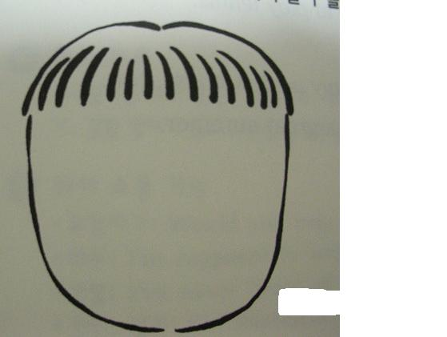
Let’s have fun~!
Please complete his or her face and body.

♦ Internet Site
http://kr.kids.yahoo.com/eng/funsong.html
♦ Picture 1.
♣ What are they talking about? Why does a boy look unhappy?
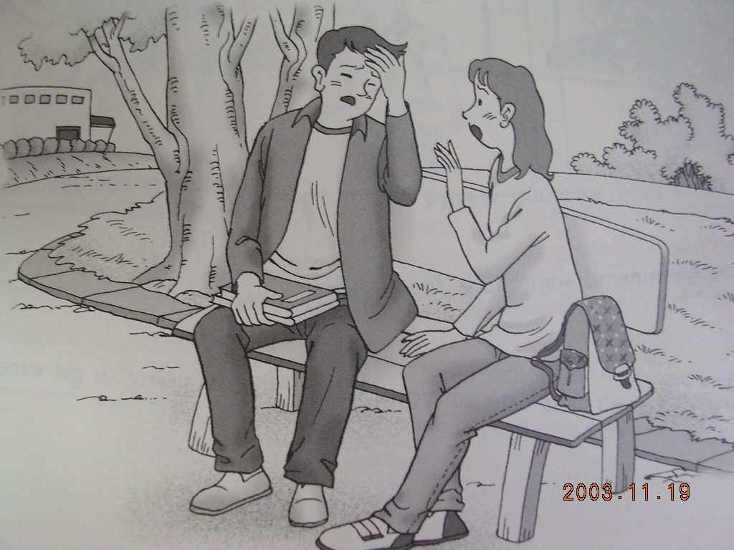

I feel really sick.
♦ Picture 2
I have a headache.
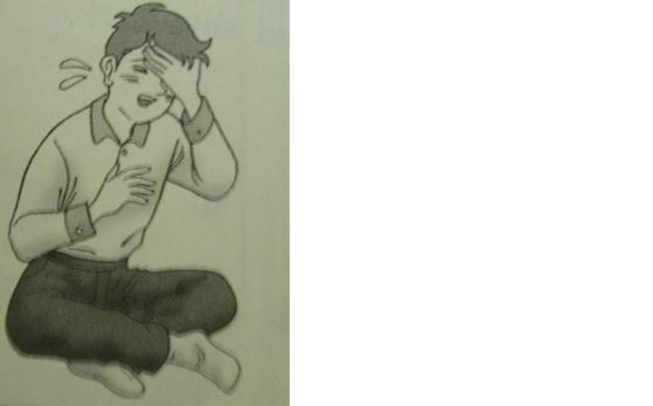

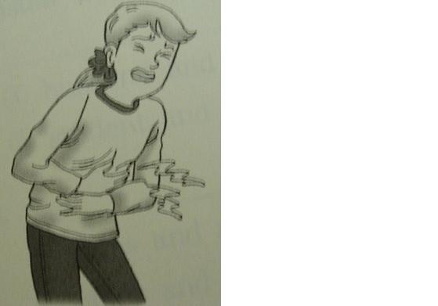

♦ Picture 3
I have a stomachache.

♦ Picture 4
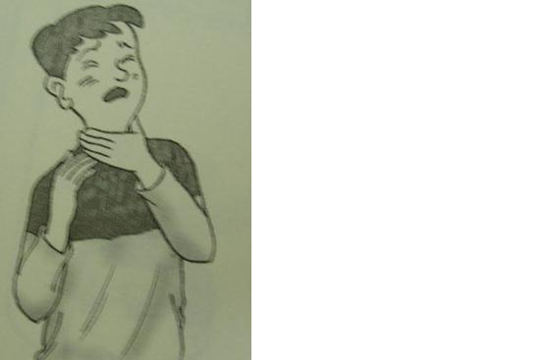
I have a sore throat.

Head
Cf. I have a cold.
I have a sore throat.
I have a fever.
Neck
ache
Tooth
Back
Stomach
♦ Picture 5
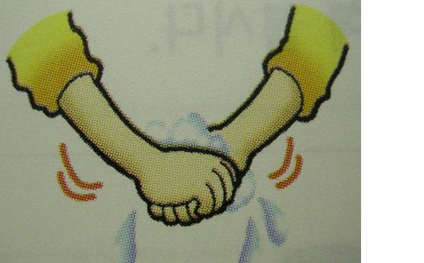Wash your hands.
♦ Picture 6
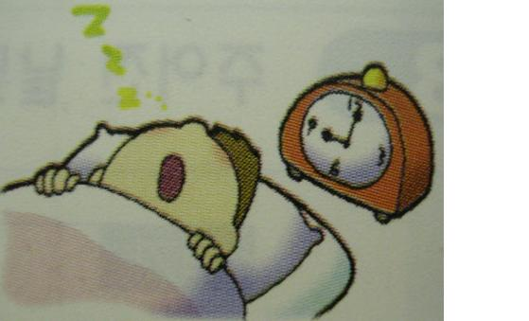Go to bed early and rest.

♦ Picture 7
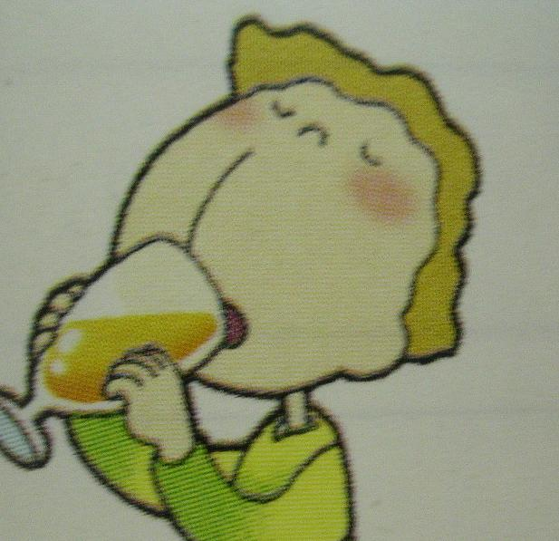 Drink lots of orange juice.

♦ Picture 8
 Gargle with salt water.

♦ Hand out 2
♣ Listen to the dialogue and match the person and picture.
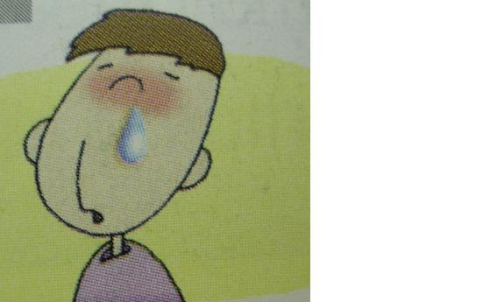

John

________________
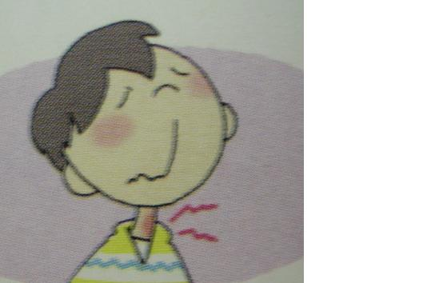

Min-su

________________
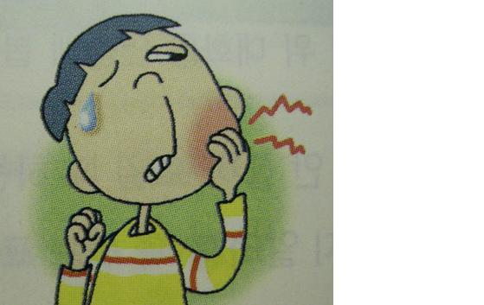

Cathy

_________________
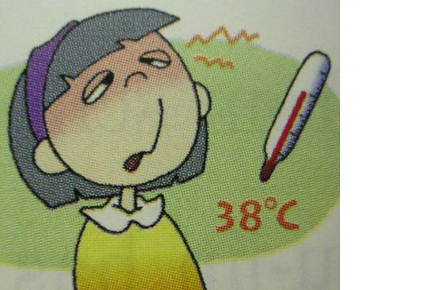

Mike

_________________
♣ Listen to the dialogue and choose the best answer.

__________________ ___________________ ____________________ ___________________

TRANSCRIPT

# Dialogue 1
Teacher: Good morning, class.
Students: Good morning, ma’am.
Teacher: Oh, what’s wrong with you? All of you seem very sick. What’s the matter with you Cathy?
Cathy: I feel really sick. I have a fever and I feel cold.
Teacher: How about you, Mike?
Mike: I feel terrible today. I have a toothache.
Teacher: And you, John?
John: I have a cold. I have a runny nose. And Min-su has a sore throat. He can’t speak aloud.
Teacher: That’s too bad. Why don’t you go to see a doctor?
Students: Okay. Thanks.
Teacher: Take care.

# Dialogue 2
W: Where is Mike?
M: He is at Dr. Kim’s office.
W: What’s wrong?
M: He has a high fever.
W: That’s too bad. He has to go to bed early and have some rest.

Q: What did a woman want Mike to do?

♦ Hand out 3
1. 
2. 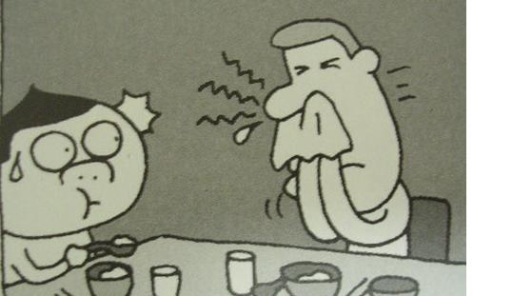
3. 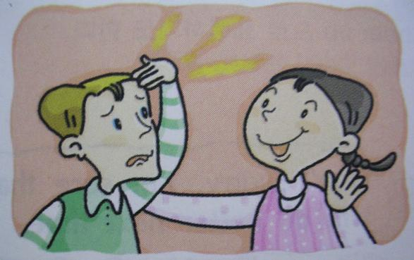
4.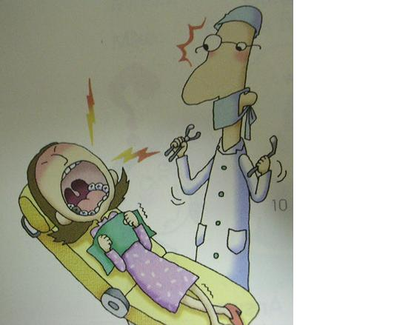
♦ Prescription (sample)

Name | 나이 | 성별 | Symptom(증상) | Advice | Photo
Su-jin | 14 | F | Sore throat | Don’t speak a lot.  Drink a lot of warm water.
Mi-na | 14 | F
In-su | 13 | M
Min-ho | 14 | M

