Listening Lesson Plan
Could you do me a favor?
Instructor:  Kang, Yeong En | Level:  Intermediate or above | Students:  12 | Length:  50minutes
Materials:
White board, board marker, board eraser
Worksheet A(12 copies):borrowers and lenders
Worksheet B(12 copies):check if you borrowed or not
empty paper for icebreaker
Script A(12 copies): snapshot for warm-up
Script B(12 copies): dialog and answer sheet
CD: Interchange 3- listening unit 3
CD player
Present(some snacks)
Goals:
To practice useful expressions.(informal and formal)
To let the Ss have a good sense of borrowing.
To practice listening and speaking through conversation and interviews.
To improve listening skills by listening to the dialogues and answering the questions.
To practice speaking with confidence by interacting with other Ss.
Assumptions:
The Ss have been exposed to listening to some dialogues.
The Ss have experiences to borrow and lend.
The Ss already know the teacher’s overall teaching style.
The Ss already know how the class is set up and run.
Language Skills and Systems:
Reading: Script, worksheet
Listening: CD, Interview, group discussion (other Ss’ speaking)
Speaking: Interview, group discussion.
Writing: note taking( vocab. on icebreaker/ check answers & the write reasons)
Lexis: vocabularies used in some items
Function: borrowing and lending expressions
Structure: Requests with modals, if clauses, and gerunds
References:
Interchange (third edition) 3- unit3
http://www.cyworld.com/nemoenglish
Anticipated Errors and Solutions:
Ss may not know formal expressions to borrow something.
- Organize the expressions from informal to formal
(Can I borrow~? / Could you lend me~? / Is it Ok if ~? / Do you mind if ~? /
Would it be OK if~? /Would you mind if~? / I wonder if~? )
Ss may not be able to express with agree or not.
- Let them know useful expressions
Agree: Sure, that’s fine. / You can use it. / I’d be glad to. /Yes, of course.
Not agree: I’m really sorry~. / Actually, I already lend it~. /I’m sorry, but I can’t.
If time is short,
- Shorten post activity time – not ask about all items. Select the best student.
If Ss finish their tasks earlier,
- Give Ss more time to have conversation with other Ss for expression.

Ice Breaker: Remaking words
Time: 6min / Materials: board, board marker, board eraser, empty paper(4 copies)
Set Up  Group work  (4 groups)  6min | Procedure  Instruction/Lead in  Good morning class. How do you feel today? It is great day, isn’t it?  Today, We are going to start with remaking word game. Are you ready to go?  We are going to work in 4 groups. (Give 3min to think and then check which team got most.)  Demonstration  “Teacher” (Teacher write this word on the board.)  Every group Ss think how can remake new words using these alphabets)  Possible answers: her, reach, eat, ear, tea, each, arch, ace, at, rat. car, arc, hat, teach..)  CCQs  Do you do it individually?  How much time do you have to make it?  Check how many words they thought.  Let every team write on the board.(3min)

Warm Up: Favors People Dislike Being Asked (snapshot)
Time: 7min / Materials: Script A: Could you…? (12 copies)
Set Up  Individual work  3min  Pair work  4min | Procedure  Instruction  (Distribute warm up script A.) Ok, here is a snapshot. As you see the pictures, think about..  Which of these favors would bother you the most?  Which would bother you the least?  Imagine that a close friend asked you each of these favors.  What would you say?  You have 3 minutes.  Demonstration  For first picture, I can say “I’m so sorry, but I can’t. I have a promise at that day. So I need a car.  CCQs  Who are you working with?  How much time do you have?  Monitor and help Ss if they need it.  Give them time warning: 30 seconds left  Instruction  After the individual work, get in pairs to share opinions.  You have 4 minutes.  Demonstration  Ask each other and answer it.  Which one would bother you the most?  Which one would bother you the least?  CCQs  Who are you working with?  How much time do you have?  Monitor and keep them on the topic. (Don’t let them have side talk time)  Give them time warning: 1 minute left.  Give extra time if Ss need it: 1 min

Main – Controlled: Listen to the dialogue
Time: 17min / Materials: CD(unit3/conversation3), CD player, scrip B(12copies)
Set Up  Whole class  5min  Individual work  9min  Whole class  3min | Procedure  Instruction  (Distribute script B) At first listening, you can see the dialog script and answer it.  When you listen to the dialog, focus on the sentence started with “Would you mind…?” and then answer whether she/he borrowed or not.  CCQs  Can you see the dialogue script at first time?  Do you have special sentence focus on?  Play CD-unit 3, number2 conversation  Ask Ss if they understood the dialog.  Yes go over the answers.  No play the track over until most Ss have all the answers.  Remind important sentence.  Ask Ss randomly for the answers.  If the answer is wrong, ask other Ss.  Even the answer is right, ask other Ss for agreements.  Go through the track to check the answers.  Instruction  Listen to three more telephone conversations. You already have answer sheet (script B). Write down each caller requests. Does the other person agree to the request? Check yes or no. it’s for 9min and you can hear only once.  CCQs  Are you working in pairs?  What do you have to do during listening conversation?  How many times will you hear the dialogue from the CD?  Check the answers as a whole class after the listening and answering on the sheet. Listen to the track one last time. If there is anything missing, pause CD right there and emphasize specific sentence.

Main – Free: BORROWERS AND LENDERS
Time: 15min/ Materials: Worksheet A(12 copies), Worksheet B(12 copies)
Set Up  Individual work  3 min  Whole class  activity  12min | Procedure  Instruction  (Distribute Worksheet A) Look at the Worksheet A. Imagine you own these items. Which ones would you be willing to lend to a friend? Which ones wouldn’t you lend? Check a response for each item. You have 3min.  CCQs  Do you need to talk to your classmates?  How much time do you have?  Instruction  Go around class and take turns asking to borrow each item. Say why you need it. When responding, say if you are willing to lend the item or not. If you won’t lend something, give an excuse. Ask many people as possible as you can. (At least 3 people) You have 10min.  Notice them I will pick one up who is able to borrow the most items and give a present.  CCQs  Will you meet only one person?  How much time do you have?  Are you allowed to go around in the class?  Keep monitor Ss’ conversation. Give tips the Ss who is not fluent.  Give the time warning: 3minutes, 1minute  Give them extra time if Ss need it: 1minute

Post: Who was able to borrow the most items?
Time: 5min / Materials: Worksheet B, present(some snacks)
Set Up  Whole class  5min | Procedure  Instruction  You finished worksheet B, right? Good job.  Ok. Who could borrow the mountain bike?  What was the reason?  (Ask them one by one)  (Let them explain how borrowed and where when will they use it.)  (find out the best student who borrowed the most)  Give present.  Conclude lesson  Elicit today’s key expressions.  Good job today. See you guys tomorrow!

Script A
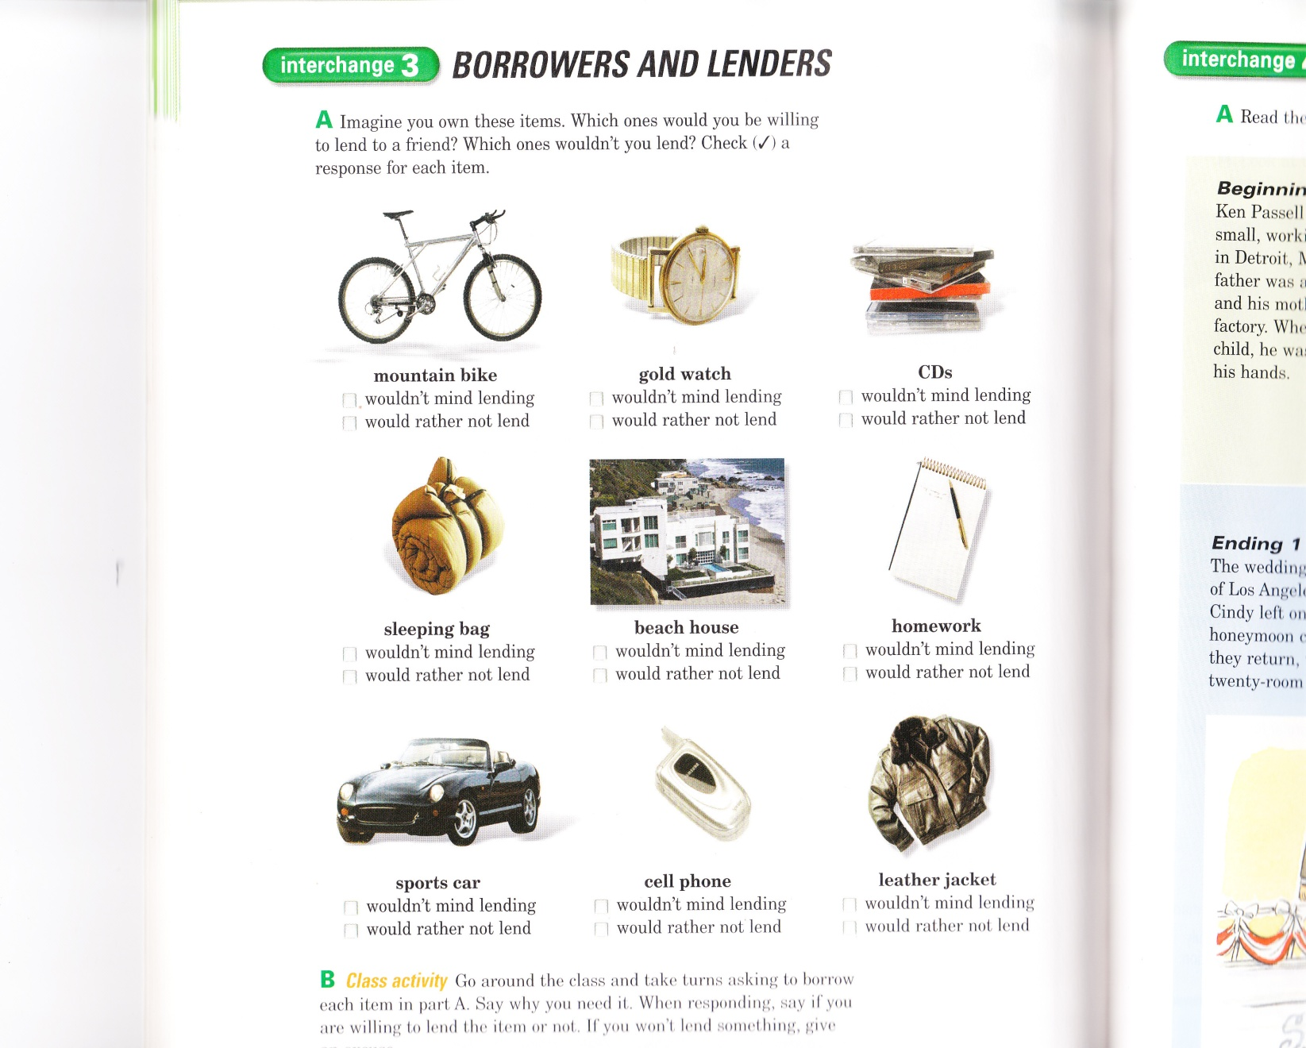

Script B-conversation: Would you mind…?

Rod: Hello.
Jana: Hi, Rod. This is Jana.
Rod: Oh, hi Jana. What’s up?
Jana: I’m going to my best friend’s wedding this weekend. I’d love to take some pictures for his website. Would you mind if I borrowed your new digital camera?
Rod: Um, no. that’s OK, I guess. I don’t think I’ll need it for anything.
Jana: Thanks a million.
Rod: Sure. Uh, have you used a digital camera before? It’s sort of complicated.
Jana: Uh-huh, sure, a couple of times. Would it be OK if I pick it up on Friday night?
Rod: Yes, I guess so.

Listening 2. Favors
Name | Request | Yes | No
Tina
Mike
Phil

Worksheet A
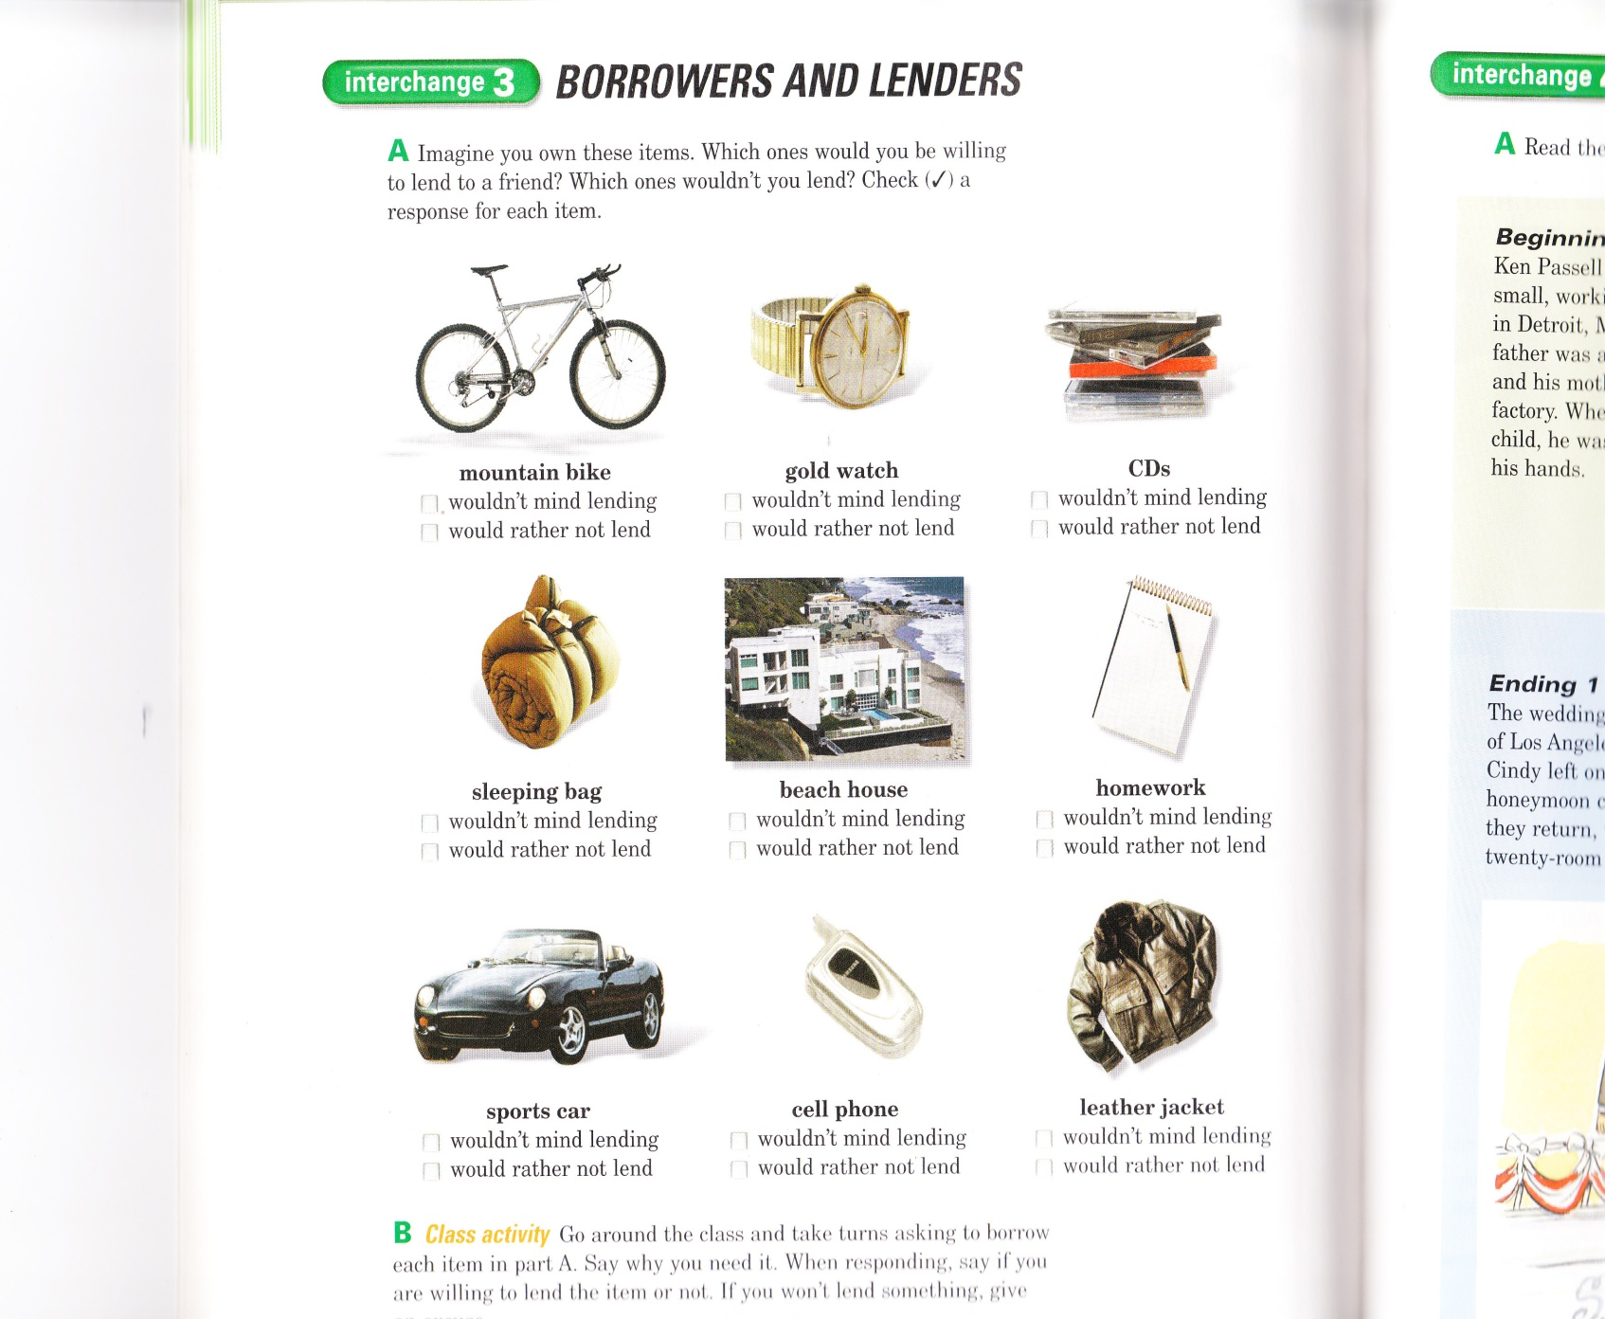

Worksheet B
Items | Lend  or not | Borrowed  or not | Why
mountain bike
Gold watch
CDs
Sleeping bag
Beach house
homework
Sports car
Cell phone
Leather jacket

