Listening
Lesson Plan

Student’s name: Park Ji Eun
Class : 39

Professor: DIANE

Date: May 6, 2009

Listening Lesson Plan

Customer Service

Instructor:.
Bok Hwan, Jeong
( JINI )
Level:
Intermediate
Students:
15
Length:
50 minutes

Materials:
- Board & Markers
- Survey sheet
- Tape , Cassette player or CD player

Aims:
To learn vocabularies by listening teacher’s explanation.
To practice converse with people in English.
To practice expressing thoughts
. To learn how to deal with bad customer service
- To compare their opinions about customer service
- To promote understanding between customer and clerk

Language Skills:

- Reading: survey sheet’s question
- Listening: Teacher explanation, Conversation, interaction with group members
- Speaking: Conversation with people , Q & A , discussion , role paly
- Writing : Answering the Questions on survey sheet
.

Language Systems:

- Discourse: through the conversation
- Function: structures for gining opinions
- Grammar: Making questions & Answering questions

Assumptions:

- Students have experience shopping in departmentstore as a customer
- Students already know the teacher’s style of teaching and the pace of the course.
- Students are familiar with each others.
- Students will understand survey sheet and answer the question sincerely.
- Students may not want to answer the question.

\

Anticipated Errors and Solutions:

- Summing up the survey sheet in advance for expecting a lack of time
- It is important for students to read and understand the survey sheet
So, use easy words.
- If there is more time than expected, give students more time.
- If they want legal solution, inform them the address of Customer Protection Center
/www. Hsp.or.kr/

References:

- Let’s Talk Business “ Customer Service ” pgs. 26~27

Pre-Activity
Materials: survey sheet, cassette player,board, markers
Time  15 min. | Set Up  Whole Class | Procedure  Greeting  Good morning, everyone. How are you today?  Do you like shopping?  Well., When you are shopping , You may receive a customer service.  (Ss answer~!)  So, Was it good or bad?  (Ss answer~!)  What comes to your mind when you think of customer service that you’ve experienced  (Write all Ss ideas on the board)  In my case, I get upset cause I have received many uncomfortable service  So, today, We are going to discuss about customer service.  Before starting class  I gave you one survey sheet .  Did you answer the questions?  (Ss answer~!)  Ok, Let’s start with the vocabularies that we’ll listen from the cassette player  Vocabulary  I’ll hear you stories about customer service  Before that, Let’s check some vocabularies  The first vocabulary is “agree”. For example, If people agree with each other’s opinion about something, they have the same opinion.  The second vocabulary is “ profit “  Does anyone know what it means?  It means that a profit is an amount of money that you gain when you are paid more for something than it cost you to make, get, or do it.  (explain the definition of each word)  Now we are going to listen dialogue between two people.  Listen and think of their opinion about customer service.  And compare with your own opinion  < Play the cassette player!!>

Main Activity
Materials: survey sheet, cassette player, board, markers
Time  20 min | Set Up  Whole Class  Pairs  Whole class | Procedure:  (During listening to the dialogue)  Let’s make pairs!  Let’s discuss your own opinion on survey sheet and opinon  about the dialouge in your group  I’ll give you 3~4 mimutes  Please tell me ypur opinion or any experience; funny story, interesting story and so on  /Sum up Ss’ opinion on survey sheet that answered before class and write it down on the board/  1. Skimming for the main idea  (T write their opinion on the board)  Ok, now, read the story silently for 2 minutes  and then explain the legend to your partner for  5 minutes. So, we have 7 minutes.  CCQ  Are you working alone?  What are you supposed to do after reading?  How much time do you have?  Begin.  (Monitor discreetly while they read & explain)  (Give time warning)  Ok, Are you done?  Are you well aware of Valentine’s Day?  (Ask Ss about the story on the basis of paper Ss read)
Task-realization
Materials: Worksheet #3 (Conversation Questions)
Time  10 min | Set Up  Pairs  Whole class | Procedure  Now, we’ll talk about our experience of Valentine’s Day.  There are some questions and 3 slots in this paper. Converse with your partner first, and then make 3 more questions and ask your partner. Write your partner’s answers. You have 10 minutes.  CCQ  Do you make questions?  Before making questions, What do you do first?  What do you write?  How much time do you have?  Do it now.  (Distribute Conversation Questions paper)  (Monitor discreetly)  (Give time warning)  (If Ss need, give them 1 or 2 more minutes)  Time’s up.  Have you finished?

Post-Task
Materials: board & markers
Time  10 min | Set up  individually | Procedure  Error correction & Feedback  (Point out student)  Read out your questions.  (Write questions that students make on the board.)  (If there are errors, facilitate peer correction.)  (Talk together about students’ answers.)  Did you enjoy? I hope it was a good time for you to speak more in English.  You did a good job.

Valentine’s Day (Student A – Legend #1)

Valentine’s Day is February 14. It is not a holiday, but it is a special day for many people in different countries around the world. Each year on Valentine’s Day, friends and lovers exchange Valentine’s cards, chocolates, candy, flowers and other gifts. In elementary schools in Canada, children make valentines for their classmates and put them in a large decorated mail box. On February 14, teacher opens the box and distributes the cards to students. Many schools also celebrate Valentine’s Day with parties. Some people like to go to a romantic restaurant on Valentine’s Day to celebrate. People of all ages love to send and receive valentines. According to the Canadian Post Office, Canadians send approximately 90 million cards on Valentine’s Day.

There are many symbols of Valentine’s Day, such as heart, roses and cupids. The symbol of cupid comes from ancient Roman times. Cupid was the son of love goddess, Venus. Cupid was a playful child who flew around shooting love arrows into people’s hearts, making them fall in love.

There are many different stories about the origins of Valentine’s Day. According to one legend, the custom of sending a card to a loved one goes back to the days of Roman Empire. In the third century, there was a priest named Valentinus. Valentinus was put in jail and sentenced to die by the Emperor Claudius because of his Christian beliefs. When Valentinus was in jail, he fell in love with the jailer’s daughter. According to the story, the jailer’s daughter was blind, but Valentinus had special abilities and was able to cure her. When he was in jail, she brought him food and delivered messages. The night before Valentinus was executed, he wrote a good-bye note to the jailer’s daughter and signed it “Your Valentine”.
Valentine’s Day (Student B – Legend #2)

Valentine’s Day is February 14. It is not a holiday, but it is a special day for many people in different countries around the world. Each year on Valentine’s Day, friends and lovers exchange Valentine’s cards, chocolates, candy, flowers and other gifts. In elementary schools in Canada, children make valentines for their classmates and put them in a large decorated mail box. On February 14, teacher opens the box and distributes the cards to students. Many schools also celebrate Valentine’s Day with parties. Some people like to go to a romantic restaurant on Valentine’s Day to celebrate. People of all ages love to send and receive valentines. According to the Canadian Post Office, Canadians send approximately 90 million cards on Valentine’s Day.

There are many symbols of Valentine’s Day, such as heart, roses and cupids. The symbol of cupid comes from ancient Roman times. Cupid was the son of love goddess, Venus. Cupid was a playful child who flew around shooting love arrows into people’s hearts, making them fall in love.

There are many different stories about the origins of Valentine’s Day. According to one legend, the Emperor Claudius wanted a strong army. Many married soldiers did not want to leave their families to fight the Emperor’s wars, so Claudius ordered young men not to marry. A priest named Valentinus lived in Rome at that time and he felt sorry for the young men and their sweethearts. He decided to marry them secretly, but the Emperor found out and put him in prison. He was executed on February 14. Since that time, Valentine’s Day has been celebrated as a special day for sweethearts and romance.

Comprehension Questions (Teacher)

- What are some symbols of Valentine’s Day?

- What do people exchange on Valentine’s Day?

- Who was Cupid?

- Who was Valentinus?

- Why was Valentinus put in jail according to the legend?

- How did Valentinus sign his good-bye note to the jailer’s daughter?

- Why did the Emperor Claudius not want young men to marry?

Conversation Questions (Students) #3

1. Do you think Valentine’s Day was created for commercial purposes?

2. Do parents have a big influence on the choice of your husband/wife?

3. What do you think about arranged marriage?

4. Did you get chocolates or cards last Valentine’s Day?

5. Did you give chocolates or cards to your sweetheart last Valentine’s Day?

6. Are you planning something special for Valentine’s Day?

8. Do you like chocolates?

9. Have you ever fallen in love at first sight?

10. Have you ever been crazy about someone?

11. What’s your ideal person?

12. Have you ever been on a blind date?

13. ________________________________________________________________?

14. ________________________________________________________________?

15. ________________________________________________________________?

Picture #1


Picture #2

Picture #3
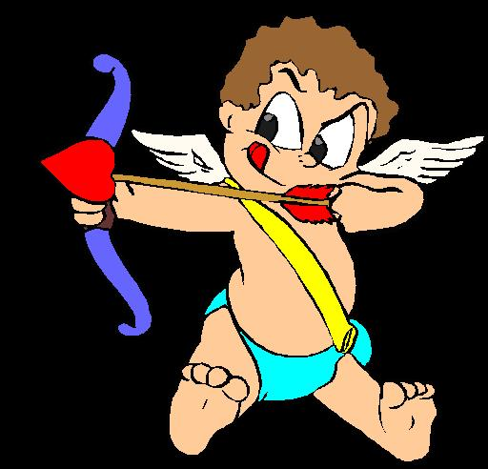

Picture #4
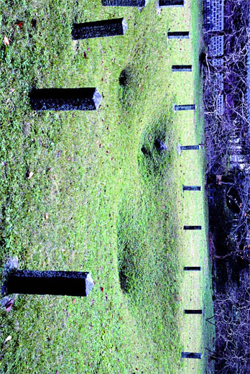

Picture #5


